

Training Administration

Quality Management System

Prepared by
Chariot Learning and Consultancy LLP

Version 1.0

Version Control Record

Version | Effective Date | Changes | Who
1.0 | 26 May 2025 | First Draft | Victor Ang

Table of Contents
Organization Chart 1
Roles and Responsibilities 2
1 Course Administration and Corporate Governance 4
1.1 Learner Communication and Management 4
1.1a Course Information to Learners 4
(i) Course Information to Learners 5
(ii) Course materials, technical hardware/software, assessment and others, if applicable 5
1.1b Course Information Vetting and Approval Process 7
(i) Responsibilities of Each Executive 8
(a) Training Executive 8
(b) Marketing Executive 8
(c) Finance Executive 8
(ii) Vetting & Approval 8
1.1c Course Confirmation 9
1.1d Closed Loop Communication with Learners 11
(i) Feedback 12
(ii) Request 17
(iii) Appeal 19
1.2 Pre-Course and Post-Course Advisory Services 21
1.2a Pre-Course Advisory Information 21
(i) Course Content and Relevance 21
(ii) Fee Payment 21
(iii) Refund Policy 22
(iv) Attendance Requirements 22
(v) Prerequisite(s) for Admission Requirements 22
(vi) Course Completion Requirements 22
1.2b Post-Course Advisory and Support 23
(i) Modes and Platforms of Support 23
(ii) Support Types 23
1.2c Training and Monitoring of Course Advisors 24
1.3 Administrative and Learning Management Systems 25
1.3.1 Administration Systems 25
1.3.1a Submission of Assessment Results to TPG 25
1.3.1b Maintenance of Records and Certification 27
1.3.1c Attendance System 28
(i) Attendance Taking Records 28
(ii) Attendance Monitoring Records 28
1.3.2 Learning Management System 30
1.3.2a Authentication of Learners’ Identities 30
1.3.2b Validation of Attendance Records and Progress 32
1.3.2c Trainer Support for Learners 32
1.3.2d Technical Helpdesk Support 34
1.3.2e Course Commencement Validation 34
1.3.2f E-Assessment Verification of Learner 34
1.4 Corporate Governance 35
1.4.1 Strategic Planning and Management Review 35
1.4.1a Developing Effective Strategies 36
1.4.1b Management Reviews 41
(i) Analysis of Key Performance Indicators (KPI) 41
(ii) Action and Review for Targets 41
1.4.2 Financial Management 42
1.4.2a Training for Financial Staff 42
1.4.2b Financial Statements Monitoring 43
1.4.3 Review of Systems and Processes 45
1.4.3a Internal Review Process 45
1.4.3b Feasibility Review 45
1.4.3c Action Plan 46
1.5 Management of Marketing Staff and Agents 47
1.5a Compliance to SSG’s Marketing Guidelines 47
1.5b Marketing Code of Conduct 48
(i) Roles and Responsibilities 48
(ii) Code of Conduct 49
1.5c Training for Marketing Staff / Agents 49
1.5d Marketing Review 50
1.5e Appraisal of Marketing Staff 52
(i) Monitoring Records on Service Delivery 52
(ii) Intervention Records of Violations 52
1.6 Tracking & Monitoring Organisational Outcomes 54
1.6a Tracking & Monitoring Organisational Outcomes Process 54
1.6b Improving Organisational Quality 55
2 Course Quality Assurance 56
2.1 System on Course Quality Assurance 57
2.1a WSQ 58
(i) Course Information 58
(ii) Assessment Records (AR) 58
(iii) Assessment Summary Records (ASR) 59
(iv) Class Attendance Record (CAR) 59
(v) Courseware Material Records 60
(vi) Credentials and Qualifications Records 63
(vii) Courseware Validation and Review Checklists 63
(viii) Industry Engagement for Curriculum Design 63
(ix) TRAQOM Course Quality Analysis 63
(x) Approved Course Proposal Records 63
(xi) Standard Curriculum Letter of undertaking Records 63
2.1b Internal Quality Assurance (IQA) System – Non-WSQ 63
2.2a Process to Screen / Profile Suitable Learner(s) 64
WSQ Courses 64
(i) Registration records 64
(ii) Checking of Prerequisites 64
(iii) Checking of Aptitude / Attitude 64
(iv) Benchmarks 64
Non-WSQ Courses 64
2.3 System for Adult Educator (AE) Management 65
2.3a Recruitment , Selection and Induction System 65
(i) AE Recruitment System and Records 66
(ii) Qualification Selection and Process Overview 66
(iii) AE Recruitment System Benchmarks 67
2.3b Deployment and Assignment System 68
(i) AE Deployment Schedule and Plan 68
(ii) AE Assignment Acceptance Documents 70
(iii) System Benchmarks 70
2.3c Monitoring and Management System 70
(i) Training Delivery Monitoring 70
(ii) Appraisal and Counselling Records 70
(iii) Code of Conduct for AEs 71
(iv) System Benchmarks 71
2.3d Training Systems for Qualified AEs 71
(i) AE Training Records and Certifications 71
(ii) Deployed Training Documents 71
(iii) Annual Training Calendar 72
(iv) System Effectiveness 72
2.3e Intervention System for AEs 72
(i) Assessment 72
(ii) Intervention Records 73
(iii) Outcome Measures of System 74
2.4 Plan-Do-Check-Act (PDCA) System 76
2.4a Course Quality Assurance Review System 76
(i) Courseware Feedback Analysis 76
(ii) Meeting for Issues and Matters 76
(iii) Documentation of Corrective Implementation 76
3 Outcomes 77
3.1 Organisational Outcomes 77
3.1a Learner Survey Response 77
3.1b Satisfaction of Feedbacks and Requests 77
3.1c Satisfaction of Course Advisory 77
3.1d Satisfaction of Administrative Matters 77
3.1e Performance and Achievements in Strategy 78
3.1f Compliance to SSG Marketing Guidelines 78
3.2 Training Outcomes 78
3.2a Training Quality and Outcomes Measurement (TRAQOM) Initiative 78
Annexes 79
Annex A.1 - Course Registration Email 79
Annex A.2 - Notification / Booking of Trainers and Assessors Email 82
Annex A.3 – Confirmation / Reminder Email 83
Annex A.4 - Final Reminder Email 84
Annex A.5 - Email for Course Materials 85
Annex A.6 - Email for Grant Application Reminder and Invoice 86
Annex A.7 - Sample Invoice – Individual-sponsored, Payment by SFC 88
Annex A.8 - SSG Training Grant Application Form 89
Annex A.9 - Post-Course Email 90
Annex A.10 - Attendance Sheet Template 91
Annex A.11 - Refund Process 92
Annex A.12 - SSG Funding Eligibility Check Process 93
Annex A.13 - Review of Assessment Appeal Case Form 94
Annex A.14 - Assessment Appeal Procedure 95
Annex A.15 - SSG Marketing Guidelines Checklist 96
Annex B.1 - Associate Trainer Application Form 98
Annex B.2 - Interview / Selection Evaluation Form for Trainer / Assessor - For training and assessment function 101
Annex B.3 - Interview / Selection Evaluation Form for Course / Curriculum Developer - For Design and Delivery of Training Programmes 102
Annex B.4 - Trainer Competencies Checklist 103
Annex B.5 - Assessor Competencies Checklist 106
Annex B.6 - Course Survey Sample 109
Annex B.7 - Course Proposal Template 110
Annex B.8 - Training Profiling Form 122
Annex B.9 - Pre-Delivery Course Materials Evaluation Checklist 123
Annex B.10 - Post-Delivery Course Materials Evaluation Checklist 124
Annex B.11 - Assessment Process Validation Checklist 125
Annex B.12 - Assessment Methods and Tools Validation Checklist 126
Annex B.13 - Assessment Evidence Validation Checklist 128
Annex C.1 - SSG Course Evaluation Form 129
Annex C.2 - Course Evaluation Form 134
Annex C.3 - L1 Consolidated Course Evaluation 136
Annex C.4 - L2 Consolidated Passing Rate Report & Attrition Rate Report 137
Annex C.5 - SSG Outcome Survey Form 138
Annex C.6 - Post Training Follow-Up Form 140
Annex C.7 - L3 Consolidated Post Training Report 141
Annex C.8 - Performance Indicators Checklist 142
Annex C.9 - Minutes of Meeting Template 143
Annex D.1 - Administrative Support and Processes 144
Annex D.2 - Learning Management / Learner Support System 147

Organization Chart

General Manager
Greg Kum

Special Project Team

Loh Yew Seng

Andy Tan

Trainers / Assessors

HR / Finance
Victor Ang

Finance Executive
Larry Ng

Finance / Grant Executive
Bella

Training Admin / Marketing
Larry Ng

Training Executive
Andy Tan

Training Executive
Loh Yew Seng

Marketing Executive
Greg Kum

Operations
Larry Ng

Course Development

Course Developer Consultant
Dr Alfred /
Greg Kum

IT Support
Larry Ng
Managing Director
Victor Ang

Roles and Responsibilities
The roles and responsibilities listed below pertain to training functions and do not include other roles and responsibilities that are not training-related.

Managing Director
- Developing and executing business strategies to achieve short and long-term goals.
- Overseeing the company's business operations and financial performance
- Supervising & mentoring trainers, assessors, and developers.
- Building and enhancing the company's public profile at events, speaking engagements, etc.

General Manager
- Act as Management Representative, i.e. the single point of liaison with external agencies such as SSG.
- Oversee all functions related to WSQ training operations.
- Supervise trainers and assessors to ensure they conduct training and/or assessment in accordance with WSQ standards.

HR / Finance Manager

Finance Manager
- Lead the finance team in:
- Providing accurate & timely quotation & invoices to customers/learners.
- Managing accounts receivable such as reconciling payment from SSG and receiving payment.
- Monitoring outstanding invoices to ensure active follow-up for timely payments.
- Financial recordkeeping.
- Maintain vendor relationships.
HR
- Recruit and onboard adult educators.
- Develop, review, and manage performance appraisal of trainers/assessors and internal staff.
- Payroll management.

Training Admin / Marketing Manager

Training Admin
- Lead the Training Executives in all training-related operations such as:
- Registration, enrolment of training grant, course confirmation, logistics arrangement, booking of trainers, courseware, attendance, assessment, etc.
- Gather and compile feedback on all training.
- Records keeping of attendance and assessments.
- Answer enquiries and provide advisory relating to courses and grants.
- Update TPG to ensure profile data is up to date.
- Installing and configuring computer hardware, software, systems, network, and printer.
- Provide support and timely trouble-shoot synchronous training.

Marketing Manager
- Guide marketing executive to
- Publish and manage course details, grants information on the company website.
- Design and develop marketing collateral to promote sales.
- Build and manage the company’s social media presence in Facebook, LinkedIn, YouTube, and any other social media channels.

Course Development

- Work with Subject Matter Experts (Associates) to conduct necessary research and develop course proposals, course materials, and/or assessment plan for courses.

Trainers & Assessors
- Conduct training and/or assessment in accordance with WSQ standards.

IT Support
- Provide daily technical support and maintenance for the company website.

Office Number: +65 67850776

Course Advisors:
- Dr Alfred
- Ms Rita
- Ms Wonder

Course Administration and Corporate Governance

Learner Communication and Management

Course Information to Learners
Course Registration
Learners can easily register for courses on the website, which offers detailed information, including:
- Course Title
- Course Start Date/Time
- Training Venue
- Sponsorship
- Name(s) On Certificate
- NRIC
- Funding Eligibility
- Course Information
- Post-Course Support
- Course Cancellation/Reschedule Policy
- Learning Outcomes
- Course Brochure
- Skills Framework
- Certification Criteria
- WSQ Funding Criteria & Other Funding Available
- Technical Hardware/Software Requirements
- Job Roles
- Trainers Information
- Review
Please refer to Annex [Insert Annex Number].

Automated Calendar Invite
Upon registration, an automated Course Calendar invite is sent to the learner. The invite includes:
- Course Title
- Course Start Date/Time
- Training Venue

Please refer to Annex [Insert Annex Number].

Automated Course Registration Acknowledgement

Upon registration, an automated email is sent to both the learner and the Training Executive. The email includes:
- Course Confirmation Information
- Payment Modes:
  - WSQ Funding, SFC Funding (for company sponsored), Skillsfuture Credit Claims (for self-sponsored) & Paynow
- Company Invoice
- Requests for Postponement or Withdrawal
- Support and Advisory Contact Details
- Order Information such as Order No, Billing Information, Payment Method, Course Name, Course Code, Course Date, Grand Total (incl. GST)

Please refer to Annex [Insert Annex Number].
Automated Grant Application Email (WSQ Courses)

Upon registration, an automated grant application email is sent to the learner.
The email includes:
- Self-sponsored
  - Eligibility Criteria, Grant Application Form
- Employer-Sponsored
  - Eligibility Criteria, Grant Application Form, Supporting Documents

Please refer to Annex [Insert Annex Number].

Move flowchart to annex (just report writing)

Course Information to Learners
Essential course information such as course date, time are sent to learner, after course enrolment. The tables below show the type of course information that are shared with learners in different emails and website.

Info type\Email type | Calendar Invite | Confirmation Email | Grant Application Email | Invoice Email | Courseware Email
Date | √ | √ | √ | √ | √
Time | √ | √ |  | √ | √
Venue | √ | √ |  |  | √
Fee |  |  |  | √
Grant Amount |  |  |  | √
Grant criteria |  |  | √

The table is a vital record-keeping tool designed to document the dissemination of key course information to enrolled learners. It ensures that learners are adequately informed about all necessary details before the course begins, enabling them to fully prepare and participate effectively.

One of the primary functions of the table is to record the communication of logistical details such as course dates, time, and venue. This ensures learners are aware of the exact duration, session timings, and location of the course. For virtual courses, this includes providing the relevant online platform details and access links. By maintaining this information in an organized manner, the table minimizes any potential confusion and guarantees that learners have clarity on when and where the course will take place.

Course materials, technical hardware/software, assessment and others, if applicable

Info type\Email type | Confirmation Email | Courseware Email | Grant Application Form | Certification Email | Additional Email (where applicable) | Website
Course Material |  | √
Hardware/Software Requirements |  |  |  |  | √ | √
App Account |  |  |  |  | √ | √
E-Attendance | √ | √ | √ |  |  | √
Assessment |  |  | √ |  |  | √
Retrieval of SOA |  |  |  | √
Refund Policy | √ |  |  |  |  | √
Withdrawal/Reschedule Policy | √ |  |  |  |  | √

Additionally, the table captures other essential details, such as the provision of course materials and technical requirements. Learners are informed about the resources they will receive, such as handouts or study guides, as well as any hardware or software needed to participate in the course effectively. For courses that include assessments, details about formats, timelines, and grading criteria are also documented and communicated. This structured approach ensures that learners are aware of academic expectations and technical requirements, promoting transparency and readiness.

The table also functions as a systematic record to track and verify the communication process. It provides evidence that all enrolled learners have been informed of the same details, ensuring consistency and preventing miscommunication. This documentation serves as an audit trail, which can be referenced for accountability and compliance purposes.

Overall, this table streamlines the process of providing essential course information, ensuring that learners are well-prepared and aligned with the course requirements. It reflects the institution’s commitment to clear communication, learner satisfaction, and operational transparency, while supporting adherence to regulatory and institutional guidelines.

Course Information Vetting and Approval Process

Manager
Vet & Approve Changes within 5 working days
Ok?
Finance Executive
- Add changes upon receiving update from email/whatsapp:
  - Course Name
  - Course Code
  - Course Fee
  - Finance System
  - Update UTAP funding (if applicable)
No
Yes
End
No
Course Information Update
- Any changes on course information such as:
  - Course Name
  - Course Information
  - Course Code
  - Course Fee
  - Skills Code
  - Duration Component
Training Executive
- Update changes upon receiving update from email/whatsapp:
  - Google Drive Folder
  - Courseware Slides
  - Courseware Assessments Documents
  - TMS
Marketing Executive
- Update changes upon receiving update from email/whatsapp:
  - Brochure
  - Website Changes

Responsibilities of Each Executive

Training Executive
- Role: Ensure all internal training materials and resources reflect the updated information.
- Actions:
  - Update the Google Drive Folder containing course-related files.
  - Revise the Courseware Slides to include updated course details.
  - Adjust Courseware Assessments and Documents to align with the new information.

Upon making these updates, the Training Executive ensures the course content is consistent with the changes.

- Marketing Executive
- Role: Update external communication and promotional materials to reflect the changes.
- Actions:
  - Revise the Brochure with the updated course details.
  - Implement changes on the organization's Website to ensure accuracy and consistency for prospective learners.

The Marketing Executive’s responsibilities ensure learners and stakeholders receive up-to-date information.

(c) Finance Executive
- Role: Ensure all financial records and systems are updated to reflect the revised course details.
- Actions:
  - Update Course Name, Course Code, and Course Fee in financial systems.
  - Adjust the Finance System to reflect the updated pricing or course-related financial records.
  - If applicable, update the UTAP Funding records to align with the new course details.

The Finance Executive ensures that financial operations and funding eligibility align with the updated course information.

Vetting & Approval

The Manager plays a critical role in ensuring the accuracy and alignment of updates with organizational standards. Upon receiving updates, the Manager has five working days to vet and approve the changes. Once approved, the process is finalized seamlessly. If the updates do not meet requirements, constructive feedback is provided to the respective executives—Training, Marketing, or Finance—for necessary revisions. This structured feedback loop guarantees that all changes adhere to high-quality standards and organizational policies, fostering accountability and continuous improvement.

The process ensures that:
- All changes to course information are systematically communicated to relevant departments.
- Updates are implemented by the correct stakeholders in their respective areas.
- Changes are vetted and approved by the Manager within a defined timeline (5 working days).
- A feedback loop allows for revisions if the updates do not meet standards, maintaining quality and consistency.

This structured workflow minimizes errors, ensures accountability, and supports a collaborative effort to maintain up-to-date and accurate course information.

Course Confirmation
Automated Confirmation Email
An automated email reminder will be sent to learners seven days before the course begins. The email will include:

- Course Title
- Course Start Date/Time
- Training Venue
- Technical Hardware/Software Requirements
- Course Materials and Learning Management System (LMS)
- Things to Bring
- SkillsFuture Credits Claim (for self-sponsored)
- Attendance Taking Guidelines
- Request for Postponement or Withdrawal
- Support and Advisory Contact Details

Automated Final Confirmation Email
Another automated email reminder will be sent to learners two days before the course begins. The email will include:

- Course Title
- Course Start Date/Time
- Training Venue
- SkillsFuture Credits Claim (for self-sponsored)
- Attendance Taking Guidelines
- Request for Postponement or Withdrawal
- Support and Advisory Contact Details

End

This flowchart outlines the process of sending automated email reminders to learners before the course starts, powered by Google Apps Script automation.

- Automated Confirmation Email (7 Days before the course start date)

Seven days before the course begins, learners receive their first automated email reminder. This email provides comprehensive details to ensure they are well-prepared, including:

- Course Title: Name of the course they are enrolled in.
- Course Start Date/Time: The exact schedule for the course to help learners plan ahead.
- Training Venue: The location details for physical or virtual sessions.
- Technical Hardware/Software Requirements: Any tools, software, or equipment learners need to bring or install before the course.
- Course Materials and Learning Management System (LMS): Information on accessing resources and the LMS platform.
- Things to Bring: A checklist of items required for the session.
- SkillsFuture Credits Claim (for self-sponsored learners): Guidance on how to apply SkillsFuture credits for funding.
- Attendance Taking Guidelines: Details on how to take digital attendance via the SingPass app, highlighting digital attendance taking is mandatory for all learners tapping on SSG training grants.
- Request for Postponement or Withdrawal: Information on how learners can request changes or cancellations.
- Support and Advisory Contact Details: Contact information for any inquiries or assistance.

- Automated Final Confirmation Email (2 Days Before the Course)

Two days before the course starts, learners receive a second automated email reminder. This serves as a final confirmation and includes essential details to reinforce preparedness:

- Course Title: Name of the course for quick reference.
- Course Start Date/Time: A reminder of the scheduled session.
- Training Venue: Final confirmation of the location.
- SkillsFuture Credits Claim (for self-sponsored learners): A follow-up reminder for claiming funding, if applicable.
- Attendance Taking Guidelines: A recap of how attendance will be recorded.
- Request for Postponement or Withdrawal: Reiterates the procedure for any last-minute changes.
- Support and Advisory Contact Details: Contact information for real-time assistance if required.

This second email, also automated through Google Apps Script, provides a helpful nudge to learners while ensuring they have all critical information in one place.

After these two automated reminders, the learners proceed to the course. These emails ensure that learners are adequately informed and prepared, reducing the likelihood of miscommunication or missed sessions.

Here are the Notion links to streamline our SOP reminder email process and ensure effective communication:

SOP: Send Course Confirmation Reminder – [Click here to access]
SOP: Send Final Reminder – [Click here to access]

These guides offer clear, actionable steps to ensure professionalism and effective communication within the workplace.

Closed Loop Communication with Learners

Withdrawal / Appeal
Refer to Withdrawal/Appeal process
Yes
+ feedback?
End
Manager shares findings and outcome with learner within 5 days
Outcome accepted?
No
Yes
Feedback
Type of Email
Complaint
Learner email to
info@chariot-learning.com

Training Exec acknowledge within 1 day
No
Manager response to learner within the day
Manager investigates with parties involved
The closed loop flowchart provides a structured approach to communication with learners after course completion. It ensures that all critical steps, from initial enquiries to feedback collection, are followed meticulously.
The Training Executive and managers receive feedback and complaints via info@chariot-learning.com. These are then reviewed to evaluate course effectiveness, learner satisfaction, and identify areas for improvement, ensuring continuous enhancement of the training experience.
Feedbacks received via email will be reviewed with manager and the Training Executive shall follow organisation’s guidelines / SOPs and act accordingly.

Feedback

Type of Feedback | Action by Who | Action by When
General (such as toilet, stationary, snack, etc) | Training Executive to reply to feedback & to check feedback with relevant party. | Within 1 day from feedback received
 | Training Executive to work with relevant party on improvement plan and seek approval from manager. | Within 5 days from feedback
Courseware | Training Executive to reply to feedback & escalate feedback to manager. | Within 1 day from feedback received
 | Manager to call learner (if required) to better understand the feedback. | Within 2 days from feedback received
 | Manager to share feedback with course developer and recommend follow-up action to course director. | Within 7 days from feedback
 | Course Manager to email to learner on the outcome of the feedback. | Within 9 days from feedback
Trainer / Assessor | Training Executive to reply to feedback & escalate feedback to manager. | Within 1 day from feedback received
 | Manager to call learner (if required) to better understand the feedback. | Within 2 days from feedback received
 | Manager to share feedback with trainer / assessor and recommend follow-up action to course director | Within 7 days from feedback
 | Course Manager to email to learner on the outcome of the feedback. | Within 9 days from feedback

General Feedback

General Feedback Received
Yes
No
No
Any feedback
End
Monitor Outcome of correction plan (within 1 month)
No
Review and approve
Yes
Share feedback with the manager and recommend improvement plan. (within 5 days)
Call learner for more info
Yes
Further check to understand feedback?
Training Executive: To acknowledge the feedback (within 1 day)
Courseware Feedback

Yes
End
No
Any feedback
Yes
Monitor next course run
No
No
Director review and approve
Course developer recommend follow-up action to course director (within 7 days)
Share feedback with the course developer
Call learner for more info
Training Executive: Acknowledge & Escalate to Manager (within 1 day)
Yes
Further check to understand feedback?
Courseware Feedback Received
Trainer / Assessor Feedback
Trainer/Assessor Feedback Received
Yes
No
No
Any feedback
End
Monitor next course run
No
Review and approve
Yes
Share feedback with trainer and recommend follow-up actions/improvements to the trainer/assessors. (within 7 days)
Manager to call learner and trainer for more info (within 2 days)
Yes
Further check to understand feedback?
Training Executive: Acknowledge & Escalate to Manager (within 1 day)

Processing Feedback

Feedback received from learners via email is systematically collected and forwarded to the relevant parties for review and action:

- Training Executive: Feedback regarding general issues, courseware, or trainers is directed to the Training Executive, who is responsible for reviewing and analyzing the feedback to identify areas for improvement.
- Course Manager: Feedback related to course quality or trainer performance is sent to the Course Manager. The Course Manager collaborates with the Training Executive to address any concerns and enhance course delivery based on the feedback provided.

This structured process ensures effective communication with learners, captures valuable feedback, and promotes opportunities for continuous learning. It underscores the organization's commitment to professionalism, learner satisfaction, and ongoing improvement.

Learners are informed in all standard email notifications that they can contact us via:

- Tel: 67850776 (9am to 6pm, Mon-Sun, excluding Public Holidays)
- Email: info@chariot-learning.com

Request

Reschedule:

Has payment been made?
Trainee request for reschedule

No
Training Executive updates the calendar invite
Finance Executive handles grant applications (if applicable)
Finance Executive adjust the invoice accordingly
Finance Executive generates a new invoice for revised date

Yes

Training Executive updates the calendar invite

Finance Executive cancels and re-enrolls the grant application (if applicable)

End

For enquiry on rescheduling, the Training Executive takes a personalized approach by understanding the reason behind the request and proactively suggesting alternative course dates to better suit the learner’s schedule.

Change of course date
If payment has not been made, the Training Executive will update the calendar invite, and the Finance Team will handle grant applications (if applicable) and generate a new invoice for the revised date.
If payment has already been made, the Training Executive will update the calendar invite, while the Finance Team cancels and re-enrolls the grant application (if applicable) and adjusts the invoice accordingly.

Here’s the link to our SOP for Rescheduling a Class, providing clear and structured guidelines for this process:
Reschedule a Class – Click here to access

Yes
No
End
Trainee request for withdrawal
Finance Executive follows the refund policy SOP
Training Executive delete calendar invite
Training Executive delete calendar invite

Withdrawal:

Has payment been made?

If learner has not made payment, training executive will delete calendar invite and stop registration.
If learner has made payment, finance executive will follow refund policy standard operating process.

Refer to this case: Withdrawal Email Case 1

Here’s the link to our SOP for Canceling a Class, offering transparent and step-by-step instructions for handling cancellations:
Cancel a Class – Click here to access

Refund
Refund policy is published to be published in Chariot Infotech website. All refund requests must be submitted in writing and will be processed according to our refund policy. Please refer to annex A.11.

Here’s the link to our SOP Refund Policy, providing clear and transparent guidelines for all refund requests:
Refund Policy – [Click here to access]

Appeal
Learner accepts outcome ?
“Not Yet Competent”
- Trainer to inform learner
Yes

No
Appeal Request
- Submit Assessment Appeal Case Form

Appeal accepted?
Appeal Panel to review
No

Yes

Reschedule Assessment
(within 2 weeks)

No change to “Not Yet Competent” Outcome

End

Learners may submit their appeal request for reassessment.

Appeal Against Assessment Outcome or Request for Reassessment

A candidate who is deemed to be “Not Yet Competent” will have the right to:
- Appeal; or
- Request for reassessment by writing in with detailed grounds for appeal/request for reassessment within 1 week of the date of assessment to the Training Manager.

For more details, refer to Annex A.13 for the Review of Assessment Appeal Case Form.

Documents Required:
- Letter of Appeal / Assessment Appeal Form submitted by Candidate
- Assessment Record Forms completed by Assessor

Possible Outcomes of the Appeal are:
- No change to “Not Yet Competent” outcome
- Recommendation for candidate to go through a reassessment that must be conducted within 2 weeks from the date of the panel’s decision and the possible outcome of the reassessment are:
- Remain as “Not Yet Competent”; or
- Reverse outcome to “Competent” with supporting reasons

For more details, refer to Annex A.14 for the Assessment Appeal Procedure.

Final Assessment

Candidates will be informed of their FA schedule on the final day of training. If a candidate is unable to attend the assigned FA date or time due to a valid reason, they must notify the Trainer immediately. The Trainer will coordinate a swap with another candidate and update the Training Manager promptly.

Pre-Course and Post-Course Advisory Services
- Pre-Course Advisory Information

All essential course information, including prerequisites, funding options, refund policies, and attendance requirements, is transparently published on our website, ensuring learners are fully informed before registration.

Course Content and Relevance

Information Disclosed on Website and Brochure include:
- Course Title
- Course Training Duration
- Course Venue
- Course Fees
- Modes of Training
- Learning Outcomes
- Course Objectives
- Course Outline & Details
- Certification Requirement: Upon meeting at least 75% attendance and passing the assessment(s)
- Minimum Entry Requirement
- Target Audience
- Trainers’ Profiles
- Software/Hardware Requirement
- Fee Payment information, including grants, subsidies, and payment modes
- Attendance Requirements
- Prerequisite (s) for Admission
- Course Completion Requirements
- Post-Course Support
- Cancellation, Rescheduling & Refund Policy
- Learner’s Review
- Other related courses learners may be interested in.
- ACRA- Name.
- UEN number / ACRA registration number.

For any inquiries before registration, learners can:
- Send a message through the website
- Email at info@chariot-learning.com
- Call us at +65 67850776

Our dedicated course advisors will respond to all inquiries within one business day, ensuring you have the clarity and support needed to embark on your learning journey.

For further information, please refer to our: Website and our comprehensive Brochure.

Fee Payment

Course fees are published on our website, along with detailed information about training grants. For eligible courses, the funding section outlines the criteria for grant eligibility and displays the nett course fee after deducting applicable grants. Learners can also explore the various payment modes available, such as SkillsFuture Credit, SkillsFuture Enterprise Credit, and PSEA, ensuring they maximize their funding opportunities.

Upon course registration, learners enrolled in grant-eligible courses will receive an automated email notification. This email serves as a reminder of the training grant eligibility criteria and includes instructions to complete the training grant application form, making the process seamless and straightforward. This ensures learners are fully informed and supported in leveraging the funding options available to them.

Refund Policy

The refund policy is easily accessible on our website, available on each course page and under the Cancellation/Rescheduling Policy tab. It is also shared with learners through email notifications, including:

- Registration Order Email
- Course Confirmation Email

For further information, please refer here: Refund Policy

Attendance Requirements

Learners must maintain a minimum of 75% attendance to be eligible for:
- A Statement of Attainment (SOA) issued by Workforce Singapore for WSQ-funded courses.

The attendance requirement is clearly outlined on each course page on our website, ensuring transparency and clarity.

E-Attendance via SingPass

For courses eligible for WSQ funding or SkillsFuture Credit, learners are informed to complete mandatory e-attendance using the SingPass app. This requirement is communicated clearly in both the course confirmation and final course confirmation emails, ensuring learners are fully informed and prepared. This streamlined process ensures compliance with funding requirements while simplifying attendance tracking.

For further information, please refer here: Confirmation Email & User Guide for E-Attendance

Prerequisite(s) for Admission Requirements

The minimum entry requirements for each course are clearly outlined on our website for complete transparency.
For courses with prerequisites:
- The specific prerequisite knowledge is detailed under the course tab on our website, providing learners with clear guidance on what is needed to succeed.
- To ensure readiness, our course advisors will personally email learners to confirm they meet the prerequisite requirements before completing their registration.

This process guarantees that learners are fully prepared, setting them up for success in their training journey.

For further information, please refer here: Prerequisite Tab

Course Completion Requirements

Learners are clearly informed of the course completion criteria on our website to ensure transparency and preparedness:
- A minimum of 75% attendance is required to meet the course requirements.
- Successful passing of an open-book assessment at the end of the course (for WSQ-funded courses).

These completion requirements are also outlined in the WSQ grant application form, reinforcing their importance and ensuring learners are well-equipped to meet these standards for a successful training experience.

- Post-Course Advisory and Support

Modes and Platforms of Support

Post-Course advisory is provided through:

- Telephone: +65 67850776
- WhatsApp: https://wa.me/6598227026
- Email: info@chariot-learning.com
- Training Centre’s Venue: 10 Jalan Besar #15-05 Sim Lim Tower, Singapore 208787

Support Types

We send a Course Completion Email that seamlessly integrates with our Post-Course Advisory Support process. Here's how the email and advisory support work together to enhance the learner experience:

Key Elements in the Email and Their Alignment with Post-Course Support:

- Digital Certificates (E-certificates):
  - The email confirms that digital certificates are sent upon course completion.
  - For WSQ courses, SOA e-certificates can be downloaded from the MySkillsFuture portal within 3–4 weeks.
  - Post-Course Advisory Support Connection: Learners can request printed copies of these e-certificates through your advisory service, providing flexibility for learners who prefer hard copies.
- Course Feedback:
  - The email encourages learners to submit feedback via:
    - The TRAQOM survey form.
    - The Course Feedback form.
  - Post-Course Advisory Support Connection: Feedback collected here can guide personalized advisory recommendations, such as suggesting related courses to meet learners' evolving needs.
- Post-Course Support:
  - The email explicitly offers support channels for learners who require further assistance:
    - Hotline: 67850776 (available daily, excluding public holidays).
    - Email: info@chariot-learning.com
  - Post-Course Advisory Support Connection: This ensures learners can seek additional guidance on certification, course content, or career advancement.
- Promotions and Continued Learning:
  - Learners are encouraged to provide Google reviews
  - Post-Course Advisory Support Connection: Personalized course recommendations can incorporate such promotions, encouraging learners to explore related training programs.
- Encouragement to Stay Engaged:
  - The email concludes with a forward-looking tone, inviting learners to return for future courses.
  - Post-Course Advisory Support Connection: By providing tailored recommendations through advisory support, you ensure continuous learning and professional growth for participants.

Enhanced Learner Engagement:
By integrating this email with our Post-Course Advisory Support, we create a seamless process that supports learners at every stage—from receiving certifications and providing feedback to exploring future learning opportunities. This structured approach fosters ongoing relationships, empowering learners to achieve long-term personal and professional development.

- Training and Monitoring of Course Advisors

Our course advisors are rigorously trained to deliver exceptional service, ensuring they are fully equipped to:
- Navigate the Chariot website, including online course registration and course search processes.
- Understand available grants and subsidies, along with their eligibility criteria.
- Recommend courses tailored to diverse skill sets, industries, software applications, and job roles.

To maintain consistency and quality, senior course advisors or managers use a comprehensive training checklist to guide new advisors during onboarding. Regular team meetings are held to address updates or questions related to policy changes (e.g., GST adjustments, SingPass e-attendance) or new initiatives.

Service Excellence Monitoring:
New course advisors undergo a 3-day on-the-job training (OJT) under the mentorship of a senior course advisor. Senior advisors, seated nearby, actively observe and monitor service delivery. If an advisor's performance is found lacking, additional coaching or re-training is provided.
To ensure quality in communication, senior course advisors are copied on all email interactions with customers. This allows for real-time feedback and personalized coaching, fostering continuous improvement and maintaining high standards of service excellence.

Administrative and Learning Management Systems

- Administration Systems

We adopt Google Drive and Google Classroom as our Learning Management System (LMS).

Submission of Assessment Results to TPG

Assessment Process

Start

Same day of assessment

Complete Assessment Records
- Assessors checked and completed the assessment records.

Upload Assessment Results to TPG
- Training Executive to update on TPG via API and update the assessment number and upload date on the database (within 7 working days)
Submit & Upload Assessment Records
- Assessors upload the assessment records on Google Drive (Softcopy)
- Assessors hand over the assessment records to Training Executive (Physical Copy)
- Retain assessment for 3 years

Feedback Gap
- Training executive inform assessors the gaps in the assessment records

Training Executive Check & Verify (within 5 working days)
Not Acceptable

Acceptable

End

All assessment records are maintained in both hard copy and soft copy formats.
- Physical records are stored in secure physical files.
- Digital records are stored in Google Drive for easy access and secure backup.

The assessment process is initiated with the assessors completing the assessment records on the same day as the assessment. These records are then submitted and uploaded to the Training Executive for checking and verification within five working days from the date of the assessment. This meticulous checking and verification process ensures the accuracy and integrity of the assessment data.

Once verified, the assessment results are uploaded to the Training Partners Gateway (TPG) via an API, streamlining the data transfer process. This ensures that the results are securely and efficiently transmitted, maintaining a high standard of data integrity.

This well-structured approach guarantees a seamless, reliable, and timely assessment process, with a focus on precision and quality at every stage. The attention to detail in recording, verifying, and uploading assessment results underscores the commitment to maintaining the highest standards in training and assessment.

The collaborative efforts of both assessors and training executives play a crucial role in upholding the integrity of the assessment process, ensuring the continued excellence of the training programs.

Activity | Officer-in-charge | Timeline
Complete assessment Records | Assessors | Same day of assessment
Submit & Upload Assessment records to Training Executive for Checking & Verification | Assessors | Within 5 working days from date of assessment
Upload assessment results to TPG via API &  Record assessment number & upload date into database | Training Executive | Within 7 working days from date of assessment

Maintenance of Records and Certification

Training Executive to
Check Attendance and Assessment

Check criteria met (Attendance & Assessment)

No
Yes

Update
Not Yet Competent
Update
Competent

End

The flowchart illustrates the process undertaken by the Training Executive to verify and update participant records based on attendance and assessment criteria. The process begins with the Training Executive reviewing the participant's attendance and assessment results to ensure compliance with program requirements. A decision point determines whether the criteria are met. If the participant satisfies both attendance and assessment standards, their completion status is updated in the Training Partner Gateway (TPG) system. If the criteria are not met, the process concludes without updating the system. This streamlined process ensures that only eligible participants are marked as completed, maintaining the integrity of training records and adherence to program requirements.

For WSQ courses, learners can download their Statement of Attainment (SOA) e-certificates from the MySkillsFuture Portal approximately 3-4 weeks after course completion, provided they have successfully passed the WSQ course assessment. The portal can be accessed via the following link:
MySkillsFuture Portal.

Attendance System

Attendance Taking Records

A course session is scheduled, and the URL link is shared with the trainer. The session code is displayed in the classroom for easy access. For attendance tracking, both digital e-attendance and a physical attendance sheet are utilized.

Attendance Monitoring Records

Notify Training Executive SOP
No
No
No
Yes
Yes
Yes
All present?
Trainer to do a headcount of the students in class
Trainer to display dynamic QR code in class
- Emailed the QR code to the trainers before class starts
Trainees to take e-attendance
- Dynamic QR code
- Trainee to take attendance one by one
Training Executive & Trainer to check trainee’s Name & last 4 character of NRIC appears in dashboard
All trainees taken e-attendance?
End
For learners unable to take e-attendance

- Inform training executive on the same day
- Take pictures of the error message
Training Executive to log case for appeal for manual attendance via the service portal

The trainer plays a pivotal role in ensuring accurate attendance tracking throughout the course. This includes monitoring daily training attendance using both e-attendance via SingPass and/or hardcopy attendance sheets. The trainer is also responsible for conducting a headcount at the beginning and end of each course session.

In the event of any absentees or missing learners, the trainer must promptly notify the Training Manager or a Training Executive for immediate action. The Training Executive will take proactive steps by contacting absentees or missing learners to determine their whereabouts and provide any necessary support to ensure their continued participation in the course.

To maintain eligibility for the Final Assessment (FA), learners are required to achieve a minimum of 75% attendance. In cases where a candidate is unable to attend the FA due to illness, supported by a valid medical certificate, the assessment will be rescheduled to a later date.

Activity | Officer-in-charge | Timeline
Trainer display dynamic QR code for learner to take e-attendance via SingPass individually | Trainer | Start of each session
Monitor and track the e-attendance taking via SingPass to ensure all learners' attendance are taken and their name & last 4 characters displayed in e-attendance summary page. | Training Executive | Start of each session
Inform trainer to re-take e-attendance via SingPass if learner name & last 4 character is not displayed | Training Executive | Before training starts
Submit Attendance Sheets to Training Executive (only physical class) | Trainer | First day of training (for confirmation of attendance); and  Last day of training (attendance sheets of all training days); and  Last day of assessment period
Inform Training Co- Ordinator of Absentee/Learner who unable to take e-attendance via SingPass | Trainers and Assessors | Same day of absence/e-attendance cannot be taken
For Learners unable to take e-attendance:  - Take pictures of Learner’s mobile phone error messages and mobile phone operating system version and  - Log case for appeal for manual attendance via the Service Portal | Training Executive | Same day of absence/e-attendance cannot be taken

- Learning Management System

- Authentication of Learners’ Identities

Physical Class
Trainers must diligently verify that the last four digits of each learner’s NRIC on the physical attendance sheet correspond accurately with their digital attendance records.
Synchronous e-Learning (Zoom)

Primary Platform: ZOOM Meetings
Backup Platform: Microsoft Teams

Upon enrollment in the program, learners will receive a comprehensive email outlining the details needed to join the class. This includes the Meeting ID credentials, a step-by-step login guide, and any additional information required to ensure seamless access to the ZOOM class.

1. Click on Join a Meeting

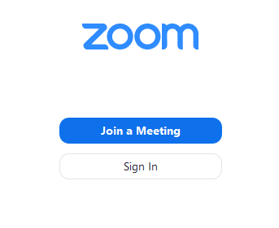
2. Perform the following before Join:

- Enter the Meeting ID (Sent to provided learner’s email as ZOOM Login Details for Virtual Class)
- Enter Name in the following Format: last 4 digit of their NRIC - Full Name
- Examples:
  - “1234F-Darryl Fong”
  - “1234A-Andrew Liaw”
- Tick “Remember my name for future meetings.”
- Tick “Turn on my video.”

Note: You can also click on the URL Link found in the Email to join the Meeting (Lesson)

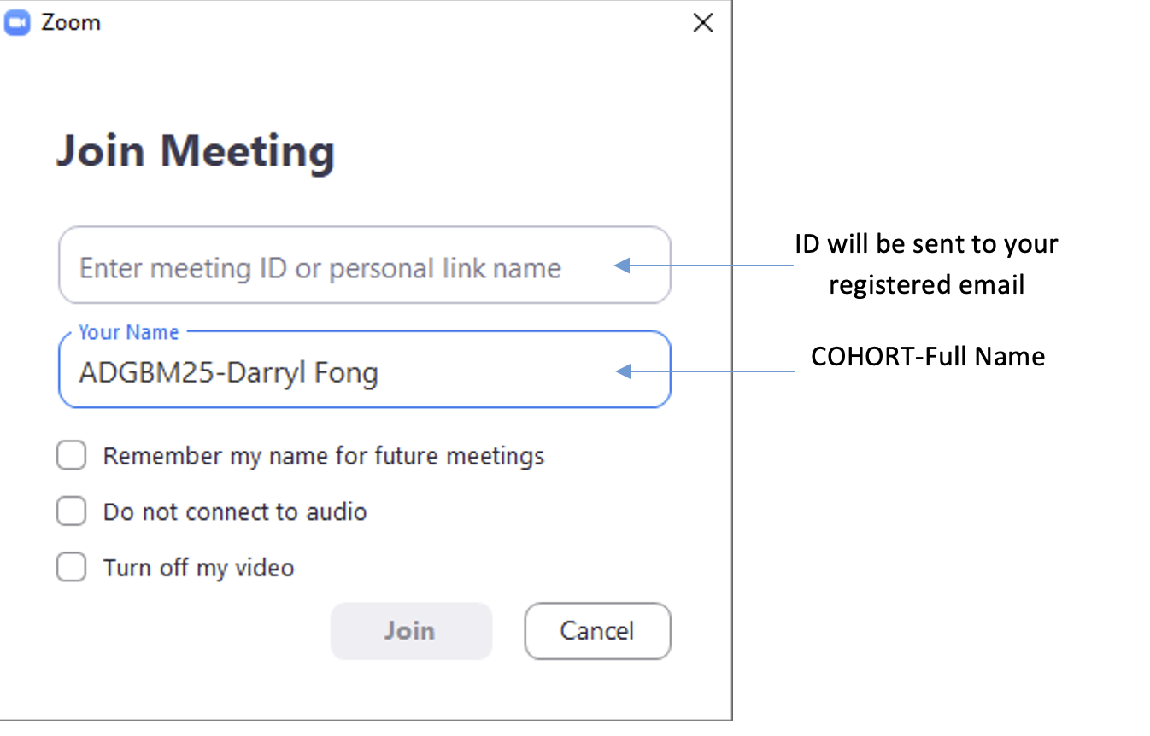
3. Check “Automatically join audio by computer when joining a meeting” before clicking on “Join with Computer Audio.”
Note: Please Test the Speaker and Microphone to ensure it is working. Learners are required to turn the video on during the session.

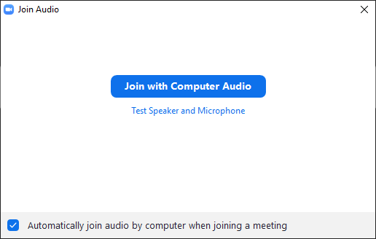

4. You are now in the Meeting (Lesson)

Once the learner is in the meeting, the trainer will check the learner's Name and verify with the learner through their NRIC or Photo to authenticate the learner’s identity.

The learner is required to take QR e-attendance via SingPass app during the session, and the trainer will take a screenshot of the completed attendance taking (including Date and Time). The learner’s camera must be turned on throughout the lesson and we have configured the recording of the training session to be switched on upon starting the class. Upon class conclusion, the recording will be uploaded to the cloud storage, where the recording will be kept for 3 years.

- Validation of Attendance Records and Progress

E-attendance is meticulously recorded across various sessions, including classroom training and practical sessions, ensuring comprehensive monitoring of learner participation. Attendance is diligently tracked for each session to maintain accurate records and uphold accountability.

To further enhance learner engagement and monitor progress, Google Classroom is utilized. The platform tracks progress through the completion of assigned activities, providing valuable insights into learners’ advancement and participation in the program.

This dual approach ensures a robust system for tracking both attendance and learning progress, fostering accountability and promoting learner success.

For reference: Attendance Records Monitoring

- Trainer Support for Learners

Physical Classroom Training
The trainer is consistently available to guide and support learners throughout the session, fostering a productive and engaging learning environment. This includes providing assistance with software requirements and courseware materials as needed.

Additionally, a Training Executive is on hand to provide seamless assistance with administrative matters, addressing any queries and ensuring that the training experience is smooth and efficient. This structured support system underscores our commitment to delivering a high-quality, learner-centered training experience.

Synchronous e-Learning
For personalized support, the Trainer can provide clarification and guidance through private chat, telephone calls, or breakout rooms, ensuring that the training delivery remains uninterrupted and focused.

Learners needing clarification during the session can also utilize the raise hand function to discreetly signal the trainer for assistance, fostering a smooth and professional learning environment.

This robust support framework is designed to enhance the e-learning experience, ensuring that all learners can fully engage and succeed in their training.

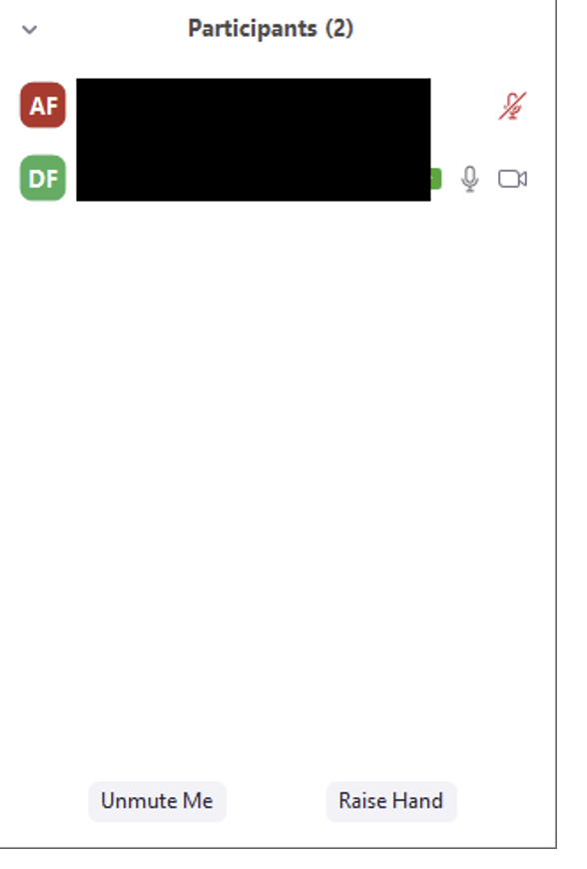
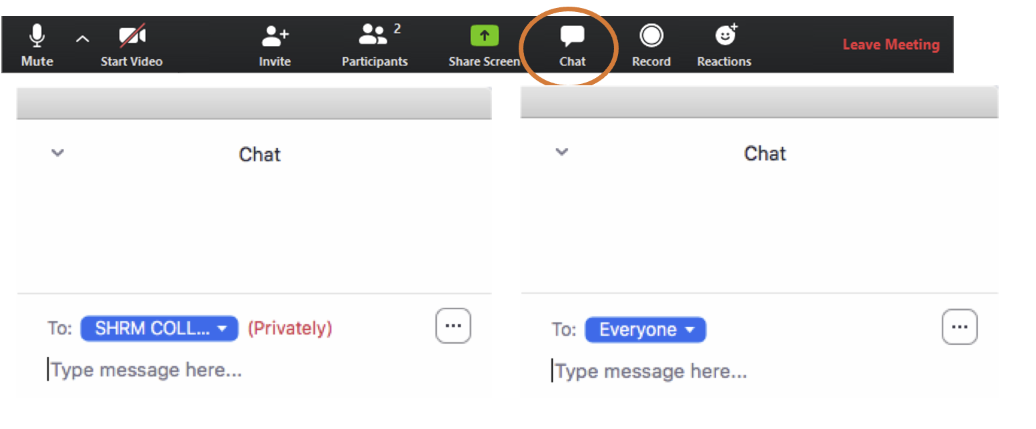

- Technical Helpdesk Support

During training sessions, learners requiring technical assistance can rely on the Training Executive for immediate support. Assistance is available via private chat, telephone call, or breakout rooms, ensuring minimal disruption to the training delivery.

Additionally, the Zoom Support Centre operates 24/7 globally, providing comprehensive support through web, chat, and phone services to address any platform-related issues.

For direct technical helpdesk support, learners can contact:
- Contact Number: +65 6785 0776
- Email: info@chariot-learning.com
- Operating Hours: 9:00 AM – 6:00 PM

Should technical issues remain unresolved within 15 minutes, Microsoft Teams will be utilized as a reliable backup platform to ensure the training continues without interruption.

- Course Commencement Validation

Once class is confirmed course sessions are created on TPG with approved course durations for each session.

Training executive will verify the course commencement and end date against the course calendar.

Chariot provides validate course commencement date, course end date and estimated number of learning hours expected to complete the course through Google Calendar invite, and Courseware and attendance taking email.

Learners will receive calendar invitations after registration, the commencement date, course end date and estimated number of learning hours will be updated via the same Google Calendar invitation.

This ensures that the learner receives the most updated details for their lessons. The courseware and attendance taking email is sent on the first day of the course commencement date. This helps to remind and provides the validated course details to the learner.

- E-Assessment Verification of Learner

Physical classroom
The Assessor will check the learner's name and verify with the learner's NRIC or Photo to authenticate the learner’s identity. The learner is required to login to SingPass and scan the assessment QR attendance during the session. The assessor will be able to view attendance taken by the learners via assessment attendance link.

Synchronous e-Learning
A list of learners will be provided to the assessor. The assessor will only allow learner(s) that are on the list to participate in the session. (Learners are required to change their username as per course registration). The learners are required to always turn on their cameras, and the ZOOM video recording is set by default for every session, from the start time to end time of the session. The complete recording will be stored for 3 years.

The Assessor will check the learner's name and verify with the learner's NRIC or Photo to authenticate the learner’s identity. The learner is required to login to SingPass and scan the assessment QR attendance during the session. The assessor will be able to view attendance taken by the learners via assessment attendance link.

For learner(s) who are late for the session, administrative support will contact the learner by phone and aid the learner to login into ZOOM. The learners who are late for more than 15 minutes may require a reschedule of the assessment date.

Once the verification process is completed, the assessor will make the e-assessment available to the learners via Chat in ZOOM. Video cameras capture the learner’s face and upper body. Throughout the e-assessment, the learners must keep their cameras on until they have submitted the e-assessment. The assessments must be completed within a single session with no intermittent breaks or interruptions.

Oral clarification will be conducted in the ZOOM breakout room after the assessment.

The entire process will be recorded and uploaded to a cloud platform and kept for three years. Automatic cloud recording will start whether the host joins by computer and stop when the meeting ends.

Corporate Governance
- Strategic Planning and Management Review

Key Discussion Elements
- Review of Last Year’s KPIs
  - A detailed analysis of the previous year's KPIs is conducted to assess the outcomes and identify areas for improvement.
  - The review focuses on:
    - Results achieved, including successes and milestones.
    - Challenges encountered, such as resource limitations, process inefficiencies, or external factors.
  - Insights gained from this review are used to inform and refine strategies, ensuring lessons learned are incorporated into the new year's plans.
- Setting New KPIs and Targets
  - KPIs for the upcoming year are established based on:
    - Organizational priorities, such as learner satisfaction, program effectiveness, and operational efficiency.
    - Growth objectives, including expansion into new markets or addressing emerging learner needs.
  - Targets are designed to be realistic yet ambitious, motivating teams to maintain high standards of training and service delivery.
  - SMART goals (Specific, Measurable, Achievable, Relevant, and Time-bound) are prioritized to ensure clarity and accountability.
- Introduction of New Initiatives or Changes
  - The meeting incorporates discussions on:
    - New initiatives: Programs, workshops, or collaborations that address industry trends and learner demands.
    - Changes in training methods or technologies: Adoption of modern tools such as AI-driven learning platforms or blended learning models.
    - Shifts in learner demographics: Adjustments to training content or delivery to cater to diverse and evolving learner profiles.
  - These initiatives aim to:
    - Enhance the center’s competitive edge.
    - Drive learner satisfaction and engagement.
    - Ensure alignment with industry standards and expectations.

Outcomes and Strategic Benefits
This comprehensive planning process enables the center to:
- Remain aligned with its mission of providing high-quality training and services.
- Foster innovation by embracing changes and addressing emerging challenges proactively.
- Adapt to evolving needs of learners and stakeholders, ensuring relevance and sustainability.
- Drive accountability and performance by setting clear expectations and measurable goals.

By conducting this annual work plan meeting, Chariot ensures that it stays on track to achieve its long-term vision while continually improving its impact on learners and the community.

- Developing Effective Strategies

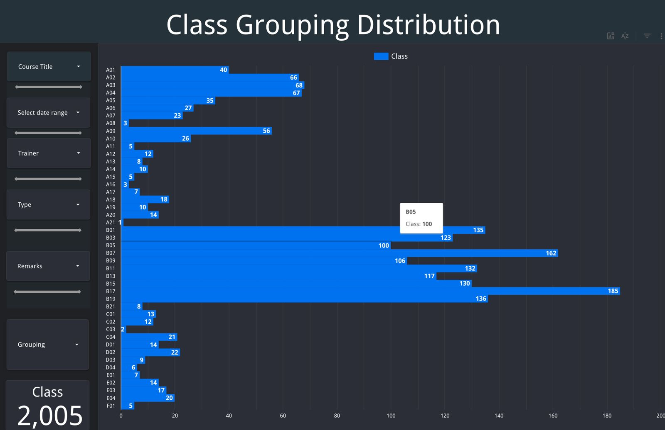

- Class Grouping Distribution

The chart provides an overview of the distribution of class groupings, represented by different course titles. The horizontal bars illustrate the number of classes offered for each course grouping, highlighting variability in enrolment across different courses. Notable insights include:

- High Enrolment Classes: Certain groupings, such as B05 and B21, demonstrate significantly higher enrolment numbers, with over 180 and 130 classes, respectively. This indicates strong demand for these courses, which may require additional resources or scheduling adjustments to accommodate learner needs.

- Low Enrolment Classes: Other groupings, such as A01 or A16, have comparatively fewer classes, suggesting either lower demand or more selective enrolment criteria.

- Distribution Insights: The data underscores the need for tailored scheduling strategies to balance resource allocation across high-demand and low-demand courses effectively.

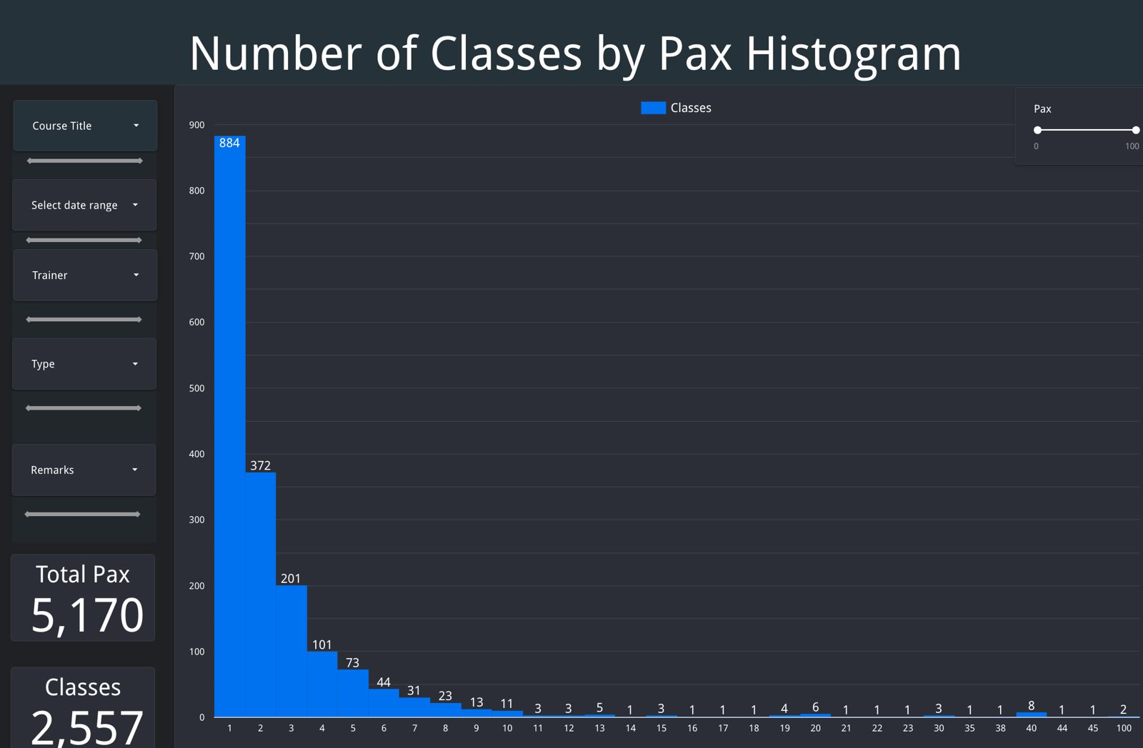

- Number of Classes by Pax Histogram

The second chart visualizes the distribution of classes based on the number of participants (Pax). The histogram reveals:

- Dominance of Small Classes: A majority of classes have fewer than five participants, with the largest number concentrated at a single participant count. This may indicate a need for a more efficient enrolment strategy to consolidate smaller groups where possible.

- Rare Large Classes: Larger class sizes (e.g., above 10 participants) are relatively rare, with very few reaching the higher thresholds such as 20 participants or more. This could reflect capacity constraints, targeted course designs, or limited demand for those offerings.

- Overall Enrolment: The total Pax count (5,170) and number of classes (2,557) highlight the extensive effort required in managing diverse course offerings while maintaining flexibility in class scheduling.

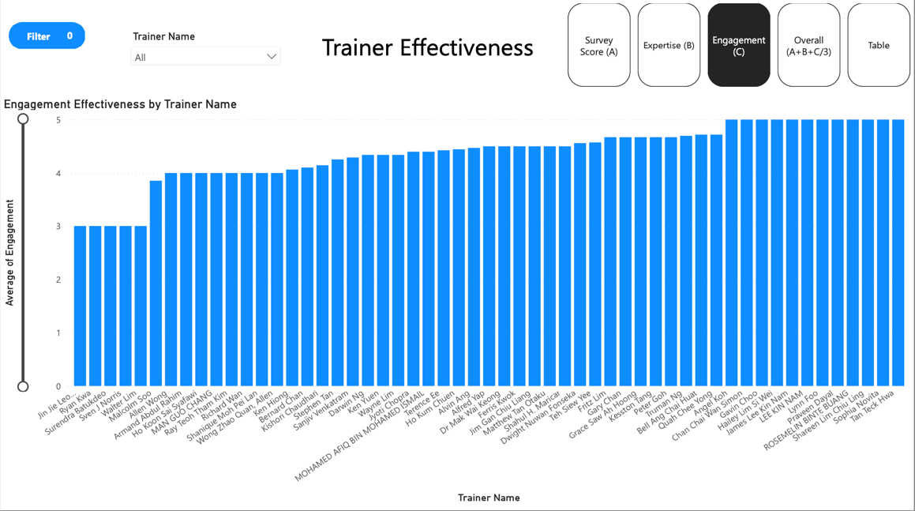

- Trainer Effectiveness Overview

This image represents a bar chart titled "Trainer Effectiveness," focusing on the "Engagement Effectiveness by Trainer Name." It measures the Average of Engagement on a scale of 0 to 5 for various trainers. Each bar corresponds to a trainer, and their engagement effectiveness is displayed, providing a comparative view.

This visualization supports the evaluation and development of strategies to enhance trainer effectiveness. By identifying trainers with high engagement scores, best practices can be documented and shared with others. For those with lower scores, targeted improvement strategies (e.g., additional training or mentorship programs) can be implemented to boost engagement levels.

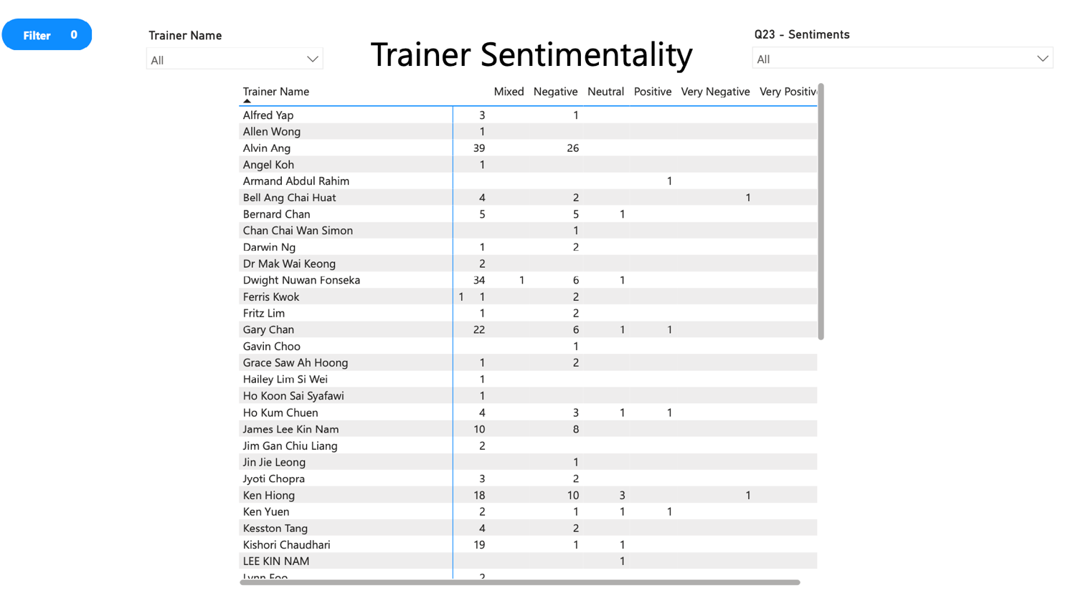

- Trainer Sentimentality Overview

This image displays a table titled "Trainer Sentimentality," which categorizes feedback sentiment for various trainers into the following categories:

- Mixed
- Negative
- Neutral
- Positive
- Very Negative
- Very Positive

Each row corresponds to a trainer, showing the count of responses for each sentiment category. This breakdown provides insights into how learners perceive individual trainers based on their experiences.

- Improving Trainer Performance:
By analyzing sentiment data, trainers with more negative or mixed feedback can be identified and supported with tailored improvement plans, such as additional training or mentorship. Positive feedback trends can help identify best practices and inform strategies to enhance overall training quality.

- Resource Allocation:
Trainers with consistently positive sentiment scores could be assigned to critical or high-demand courses, ensuring a higher likelihood of learner satisfaction and success. Conversely, those with negative feedback may require closer monitoring and specific action plans.

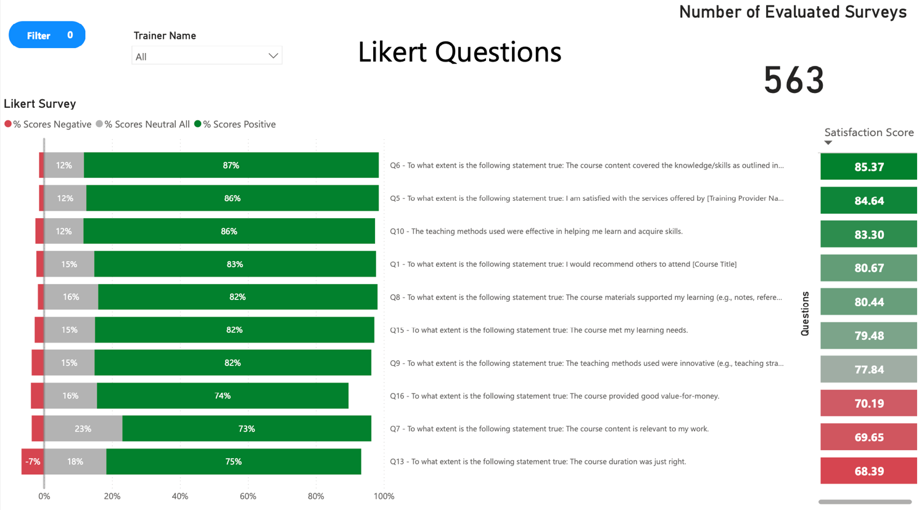

- Likert Survey Overview

This image represents a Likert survey analysis that includes responses to several survey questions, categorized into three sentiment groups:

- Positive (Green): Indicates favourable responses.
- Neutral (Gray): Indicates indifferent or undecided responses.
- Negative (Red): Indicates unfavourable responses.

The survey results are displayed as percentage bars, with each question showing the proportion of positive, neutral, and negative feedback. The total number of evaluated surveys is 563, providing a comprehensive dataset for analysis.

- Identifying Strengths and Weaknesses:
The breakdown of responses highlights areas where the training content or delivery excels (e.g., high percentages of positive feedback) and areas requiring improvement (e.g., high percentages of negative or neutral feedback). For instance, questions with lower positive scores can help pinpoint gaps in course content, teaching methods, or learner satisfaction.

- Targeted Interventions:
By analyzing specific questions with lower positive sentiment, targeted strategies can be developed to address issues, such as enhancing course content relevance, improving teaching methods, or adjusting course duration to better meet learner needs.

Strategies for Areas of Improvement

- Optimizing Class Sizes: Consolidating smaller classes into larger groups could improve efficiency and resource utilization without compromising learning outcomes.
- Resource Allocation: High-demand courses, such as those in groupings B05 and B21, should be prioritized for scheduling and resource deployment, ensuring adequate trainer availability and facility allocation.
- Customized Scheduling: The variability in enrolment and participant numbers necessitates a flexible scheduling system, potentially leveraging predictive analytics to anticipate demand and adjust schedules dynamically.
- Monitoring and Feedback: Continuous monitoring of enrolment trends and participant feedback will enable ongoing refinement of strategies, ensuring alignment with organizational objectives and learner needs.
- Setting Engagement Targets for Continuous Improvement: Setting Engagement Targets for Continuous Improvement: Targets can be set (e.g., achieving an average engagement score of 4 or higher) to ensure continuous improvement. Trainers falling below the target can be flagged for follow-up actions.
- Utilizing Sentiment Analysis for Strategic Improvement: Utilizing Sentiment Analysis for Strategic Improvement: Sentiment data can serve as a Key Performance Indicator (KPI) for trainers, ensuring alignment with organizational goals to enhance learner experiences. Targets can be set (e.g., reducing the percentage of negative sentiments or increasing very positive responses) to monitor progress. By addressing feedback from sentiment analysis, trainers can adapt their teaching methods to better engage learners and meet their needs, leading to improved learning outcomes and satisfaction.
- Leveraging Likert Survey Insights for Strategic Planning: Likert survey results provide valuable insights that can be tied to Key Performance Indicators (KPIs), such as learner satisfaction and content effectiveness. Setting clear targets, such as achieving 85% or higher positive feedback on course relevance, ensures continuous improvement by identifying strengths and addressing areas for development.

In conclusion, these strategies collectively optimize resource utilization, enhance learner experiences, and ensure continuous improvement through data-driven insights, targeted interventions, and alignment with organizational objectives.

- Management Reviews

To ensure consistent progress and timely intervention, we conduct quarterly management reviews. These reviews serve as a critical mechanism for analyzing organizational performance, tracking Key Performance Indicators (KPIs), and developing targeted action plans. By fostering a proactive approach, the quarterly reviews ensure the organization remains agile and aligned with its strategic goals.

Purpose of Quarterly Management Reviews

The primary objectives of the quarterly management reviews are to:
- Monitor Progress: Evaluate the organization’s performance against predefined KPIs and strategic targets.
- Identify Challenges and Opportunities: Detect trends, deviations, or external factors that require immediate attention or adjustment.
- Plan and Act: Develop actionable strategies to address performance gaps or capitalize on new opportunities for growth.

Analysis of Key Performance Indicators (KPI)

- Assessment of KPIs:
  - A detailed review of current KPIs against the targets established during the annual work plan meeting.
  - Identification of areas where performance is meeting, exceeding, or falling short of expectations.
- Trend Analysis and Insights:
  - Examination of performance trends over time to highlight consistent progress or recurring issues.
  - Recognition of patterns that may impact long-term goals, providing data-driven insights for future planning.
- Consideration of External and Internal Factors:
  - Acknowledgment of any changes in the business environment, industry trends, or operational challenges that may influence KPI outcomes.
  - Adjustments to strategies or goals are proposed to address these evolving factors.

Action and Review for Targets

Building on the KPI analysis, the management team transitions into action planning to ensure continuous improvement. This involves:

- Development of Actionable Plans:
  - For each identified gap or opportunity, specific and measurable steps are defined.
  - These steps are accompanied by clear timelines, milestones, and assigned responsibilities, ensuring accountability at every level.
- Alignment with Strategic Objectives:
  - Action plans are carefully reviewed to ensure they align with the organization’s overarching mission and goals.
  - This ensures that efforts are not only reactive but also proactive, contributing to sustained growth and performance.
- Approval and Implementation:
  - Once finalized, the action plans are presented to the management team for review and approval.
  - Approved plans are communicated across relevant departments to ensure clarity and coordination in execution.

By combining regular KPI analysis with actionable strategies, Chariot fosters a culture of continuous improvement and accountability, ensuring that organizational goals are consistently met or exceeded.

- Financial Management

- Training for Financial Staff

Add workflow
To maintain high standards of accuracy, efficiency, and compliance in financial operations, Chariot has implemented a comprehensive Finance Staff Training Program. This program is designed to ensure that all finance personnel are equipped with the knowledge and skills required to perform financial transactions accurately and in alignment with organizational and regulatory standards. The training program covers both technical and procedural aspects of financial management, enabling staff to effectively utilize the tools and platforms essential to their roles.

Training Objectives

The primary goals of the training program are to:
- Enhance Competency: Equip finance staff with the technical expertise to use key financial systems and tools effectively.
- Ensure Compliance: Provide thorough guidance on adhering to regulatory and grant-related requirements.
- Streamline Processes: Standardize financial workflows to ensure consistency and minimize errors in transaction handling.

Training Components

- Utilizing QuickBooks for Financial Transactions
  - Training focuses on mastering the organization’s accounting software, QuickBooks, including:
    - Invoice Creation: Step-by-step guidance on preparing accurate and compliant invoices for various financial transactions.
    - Payment Processing: Instructions on recording and reconciling received payments to ensure up-to-date financial records.
  - These skills ensure proper documentation of financial transactions and help maintain accurate accounting records.

- Applying for SSG Training Subsidies on TPGateway
  - Staff are trained on how to efficiently navigate TPGateway, the online platform for managing SkillsFuture Singapore (SSG) grants.
  - The training includes:
    - Applying Subsidies: Detailed procedures for applying training subsidies, ensuring that all eligible claims are made in compliance with SSG guidelines.
    - Submission Requirements: Clear guidance on preparing and submitting required documentation for grant applications.

- Managing SkillsFuture Credit Payments on TPGateway
  - Training includes the end-to-end process of handling SkillsFuture Credit transactions, such as:
    - Verification of Payments: Ensuring SkillsFuture Credit payments are correctly reflected on TPGateway.
    - Requesting Disbursements: Properly requesting fund disbursement to ensure timely receipt of payments.

- Monitoring Outstanding Training Grants on TPGateway
  - Finance staff are taught how to monitor and manage outstanding grants effectively, including:
    - Grant Tracking: Utilizing platform tools to check the status of pending or incomplete claims.
    - Follow-Up Procedures: Steps to address discrepancies or delays in grant disbursement.

- Financial Statements Monitoring

To ensure consistent financial performance and maintain the highest standards of accuracy, the finance team at Chariot conducts a weekly review of financial reports. This routine practice fosters collaboration, promotes accountability, and enables proactive decision-making to address any financial issues promptly. By prioritizing regular financial assessments, the organization ensures alignment with its strategic goals and financial integrity.

Objectives of the Weekly Review
The weekly financial review aims to:

- Monitor Financial Health: Provide a real-time snapshot of the organization’s financial standing through detailed reports.
- Identify and Address Issues: Highlight potential areas of concern, such as overdue payments or budget deviations, and implement timely corrective actions.
- Ensure Accuracy and Compliance: Verify the accuracy of financial data to maintain compliance with regulatory and organizational standards.
- Facilitate Decision-Making: Provide actionable insights to management for informed decision-making regarding budgeting, resource allocation, and financial strategies.

Key Financial Reports Reviewed
- Aging Report
  - The aging report is analyzed to track outstanding receivables and payables, providing a clear understanding of:
    - Overdue Invoices: Identifying clients or accounts with overdue payments and prioritizing collection efforts.
    - Cash Flow Management: Ensuring sufficient liquidity to meet operational needs by managing payment schedules.
  - Action plans are developed to follow up on overdue accounts, ensuring timely resolution and maintaining positive stakeholder relationships.
- Profit and Loss (P&L) Statement
  - The P&L statement is reviewed to assess the organization’s financial performance for the week, focusing on:
    - Revenue Trends: Analyzing income streams to determine growth patterns or areas requiring improvement.
    - Expense Monitoring: Identifying cost drivers and opportunities for cost optimization.
    - Net Profit Margins: Evaluating profitability against expectations and adjusting financial strategies accordingly.
  - Regular monitoring of the P&L ensures that financial goals are on track and resources are allocated efficiently.

Collaborative Approach to Financial Review
- Team Involvement:
  - The finance team collaborates to share insights, discuss findings, and develop actionable solutions to address any discrepancies or inefficiencies in financial performance.
  - This collaborative approach promotes accountability, as each team member contributes to maintaining the integrity of financial records.
- Proactive Problem-Solving:
  - During the reviews, potential risks such as cash flow shortages or declining revenue are identified early, allowing the team to implement mitigation strategies before issues escalate.
- Continuous Improvement:
  - Feedback from the review process is used to refine reporting practices, enhance data accuracy, and improve overall financial management processes.

Strategic Benefits
- Enhanced Transparency:
  - Weekly reviews ensure that financial data is consistently monitored and shared across the finance team, fostering a culture of openness and trust.
- Informed Decision-Making:
  - Regular analysis of key financial metrics enables management to make timely and well-informed decisions regarding organizational finances.
- Operational Efficiency:
  - Early identification of issues, such as overdue payments or budget deviations, helps minimize disruptions and ensures smoother financial operations.
- Alignment with Goals:
  - By regularly evaluating financial performance, the organization stays aligned with its short-term and long-term strategic objectives.

- Review of Systems and Processes

- Internal Review Process

As part of our ongoing commitment to organizational excellence, a Work Improvement Initiative has been introduced to actively involve staff in reviewing current systems and processes. This initiative aims to foster a culture of continuous improvement by encouraging employees to identify areas for enhancement and propose actionable recommendations.

Recommendations and Follow-up Process

To ensure a structured and efficient approach to evaluating and implementing suggestions, the following steps will be undertaken:
- Submission of Recommendations
Staff members will submit their recommendations to their respective managers. These submissions will detail the identified challenges within existing systems or processes and propose potential solutions.
- Preliminary Review
Submitted recommendations will be reviewed by the relevant officer-in-charge or manager. During this stage, the focus will be on studying the feasibility and practicality of the suggestions in addressing the identified challenges.
- Evaluation for Management Review
Recommendations deemed viable and impactful during the preliminary review will be escalated for Management Review. This phase involves a thorough evaluation to align the proposed improvements with organizational objectives and resource availability.

By engaging staff in this initiative, the organization seeks to harness diverse perspectives to streamline operations, improve efficiency, and enhance overall productivity. The structured follow-up ensures transparency and accountability in the process, paving the way for meaningful change.

For reference: Minutes of Meeting – Google Calendar Invite Automation

- Feasibility Review

Once a suggestion has been reviewed and approved by Management, a structured approach will be employed to ensure effective evaluation and implementation of the proposed improvement. The key steps in this process are as follows:

- Formation of a Task Force
A dedicated task force will be established, comprising individuals with the requisite expertise and knowledge of the identified issue. This team will be responsible for conducting an in-depth analysis of the problem and exploring viable improvement opportunities. Members may include representatives from relevant departments, subject matter experts, and other key stakeholders as needed.
- Data Collection and Analysis
The task force will focus on collecting comprehensive data and information related to the identified problem. This may include:
  - Reviewing existing processes and documentation: Understanding the current workflow and pinpointing inefficiencies.
  - Stakeholder consultations: Engaging with employees and departments directly impacted by the issue to gather insights and feedback.
  - Benchmarking and research: Examining industry best practices or case studies for innovative solutions.
- Problem Review and Improvement Plan Development
Using the data collected, the task force will conduct a detailed review of the problem. The team will analyze root causes, assess the feasibility of potential solutions, and develop a comprehensive improvement plan. This plan will include specific actions, timelines, and resource requirements to address the issue effectively.
- Reporting to Management
The findings and proposed improvement plan will be documented and presented to Management for final approval. This ensures alignment with organizational goals and secures the necessary resources for implementation.

For reference: Minutes of Meeting (2) – Google Calendar Invite Automation

- Action Plan

Following Management approval of suggested changes, a systematic approach will be adopted to ensure the successful execution and integration of the proposed improvements. The steps are outlined below:

- Development of Action Plans
The task force will design detailed action plans to outline the steps required for implementation. These plans will include:
  - Specific tasks and responsibilities assigned to team members.
  - Timelines for completion of each phase.
  - Necessary resources and tools to support implementation.
- Pilot Testing
To evaluate the feasibility and effectiveness of the changes, the task force will implement the proposed improvements on a smaller scale. The pilot phase will serve as a controlled environment to identify potential challenges, refine processes, and gather feedback from stakeholders involved in the testing.
- Review and Approval of Test Results
Once the pilot testing is complete, the task force will analyze the outcomes to assess the effectiveness of the changes. A detailed report will be prepared, summarizing:
  - Key findings from the test.
  - Lessons learned and areas for adjustment.
  - Recommendations for proceeding to full implementation.
Management will review this report and approve the transition to full-scale implementation if the pilot results meet the desired objectives.
- Full-Scale Implementation
Upon receiving approval, the changes will be rolled out organization-wide. The task force will ensure clear communication of the new processes or systems to all employees through appropriate channels, such as meetings, training sessions, or internal memos.
- Monitoring and Feedback Collection
The task force will actively monitor the newly implemented processes or systems for a period of two weeks. During this time, they will:
  - Collect feedback from employees to identify any issues or areas requiring further adjustment.
  - Track performance metrics to measure the impact of the changes against predefined success criteria.
- Final Evaluation and Handover
At the conclusion of the monitoring period, the task force will conduct a final evaluation to ensure the new processes or systems are functioning as intended. A summary report will be prepared and shared with Management, after which the responsibility for ongoing management and optimization of the processes will be handed over to the relevant departments.

For reference: Minutes of Meeting (3)- Implementation and Monitoring of Calendar Invite Automation

Management of Marketing Staff and Agents

- Compliance to SSG’s Marketing Guidelines
New Course/Event
No
Go for training and complete it
Yes
Acceptable
Upload on website/Send out via automation/Print out
Course Manager will review and veriify compliance with SSG guidelines.

Not
Acceptable
Marketing Executive to generate marketing assets via automation/manually
Marketing Executive completed Training Package and signed code of conduct?

To ensure all marketing materials comply with SkillsFuture Singapore (SSG) Marketing Guidelines, the outlined process is visually represented in the flowchart. The step-by-step process is explained below:

- Initiation of a New Course
The process begins when a new course is created, triggering the need for marketing materials to be developed.

- Generation of Marketing Assets
Marketing executives are tasked with creating the necessary marketing materials. This can be done either manually or through automation, ensuring that all required information is included in line with the SSG guidelines.

- Compliance Review and Verification by Course Manager
Once the marketing materials are prepared, the Course Manager will review and verify their compliance using the SSG Marketing Guideline Checklist (Annex A.14). This step involves checking for:
  - Accurate representation of the course offerings.
  - Proper application of SSG logos, disclaimers, and other required attributions.
  - Absence of misleading or exaggerated claims.

- Decision Point: Acceptable or Not Acceptable
  - If the materials do not comply with the guidelines, they will be sent back to the marketing team for revisions.
  - If deemed acceptable, the materials proceed to the final step.

- Approval and Dissemination
Approved materials will be uploaded to the appropriate platforms, such as the organization's website, distributed through automation, or printed as needed.

This process ensures that all marketing initiatives meet SSG’s standards, maintain consistency, and reflect the organization's commitment to transparency and compliance. The attached flowchart serves as a clear visual representation of this workflow for better understanding and reference.

- Marketing Code of Conduct

All marketing staff will go through training with their manager to under their roles and responsibilities and their code of conduct.

Roles and Responsibilities

Marketing Executive - Marketing Initiatives

The Marketing Executive is responsible for conducting comprehensive marketing research to analyze competitors’ products and services. This research will enable the team to effectively communicate the unique value of the organization’s offerings while identifying areas for potential improvement. By understanding the competitive landscape, the Marketing Executive will help position the company more strategically in the market.

Additionally, the Marketing Executive will ensure that marketing content is accessible to all target audiences. This involves creating materials that assume minimal prior knowledge of the services provided and distributing content promptly to meet and exceed consumer expectations. Accessibility is a key focus to ensure the content resonates with a diverse audience. The Marketing Executive is also tasked with proactively engaging with customers to understand their needs and provide tailored support to enhance service delivery. Building stronger connections with customers will help improve overall satisfaction and foster trust in the brand.

A key responsibility is to prioritize user-centric advertising. The Marketing Executive will focus on developing clear, engaging advertisements that enhance the user experience and strengthen audience engagement. This approach aims to create a more empathetic and impactful connection with the target market.

Immediate action is required for the Marketing Executive to explore social media platforms and initiate these responsibilities, ensuring timely and effective execution of the outlined objectives.
For marketing agents, their specific roles and responsibilities are outlined in the Marketing Agent Contract, detailed in Annex A.15. These references are readily available to promote adherence to organizational and regulatory standards.

Code of Conduct

To uphold ethical and professional standards in all marketing activities, a Code of Conduct for Marketing will be distributed and implemented as follows:

- For Marketing Executives
Upon completing their training, each marketing executive will be provided with a copy of the Code of Conduct for Marketing. They will be required to formally acknowledge receipt of the document, confirming their understanding and commitment to adhering to its principles. The document serves as a vital reference guide, allowing marketing executives to consult it whenever they face uncertainties in their day-to-day operations. This ensures that all marketing efforts remain aligned with organizational values and regulatory requirements.

- For Marketing Agents
The Code of Conduct for Marketing applicable to marketing agents will be incorporated directly into their contractual agreements. This integration ensures that marketing agents are fully informed of their ethical responsibilities and obligations from the outset of their engagement. The contractual inclusion reinforces the organization's commitment to maintaining transparency, compliance, and accountability in all external marketing activities. Details regarding the code of conduct for marketing agents can be found in Annex A.15.

This structured approach ensures that both internal and external marketing professionals are equipped with clear guidelines to foster ethical practices and maintain the organization's reputation.

- Training for Marketing Staff / Agents

To ensure that all marketing activities align with SkillsFuture Singapore (SSG) Marketing Guidelines, a structured training program will be conducted for both marketing executives and marketing agents. This training is designed to provide comprehensive knowledge and understanding of SSG guidelines, ensuring that all marketing assets developed adhere to the required standards.

During the training, participants will gain familiarity with the key principles of compliance, including the proper representation of course details, accurate use of disclaimers and attributions, and the avoidance of misleading claims. This process equips marketing professionals with the necessary expertise to create and review marketing assets that uphold organizational integrity and regulatory standards.

In addition to training, regular meetings and updates will be conducted to address any changes in critical course information, such as course dates, times, fees, or venues. Timely communication of such updates is essential to ensure the accuracy of marketing materials. Marketing executives and agents will be briefed on the changes, and revised materials will be developed and disseminated promptly to maintain consistency and compliance. These updates will also serve as an opportunity to revisit and reinforce the importance of SSG compliance, fostering a culture of continuous improvement and vigilance.

By combining thorough training with ongoing communication and updates, the organization ensures that all marketing professionals are well-equipped to produce assets that are accurate, compliant, and aligned with both regulatory requirements and organizational objectives. This structured approach minimizes the risk of errors and enhances the credibility of marketing efforts.

For reference: Minutes of Meeting_Update on SSG Guidelines

- Marketing Review

The flowchart outlines the process for creating, vetting, and approving marketing assets to ensure compliance with SkillsFuture Singapore (SSG) guidelines. This systematic approach is designed to maintain the accuracy and professionalism of promotional materials while aligning with regulatory standards. Below is a detailed explanation of each stage in the flowchart, specific to Chariot:
Approved
Not
Approved
End
Course Manager will review and verify compliance with SSG guidelines.

Choose courses according to theme & create marketing assets

Choosing Courses to Promote and Creating Marketing Assets
The process begins with selecting courses to be promoted to potential learners. These courses are chosen based on two main criteria:

- General Promotions: Courses that are relevant and can be promoted through broader marketing channels, such as newsletters sent via platforms like Mailerlite. These newsletters are targeted to reach Chariot’s subscriber base and inform them about available programs.

- Roadshow-Specific Promotions: Courses that align with specific roadshow themes are selected to create a cohesive promotional strategy. For example, if the theme is centered on professional skills development, relevant courses such as leadership or project management programs will be chosen.

Once the courses are identified, marketing assets are created. These assets include newsletters, advertisements, brochures, or other digital and print media content. The content is crafted to reflect the course offerings, highlighting key details such as the program structure, benefits, and target audience.

Vetting and Compliance Verification
After the marketing assets are created, they are submitted to the Course Manager for review. The Course Manager at Chariot plays a critical role in this process, ensuring:

- Compliance with SSG Guidelines: The Course Manager verifies that the promotional materials adhere to SSG’s requirements, including accurate representation of course information, proper use of logos and disclaimers, and avoidance of misleading claims.
- Relevance and Quality: The content is checked for clarity, professionalism, and alignment with Chariot’s branding standards.
- Vetting Records: A formal record of the vetting process is maintained, documenting any corrections or approvals for future reference and accountability.

Decision Point – Acceptable or Not Acceptable
If the marketing materials are not acceptable, they are returned to the marketing team for revisions. The team will address feedback provided by the Course Manager, ensuring that all necessary changes are made before resubmitting for review. This loop continues until the materials meet the required standards. If the materials are deemed acceptable, they are approved for dissemination.

Approval and Dissemination of Marketing Assets
Once approved, the marketing assets are finalized and deployed across the appropriate channels. Examples include:

- Newsletter Campaigns: Approved marketing content is sent to potential learners via platforms like Mailerlite, ensuring that subscribers are informed about the latest course offerings from Chariot.
- Roadshow Promotions: Marketing assets are printed or distributed digitally to align with the roadshow theme, helping to capture the attention of attendees and reinforce the event’s messaging.
- Other Distribution Channels: Assets may also be uploaded to Chariot’s website, shared on social media, or distributed through automation tools to maximize reach and impact.

- Appraisal of Marketing Staff

Monitoring Records on Service Delivery

To ensure quality, consistency, and compliance with organizational standards, all marketing assets, including materials and advertisements, are subject to a thorough vetting process by the Manager. This critical review ensures that all promotional materials align with Chariot’s branding guidelines, meet SkillsFuture Singapore (SSG) compliance requirements, and effectively convey accurate and professional messages to the target audience. The vetting process also helps identify any potential gaps or errors, which can then be addressed before dissemination.

In addition to overseeing the creation and approval of marketing assets, the Manager is also involved in the monitoring of marketing-related communications. All email correspondence related to marketing activities will include the Manager in the recipient list, ensuring real-time oversight and fostering accountability in the Marketing Executive’s service delivery. By being included in these communications, the Manager can:

- Monitor the tone, accuracy, and professionalism of interactions with internal and external stakeholders.
- Provide timely guidance or corrections if issues arise in the communication.
- Ensure that responses align with the organization’s objectives and maintain a high standard of service delivery.

Intervention Records of Violations

Feedback on Marketing Violations

Acknowledge by Marketing Executive

Course Manager to investigate

Any violation?
Corrective measure to be taken
Stop the marketing practice

Course manager to check, verify & monitor

End

The flowchart outlines a structured approach for managing marketing violations at Chariot, ensuring compliance with SkillsFuture Singapore (SSG) guidelines and upholding professional standards. This process ensures that any discrepancies in marketing practices are promptly identified, investigated, and resolved effectively.

The process begins with feedback on potential marketing violations, which may come from internal or external stakeholders, including customers or regulatory bodies. This feedback acts as the trigger for further action and ensures that concerns are addressed promptly. Upon receiving the feedback, the Marketing Executive acknowledges the reported issue, confirming their responsibility and commitment to resolving it. This acknowledgment ensures transparency and accountability at the initial stage.

The Course Manager takes the lead in conducting a detailed investigation into the reported violation. This involves reviewing the materials, communication, and processes to determine whether the issue violates SSG guidelines or organizational standards. Based on the findings, the Course Manager makes a decision on whether a violation has occurred. If no violation is found, the process is documented and closed. However, if a violation is confirmed, immediate action is taken to address the issue.

When a violation is identified, the first step is to halt the marketing practice in question to prevent further non-compliance. Corrective measures are then implemented to resolve the issue. These measures may include revising the marketing materials, addressing gaps in processes, or providing additional training to ensure such issues do not recur. The Course Manager ensures that all corrective actions align with SSG guidelines and organizational policies.

Once corrective actions are implemented, the Course Manager verifies their effectiveness and monitors future marketing activities to prevent recurrence. This final step ensures that the organization maintains a high standard of compliance and accountability. Documentation of the entire process is maintained to support continuous improvement and to serve as a reference for future compliance efforts.

This structured workflow ensures that marketing practices at Chariot remain professional, compliant, and aligned with regulatory requirements, minimizing risks and safeguarding the organization's reputation.

Tracking & Monitoring Organisational Outcomes
- Tracking & Monitoring Organisational Outcomes Process

The WSQ Committee convenes on a quarterly basis to systematically review outcomes and feedback gathered from key stakeholders, including learners, trainers, and assessors. This regular review aims to ensure the alignment of training programs with organizational objectives and stakeholder expectations.
Feedback Chariot courses, along with data from the TRAQOM quality surveys, is collected and compiled on a monthly basis. These metrics are consistently monitored and tracked against predefined performance targets to ensure quality and efficacy.

For courses where feedback ratings fall below the established targets, an investigation is initiated to determine potential underlying causes. The Training Manager conducts an in-depth analysis of recurring comments, patterns, and themes to identify areas of concern. This process ensures that feedback is contextualized and actionable insights are derived.

The Training Manager collaborates with relevant stakeholders, including trainers, course developers, and assessors, to discuss the findings. This collaborative approach facilitates the identification of specific performance gaps, whether related to course content, delivery, or assessment methods.
Identified gaps, along with corresponding action plans, are documented by the Training Manager. These plans include targeted interventions and measurable objectives aimed at addressing deficiencies. Progress is closely monitored to assess the effectiveness of the implemented measures, ensuring continuous improvement in training quality and learner outcomes.

This structured approach reinforces a commitment to quality and provides a robust framework for addressing and mitigating performance gaps in training delivery.

- Improving Organisational Quality

During the quarterly meetings, the WSQ Committee will conduct a comprehensive review of Key Performance Indicators (KPIs) to evaluate the effectiveness of improvement actions implemented for areas that fall below target. This review aims to assess the progress of corrective measures, identify any persistent challenges, and ensure alignment with organizational goals.

For areas that fail to demonstrate measurable improvement despite prior interventions, the committee will initiate a deeper investigation to uncover underlying issues. This process involves engaging relevant stakeholders, such as trainers, course developers, or assessors, to gain a thorough understanding of the challenges and collaboratively identify alternative solutions.

Further improvement strategies will be developed based on the findings, with a focus on targeted and actionable steps to address identified gaps. Progress on these measures will be monitored closely to ensure continuous quality enhancement and adherence to performance expectations. This iterative approach reflects the committee's commitment to maintaining high standards and fostering a culture of accountability and continuous improvement.

Course Quality Assurance

We follow ADDIE model in the course development process.

Plan for New Course:

- A Course Survey / Interview may be conducted with relevant stakeholders to analyse the need and relevance of the proposed course for the industry. (Annex B.6 Course Survey Sample)
- Based on the feedback from stakeholders, identify performance gaps / needs of training and confirm new course to develop
- Manage development of course proposal and materials

WSQ Course Accreditation:

1. When designing the content, the following must be included:
- Define clear and measurable course learning outcomes
- Outline what the learner will be able to achieve because of completion of the course. These outcomes are a general description of his / her newly acquired level of skills, knowledge, and attitudes.
- Use verbs that denote a clearly measurable outcome such as produce, explain, compile, identify, create, analyse to state what a learner will be able to do by the end of the course.
2. Set course admission requirements
- Admission requirements ensure that learning is pitched at a correct level for a specific target audience. Describe what the entry requirements for the course are. (e.g. assumed attitudes, skills, and knowledge, required years of experience in relevant domain, measures to ascertain learner suitability, etc.)
3. Define course scope
- Make deliberate decisions to sequence the learning units in a certain way to achieve the course objectives.
- Explain how and why the learning units / modules are being sequenced in a particular manner.
- Ensure availability of resources to support the courses offered
- Provide images and the details of the facility and equipment supporting the delivery / assessment.
4. Set assessment guideline
- Ensure that the assessment fulfils the Principles of Assessment (POA) and Rules of Evidence (ROE).
- Determine optimum duration
- Keep in mind of the following to determine the optimum course duration
- Attention spans of learners
5. Degree of interactivity
- Amount of content to be covered
- Submit course proposal to SSG for approval and accreditation.
(Annex B.7 Course Proposal Template)

Develop New Course Materials:

- Determine the pre-requisite skills of the learners, as well as instructional and assessment methods to maximise learning outcomes through using a Training Profiling template. (Annex B.8 Training Profiling Form)
- Based on the approved Course Proposal and in consideration of the industry needs, conduct necessary research on background to course materials
- Contextualise course materials and delivery strategies to meet the needs of learners
- Follow WSQ requirements and work within timeline
- Send final draft to WSQ Committee for review and feedback through using a Pre- Delivery Course Materials Evaluation Checklist. (Annex B.9 Pre-Delivery Course Materials Evaluation Checklist)
- Incorporate recommendations and update course materials

Learning Management System:

- We use Google Classroom for LMS to deliver all the essentials, such as being able to download training content and resources.

Review Existing Course Materials:
- Review and update existing course materials annually (on every December) to ensure the content meets the needs of learners as well as the change of regulations. (Annex B.10 Post-Delivery Course Materials Evaluation Checklist)
- Conduct Post-Assessment Validation to gather information about the effectiveness of the assessment process, methods and tools, and the validity of the evidence collected (refer to Annex B.11 – B.13 for more details).
  - Assessment Process Validation Checklist
  - Assessment Methods and Tools Validation Checklist
  - Assessment Evidence Validation Checklist

- System on Course Quality Assurance

All relevant documents are securely stored in Google Drive within designated folders, with access restricted to authorized personnel to ensure confidentiality and maintain data integrity.

Course materials and assessment plans are systematically organized in their respective course folders. Assessment records, including evidence, assessment record forms, assessment summary forms, and appeal forms, are stored in the assessment subfolder corresponding to each course. These records are protected against unauthorized access to uphold data protection standards and ensure compliance with applicable regulations.

Assessment records are retained for a period of three (3) years from the date of assessment. After the retention period, the records are securely destroyed in accordance with data management and privacy requirements.

The following categories of documents are retained to support training administration, quality assurance, and outcomes:

Course Administration
- Communications with learners regarding course matters
- WSQ Training Database Records
- Attendance Records/Attendance Sheets (if applicable)
- Assessment Record Forms and supporting evidence
- Assessment Appeals and Requests for Reassessment
- Invoices

Training Quality
- Course Materials and Assessment Plans
- Trainer Management and Deployment Records
- Course Delivery Records

Training Outcomes
- Validation and Evaluation Records
- Notes of Meetings

The Training Manager is responsible for overseeing the maintenance, organization, and compliance of these records. This includes ensuring proper documentation, timely updates, secure storage, and adherence to retention and destruction policies. This systematic approach reinforces accountability, supports operational efficiency, and safeguards the integrity of training operations and outcomes.

WSQ

All WSQ courseware and assessment materials are developed using standardized WSQ templates and are meticulously aligned with WSQ standards. The Course Manager is responsible for thoroughly reviewing and vetting these materials to ensure compliance and quality.

Course Information

Complete the course information template by providing details on the most recent two course runs for each of the two courses with the highest claim amounts submitted to SSG over the past two years..

Assessment Records (AR)
Physical Classes
Online Classes

Trainers to hand over the completed assessment records to Training Executive
Trainers to upload completed assessment records in Google Drive

Not
Approved
Not
Approved
Training Executives to verify and check

Approved
Training Executive files records every two weeks
End
Assessment records are securely stored either in Google Drive or in the office, depending on the mode of delivery.

For online classes, assessment records are organized and saved in Google Drive, categorized by course, date of assessment, and trainer. The Training Executive will verify the Google Drive folders once trainers notify that the completed assessments have been uploaded.

For physical classes, assessment records are systematically filed in the office, arranged in ring binders according to the year, month, and date of assessment. The Training Executive will file the physical copies every two weeks to ensure timely organization and record-keeping.

This structured approach ensures accessibility, organization, and compliance with documentation standards across both online and physical learning environments. Additionally, the regular verification and filing process reinforces accountability and maintains the integrity of assessment records.

Assessment Summary Records (ASR)

Assessment Summary Records are also securely stored either in Google Drive or in the office, depending on the mode of delivery.

For online classes, the Assessment Summary Records are organized and saved in Google Drive, categorized by course, date of assessment, and trainer, following the same structure as outlined above. The Training Executive will verify the Google Drive folders once trainers notify that the completed assessments have been uploaded.

For physical classes, the Assessment Summary Records are systematically filed in the office, arranged in ring binders according to the year, month, and date of assessment, consistent with the approach outlined above. The Training Executive will file the physical copies every two weeks to ensure records are properly organized and up to date.

This structured process ensures efficient organization, secure storage, and compliance with documentation standards for both online and physical learning environments. The regular review and filing by the Training Executive reinforce accountability and the integrity of the assessment summary records.

Class Attendance Record (CAR)

Class attendance records are systematically filed in the office according to the year, month, and date of the courses. After each class ends, both the Trainer and Training Manager are required to sign off on the attendance record to verify its accuracy and completion. The Training Executive ensures that these signed records are filed every few days to maintain timely and organized documentation.

Courseware Material Records

End
Aligned
Not Aligned
Storage and Organization in Google Drive
Minor Updates and Revision
Course manager to check and verify if its aligned to WSQ standards
Courseware Development
(within a month)
Approved Course Proposal
Courseware is developed in accordance with the SSG-approved course proposal and is created once the course is officially approved. Typically, this process is completed within a week. Upon completion, the Course Manager will thoroughly review and vet the materials to ensure they meet the required standards and align with the approved proposal.

Once finalized, courseware material records, including training materials, lesson plans, learner guides, facilitator guides, and assessment plans, will be securely stored in their respective folders within Google Drive. This approach ensures centralized access, streamlined organization, and the secure storage of all course-related resources.

In the event of changes, such as updates to the template or course code, the Course Manager will notify the Training Executive to implement the necessary revisions. All courseware will then be updated to reflect the latest version, ensuring accuracy and compliance with the updated requirements.

New Course
Verified
Not Verified
Review and Improve courseware based on feedback
Observer sits in for first class run
Review courseware with trainers
End
Create Courseware
The Course Development Workflow follows a structured approach to designing, reviewing, and refining course materials to ensure high-quality training delivery. The process begins with the initiation of a new course, identified based on training needs, industry demand, or curriculum updates. Once the course is confirmed, the courseware is created, including lesson plans, training materials, and assessments that align with learning objectives and industry standards.

Following the initial development, the courseware undergoes a review process with trainers to ensure content accuracy, relevance, and instructional effectiveness. If the trainers approve the materials, the process moves forward; otherwise, necessary revisions are made before another review cycle. Once approved, an observer sits in during the first class run to assess delivery, learner engagement, and the overall effectiveness of the course content. Feedback is then gathered, and the courseware is refined and improved based on observations and trainer input.

The final stage involves incorporating the necessary revisions before the course is finalized for full implementation. This structured workflow ensures that each course meets high instructional standards, enhances learner engagement, and maintains alignment with industry and organizational training objectives.

Credentials and Qualifications Records
Trainer credentials are securely maintained in both Google Drive and Notion for comprehensive record-keeping and efficient accessibility.

Courseware Validation and Review Checklists
Notion is utilized to manage and track courseware reviews and validation checklists, ensuring a streamlined and efficient documentation process..

Industry Engagement for Curriculum Design
We engage industry stakeholders in understanding current situation and analysing performance gap. From the gap, we design the curriculum.

Refer to the industry survey for the 2 selected courses.

TRAQOM Course Quality Analysis
The TRAQOM survey is monitored, tracked, and reported on a monthly basis by the Training Manager. The results are reviewed with the management team to identify any areas requiring further action.

For detailed insights, please refer to the TRAQOM report.

Approved Course Proposal Records
Approved course proposal records are securely stored within their respective course folders in Google Drive, ensuring organized and accessible documentation.

Standard Curriculum Letter of undertaking Records
Standard Curriculum Letter of undertaking records will be stored in google drive.

Internal Quality Assurance (IQA) System – Non-WSQ

We exclusively offer WSQ-certified courses and do not provide non-WSQ courses.

- Process to Screen / Profile Suitable Learner(s)

WSQ Courses
The minimum entry requirement for each WSQ course, such as knowledge and skillset, are published in our website and brochure.

Registration records
All registrations will be routed to training advisor to screen learners and advise them on funding and completion requirement.

Checking of Prerequisites
Course advisors will verify learners' prerequisite knowledge and highest qualifications by reviewing the information provided in the grant application form.

Checking of Aptitude / Attitude

Trainer selection focuses on evaluating prerequisite knowledge to determine trainees’ suitability for advanced courses. For specialized programs like Python Intermediate or Advanced Xero for Non-Finance Professionals, a brief phone interview assesses relevant experience. This ensures participants possess the foundational knowledge needed for effective learning, whether through prior education or workplace experience, enhancing course engagement and outcomes.

Benchmarks

The following benchmarks are monitored monthly:
- Attrition rate
- Passing rate
- Education Level
- Age Group
Please refer to Annex attrition and passing rate report for reference.

Attrition Rate
If learner withdraw from course before completion, trainer or course advisor will investigate reason and recorded on the attendance sheet.

Passing Rate
If learner fails the assessment, trainer are to immediately report result to course advisor and advise whether the learner needs further coaching before arranging for re-assessment.

Correlation Between Attrition/Passing Rate and Education Level/Age Group

The attrition rate and passing rate are analyzed in relation to education level and age group to identify potential factors affecting learner success. If a noticeable trend emerges—such as a higher failure rate among a specific demographic—it may indicate the need to refine our learner screening and selection process to ensure that participants have the necessary foundational knowledge before enrollment.

At present, our ability to conduct a comprehensive analysis is limited due to insufficient data, as our attrition rate remains extremely low. However, as more data is collected over time, we can refine our screening criteria and intervention strategies to enhance learner success and optimize training outcomes.

Non-WSQ Courses

We exclusively offer WSQ-certified courses and do not provide non-WSQ courses.

  - System for Adult Educator (AE) Management

- Recruitment , Selection and Induction System

Trainer Application
- Fill up Singapore Trainer Application Form
- Send CVs and ACLP cert and Credentials
Reject
Accept
Offer
- contract agreement to applicants
- Applicants sign Trainer Contract
Outcome of Evaluation
(Training Manager)
Interview Process
- Interview with manager physically or virtually
  - Assess by using Selection Evaluation Form for Trainer / Assessor
Notify applicants
Suitable / Shortlist
(Training Manager)
No
End
End
Induction
- Training Executive conducts briefing to familiarize the new trainer with:
  - Training policies & procedures, code of conduct
  - Course Materials, tools, platforms

Review Application
- Manager screen resumes and applications
  - relevant certifications, teaching experience, industry expertise, etc
Yes

AE Recruitment System and Records

Applicants for the AE position are required to submit a soft copy of their curriculum vitae, including details of their technical and professional qualifications, to the HR team for initial screening to assess their suitability for the role.

The qualifications, skill sets, technical and professional certifications, and areas of competency for all successful candidates will be systematically documented and maintained in Notion for future deployment and reference purposes.

Qualification Selection and Process Overview

Screening and Interview Process
Applicants meeting the required competencies, skill sets, and work experience will be shortlisted for an interview. The interview process is designed to assess the relevance and timeliness of the applicant’s skill sets and experience while also evaluating their communication abilities.

Recruitment / Selection Critical Competency Benchmarks

Trainer / Assessor:
- Demonstrates the ability to lead, coach, and effectively communicate competency-based principles.
- Incorporates industry-relevant examples in training and assessment delivery.
- Delivers high-quality training and assessment programs using key pedagogical and adult learning principles.
- Responds promptly and effectively to address unexpected classroom contingencies.

Course / Curriculum Developer:
- Displays strong leadership, coaching, and communication skills.
- Integrates relevant content and examples into the design and development of training and assessment programs, following WSQ competency-based principles and adult learning strategies.
- Proactively undertakes professional development responsibilities.

Recruitment Criteria

Trainer / Assessor:
- Holds at least a Workplace Literacy (WPL) skill proficiency level equivalent to Level 5, a Diploma, or an equivalent qualification.
- Possesses a WSQ Advanced Certificate in Learning and Performance (ACLP) or equivalent.
- Has a minimum of 3 years of relevant industry experience (e.g., IT, Finance, Sales, Marketing, Customer Service) OR 3 years of experience in adult training and education.

Course / Curriculum Developer:
- Holds a WSQ Diploma in Adult and Continuing Education (DACE).
- Has at least 5 years of relevant industry experience OR 5 years of experience in adult training and education.

Recruitment Process and Policies
- The HR team conducts an initial CV screening to identify suitable applicants.
- Shortlisted CVs are submitted to the training manager for further review.
- The HR team arranges interviews with the training manager and HR personnel for shortlisted applicants.
- Shortlisted applicants are informed of the interview timeslot and instructed to bring all necessary documents for verification.
- The HR team and training manager evaluate applicant suitability during the interview process and record the evaluation using the Interview / Selection Evaluation Form (Annex B.2).

Induction for Recruited AEs
All recruited AEs will undergo an induction program, which includes:
- Familiarization with the trainer’s/assessor’s code of conduct.
- A recap of processes such as SSG e-attendance via SingPass and the TRAQOM survey

AE Recruitment System Benchmarks
- Time to recruit suitable trainee will be benchmark for each course type.

- Deployment and Assignment System

AE Deployment Schedule and Plan
Workflow Process
No
Yes
Trainer Assigned & Confirmed
Training Manager Intervenes
System Alerts: No Trainer Found
Suitable trainer found?
Give priority to high rated trainers
Automatic Assignment

- Automatic Assignment:
The system automatically assigns trainers to courses based on predefined criteria, including trainer availability, qualifications, and course requirements. This reduces manual intervention and streamlines the assignment process.

- Prioritization of High-Rated Trainers:
Trainers with strong past performance, positive feedback, and high ratings are given priority in the assignment process. This ensures that courses are delivered by competent educators with a proven track record of effectiveness, enhancing overall training quality.

- Evaluation of Trainer Availability:
The system assesses whether a suitable trainer has been successfully assigned. If an appropriate trainer is found, the assignment is confirmed, and the trainer is notified. If no suitable trainer is available, the process moves to the next step.

- System Alerts for Unassigned Courses:
In cases where no suitable trainer is identified, the system triggers an alert to the training manager, notifying them of the unfilled course. This proactive measure ensures that gaps in trainer assignments are promptly addressed.

- Training Manager Intervention:
The training manager manually reviews the situation and takes appropriate action, which may include:
  - Identifying and assigning an available qualified trainer.
  - Rescheduling the session if necessary.
  - Exploring alternative solutions to ensure training continuity.

- Trainer Confirmation and Notification:
Once a trainer is successfully assigned—whether through automated selection or manual intervention—their assignment is confirmed. Trainers are then notified via Google Calendar invitations and email communication, providing them with course details, schedules, and relevant materials.

Training Management System: Course Assignment with Trainer Prioritization

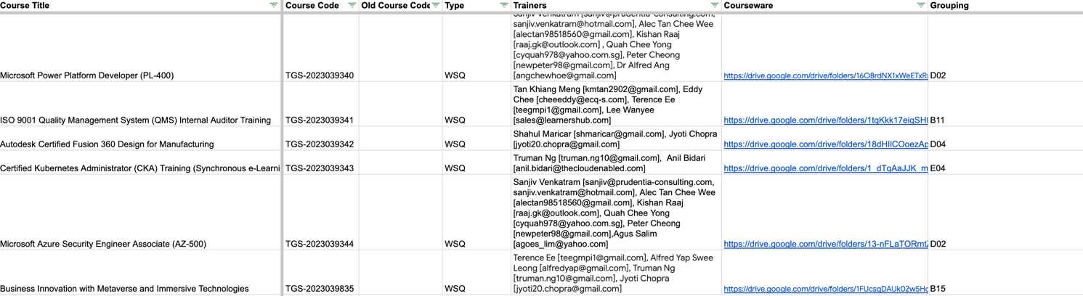

This Training Management System (TMS) is designed to efficiently assign courses to trainers while giving higher priority to those with better past ratings and performance. The table provides details on course titles, codes, trainers, courseware links, and groupings, helping streamline the assignment process.

Key Features of the Training Management System:

- Automated Course Assignment
  - The system assigns courses to all available trainers listed for each course.
  - Trainers are selected based on predefined qualification criteria and experience.

- Trainer Prioritization Based on Ratings
  - Trainers with higher ratings from past sessions (learner feedback, sentiment analysis, and evaluation metrics) are prioritized for course assignments.
  - If a high-rated trainer is unavailable, the next best-rated trainer is assigned.

- Courseware & Grouping Information
  - Each course is linked to courseware folders (Google Drive links), ensuring trainers can access relevant materials.
  - Courses are categorized into groupings (e.g., D02, B11, B15), which help in organizing and managing training schedules efficiently.

- Handling Trainer Availability Issues
  - If no highly-rated trainer is available, lower-rated but eligible trainers will be assigned.
  - If no trainer is available, the training manager will be alerted to manually assign or reschedule the course.

- Trainer Scheduling & Notification
  - Once a class is confirmed, Adult Educators (AEs) are scheduled via Google Calendar invites to ensure clear communication.
  - Email notifications are also sent to trainers with class details, course requirements, and access to relevant materials.

- Performance Monitoring & Feedback
  - After training sessions, trainer performance is reviewed, and ratings are updated.
  - Trainers with low ratings may receive coaching or be reassessed for future assignments

AE Assignment Acceptance Documents
Adult Educators are required to confirm their course assignments by accepting the Google Calendar invite, which serves as an official notification of their scheduled training session. Upon acceptance, trainers will be granted access to the courseware and assessment materials at least one week before the course commencement to ensure adequate preparation.

System Benchmarks
The following benchmarks/metrics are monitored monthly:
- Success/Failure Rate
- Error Rate

The Deployment and Assignment System is continuously monitored to ensure efficiency, accuracy, and optimal resource allocation. The key benchmarks assessed monthly include Success/Failure Rate (measuring assignment completion vs. non-assignment) and Error Rate (tracking incorrect trainer assignments). Additionally, the time taken to deploy a suitable trainer serves as a crucial metric for evaluating system efficiency.

Currently, due to insufficient data, a comprehensive analysis cannot yet be conducted. However, as more data is gathered over time, these benchmarks will enable data-driven decision-making to refine assignment processes, reduce errors, and enhance overall operational effectiveness. The system's continuous improvement efforts aim to ensure timely trainer deployment while maintaining high training standards.

- Monitoring and Management System

Training Delivery Monitoring
- Trainer will be observed by senior trainer/HR at least 1 session in every 12 months
- Assessor will be observed by senior trainer/HR at least 1 session in every 12 months
- Observation schedule will be provided to the trainers/assessors 2 weeks before the observation takes place.
- Please refer to Annex B.4 & B.5 Competencies Checklist.

Appraisal and Counselling Records

- The Senior Training Manager or HR will conduct the observation and provide feedback to the trainer or assessor, highlighting their strengths and areas for improvement. This includes aspects such as deviation from the lesson plan or learning objectives and concerns regarding training pace (too fast or too slow).
- Trainers requiring further coaching may be required to attend a similar class conducted by another trainer to observe best practices and performance standards.
- For trainers who receive a rating below 3 or negative learner feedback, HR will gather additional insights from learners regarding the trainer’s performance. A follow-up meeting will be conducted with the trainer to discuss necessary improvement actions. The trainer will formally acknowledge the improvement plan, and their subsequent course evaluations will be closely monitored to ensure their performance meets the required standards.

Code of Conduct for AEs
- All new AE will be briefed on code of conduct for AE.

System Benchmarks
The following benchmarks/metrics are monitored monthly:
- Rating Improvement
- Trainer Effectiveness

To ensure continuous quality improvement and adherence to training standards, the system benchmarks trainer performance through monthly evaluations. Key metrics include Rating Improvement and Trainer Effectiveness, both monitored via TRAQOM. Trainers receiving ratings below 3 or negative learner feedback will undergo further assessment, where HR gathers learner insights and implements targeted performance improvement plans. Subsequent course evaluations will be closely monitored to ensure that trainers meet the required standards. These benchmarks support a data-driven approach to maintaining high-quality training delivery and professional development.

- Training Systems for Qualified AEs

AE Training Records and Certifications
To ensure that trainers are well-equipped to deliver high-quality training, a Train-the-Trainer program is arranged for trainers before they conduct a new course, based on an as-needed basis. This ensures that trainers are familiar with course content, instructional methodologies, and assessment criteria, maintaining consistency and effectiveness across training sessions.

A Trainer Rating System is implemented to evaluate trainer performance based on learner feedback and effectiveness. Trainers with higher ratings are prioritized for more class assignments, reinforcing a merit-based deployment system that rewards high-performing educators.

Additionally, trainers may undergo external training programs as needed to further enhance their competencies and align with industry best practices. Training records and certifications are systematically documented.

For reference: (Train-the-Trainer Attendance Sheet & Jyoti - WSQ Certificate)

Deployed Training Documents
- Trainers participating in the Train-the-Trainer program are required to sign the attendance record as formal documentation of training completion. Additionally, trainers will be granted access to the Google Drive folder, which contains all relevant courseware and training materials, as well as the Google Classroom (LMS) for course management and instructional resources.

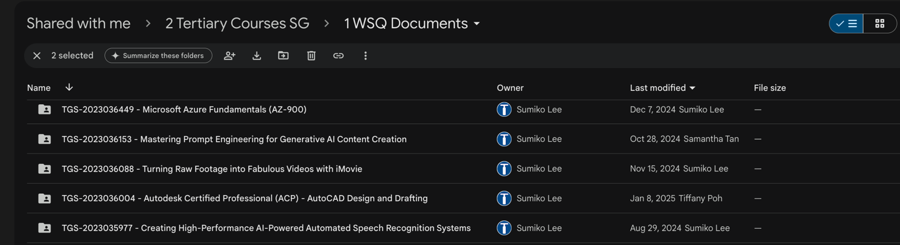

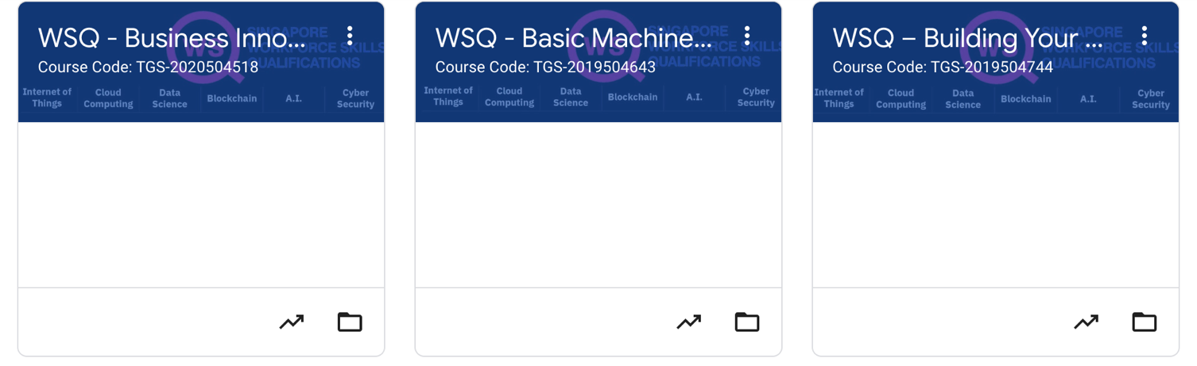

Annual Training Calendar
- Suitable trainings are identified and shared with all AE for their consideration

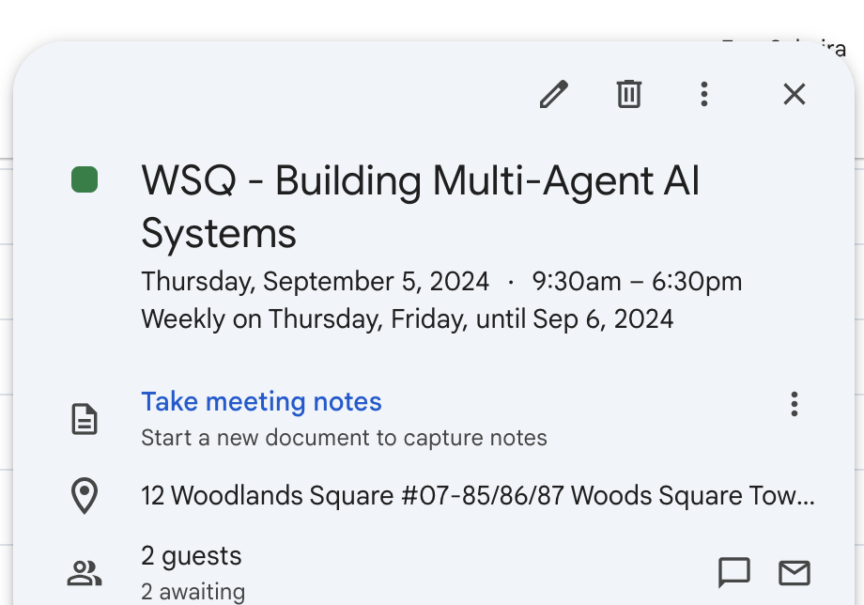

System Effectiveness
- Trainer and course ratings are continuously monitored to assess training effectiveness and identify areas for improvement. This evaluation is conducted through course surveys and TRAQOM, ensuring that training needs are addressed proactively to maintain high-quality learning outcomes.

- Intervention System for AEs

Assessment
- Assessors are brief and are to be familiarise with code of conduct for assessor.
- Training manager will randomly check assessment records to ensure the answer provided are not same for the same class
- If there is feedback that assessor has breached SSG guideline, training manager will
  - Check assessment records for abnormalities, and
  - Sit-in assessor’s class unannounced to observe how assessment is conducted
- Training manager will observe class and record observation.

Intervention Records

Feedback Received

Investigation:
Check with Trainee/Trainer

Feedback Valid?
Yes
Follow up actions with the Assessor

No

End

Observation for upcoming class
Report findings to stakeholder

End
Repeated Issue:
Escalate to more severe action

The Feedback Handling Workflow ensures a structured approach to evaluating and addressing feedback through investigation, corrective action, and escalation if necessary. When feedback is received, it is first reviewed with the relevant trainee or trainer to determine its validity. If deemed invalid, the process ends; otherwise, corrective actions are implemented through an assessor, counselling, or adherence to the Code of Conduct. A decision-making phase follows, where observations in upcoming classes help determine whether further intervention is required. Findings are then reported to stakeholders for transparency, and if the issue persists, it is escalated for more severe actions, such as disciplinary measures. This workflow promotes fair evaluation, structured monitoring, stakeholder communication, and continuous improvement while ensuring accountability in handling recurring issues.

Outcome Measures of System

The Training Manager will conduct unannounced classroom observations to evaluate the Assessor’s adherence to the Code of Conduct and ensure compliance with established training standards. These observations serve as a quality assurance measure to uphold the integrity of training delivery.

Any recurring issues or instances of non-compliance identified during these assessments will be systematically monitored, documented, and subject to further evaluation and corrective actions as necessary. This structured approach ensures continuous improvement and accountability within the training environment.

2.4 Plan-Do-Check-Act (PDCA) System

- Course Quality Assurance Review System

Courseware Feedback Analysis

The Plan-Do-Check-Act (PDCA) framework is implemented to ensure continuous courseware quality assurance. This structured approach ensures that course materials remain relevant, up to date, and aligned with industry standards. By systematically incorporating feedback and periodic reviews, the PDCA process enables continuous improvement in course content, assessment methods, and learner experience.

Industry engagement is essential in maintaining course quality, with content updates dependent on vendors such as AWS, CompTIA, and Microsoft. Courseware revisions are only made when these vendors release updates, typically on an annual basis rather than at regular intervals. Additionally, stakeholder feedback from employers, industry bodies, and learners is reviewed to ensure that the curriculum remains relevant and aligned with industry standards, addressing both learner and stakeholder expectations.

Meeting for Issues and Matters

The Check (Monitor, Review) phase ensures that implemented courseware updates are evaluated for effectiveness in enhancing learning outcomes and industry alignment. This process involves regular review meetings where learner performance, feedback reports, and industry trends are analyzed. Course ratings and learner engagement metrics serve as indicators of success, providing insights into how well the updated courseware meets expectations. If low satisfaction scores or negative feedback are identified, further investigations are conducted to address potential gaps.

Stakeholders, including employers, training managers, and industry bodies, actively contribute to the review process, providing insights into course effectiveness and industry needs. Given that courseware quality directly influences ratings, timely and relevant updates play a crucial role in maintaining high learner satisfaction, engagement, and perceived value. All findings are systematically documented, covering stakeholder feedback analysis, meeting notes, matters arising, and follow-up actions. Closure documentation ensures that corrective actions are tracked, with outstanding concerns flagged for further attention in the next PDCA cycle.

Documentation of Corrective Implementation

The Act (Improve) phase focuses on implementing corrective actions and refining the courseware quality process to ensure continuous improvement. Based on the findings from the monitoring phase, targeted updates are introduced to enhance content accuracy, improve delivery methods, and refine assessment criteria. To maintain consistency and quality across course materials, standardized best practices are followed in every update cycle.

A document control mechanism is used to track the latest courseware versions and ensure proper record-keeping. For slides, version updates are reflected in both the file name and the first page of the slide deck to maintain clarity and prevent outdated content from being used. For Assessment Plans (AP), Facilitator Guides (FG), Learner Guides (LG), and Lesson Plans (LP), updates follow a structured document control process, ensuring that each revision is recorded with a version number, effective date, description of changes, and the responsible person, creating a clear history of modifications.

This structured approach ensures that courseware updates are systematically documented, easily accessible, and aligned with industry requirements. By continuously integrating feedback, monitoring results, and refining courseware, the PDCA cycle drives sustained quality improvements in training programs.

Outcomes

- Organisational Outcomes

To ensure continuous improvement and alignment with strategic objectives, the organization systematically monitors and tracks key performance indicators (KPIs). These metrics provide valuable insights into the effectiveness of training programs, resource utilization, and overall business performance. The key KPIs assessed include:

- Learner Satisfaction Rating – Measures the overall experience and satisfaction of learners with the course content, delivery, and support.
- Trainer Rating – Evaluates the effectiveness and competency of trainers based on learner feedback and performance assessments.
- Course Rating – Assesses the relevance, quality, and impact of the course content in meeting learning objectives and industry requirements.
- Resource Utilization – Tracks the efficiency in the allocation and usage of training resources, ensuring optimal performance and cost-effectiveness.
- Marketing Key Performance Indicators (KPIs) – Analyzes the effectiveness of marketing efforts in attracting and retaining learners, including campaign performance and outreach success.
- Revenue Growth – Measures financial performance, including enrollment trends and revenue generation, to assess overall business sustainability and expansion.

Learner Survey Response

The organization has established a TRAQOM quality survey response rate target of 75% to ensure meaningful data collection for evaluating course effectiveness and learner satisfaction.
To achieve this target, a structured approach is implemented:

- Automated Email Reminders: Learners receive an email notification on the course end date, prompting them to complete the TRAQOM survey. This serves as a formal reminder to encourage participation.
- Trainer Facilitation: Trainers play a crucial role in ensuring survey completion by reminding and guiding learners to submit their responses before class dismissal. This proactive approach helps improve response rates and ensures valuable feedback is collected in a timely manner.

By implementing these measures, the organization enhances data reliability and strengthens its ability to monitor and improve training quality based on learner feedback.

Satisfaction of Feedbacks and Requests

To enhance our services and course quality, course advisors will request learners to complete the Learner Satisfaction Survey after addressing their requests, feedback, or appeals. Learners will be encouraged to provide a star rating for our service through a Google survey, allowing us to gather valuable insights for continuous improvement.

Satisfaction of Course Advisory

To improve our service and course, course advisors will request for learners to complete learner satisfaction
survey after course advisors have provided pre-course/post-course advice.

Customer Satisfaction Survey

Satisfaction of Administrative Matters

To enhance the efficiency and responsiveness of our administrative services, including registration processes and communication with learners, we actively monitor and track the TRAQOM quality survey. This enables us to assess service performance, identify areas for improvement, and implement targeted enhancements to optimize the overall learner experience.

Performance and Achievements in Strategy

All Key Performance Indicators (KPIs), except for revenue growth, are monitored and tracked on a quarterly basis. The management team conducts regular reviews of these KPIs to assess performance and identify areas requiring follow-up action if targets are not met.

The KPIs monitored include:

- Learner Satisfaction – Overall score from the TRAQOM survey, measuring learner experience and satisfaction.
- Marketing Effectiveness – Assessment of the effectiveness of various marketing channels in reaching and attracting learners, including:
  - Social Media Platforms (Facebook, Instagram, etc.)
  - MySkillsFuture Portal
  - Chariot Courses SG Website
  - Chariot Courses SG Newsletter / Email / WhatsApp Campaigns
  - Internet Search
  - Referrals (Family, Friends, Colleagues, Employers)
- Revenue Growth – Course sales revenue, tracked for overall financial performance.
- Resource Utilization – Monitoring of training room utilization rates to ensure optimal use of resources.
- Trainer Rating – Overall trainer performance rating based on learner feedback.
- Course Rating – Overall course effectiveness rating, evaluating content relevance and delivery.

Regular analysis of these KPIs ensures continuous improvement in service quality, course effectiveness, and operational efficiency.

Compliance to SSG Marketing Guidelines

All newly onboarded marketing team members receive a comprehensive briefing on the SSG Marketing Guidelines and are provided with a copy of the guidelines for reference. This ensures that all marketing activities adhere to regulatory requirements and maintain compliance standards.

To uphold consistency and compliance, the Marketing Manager utilizes the SSG Marketing Guideline Checklist for the following purposes:

- Approval of new marketing activities to ensure alignment with SSG regulations.
- Annual review of the course website and standard course brochure to maintain accuracy, relevance, and compliance with updated guidelines.

This structured approach ensures that all marketing efforts remain compliant with SSG requirements while supporting transparency and accountability in promotional activities.

- Training Outcomes
- Training Quality and Outcomes Measurement (TRAQOM) Initiative

*Add in TRAQOM Dashboard + link
*Add YY’s analytics

All training courses are monitored from the course development to course completion to check the course objectives are achieved and areas of improvement.

- TRAQOM Survey: This survey is a part of the national quality assurance framework for training providers and is used to evaluate course effectiveness and learner satisfaction.
- Course Feedback: This feedback is critical for continuous improvement in training delivery and learner experience. **KIV

TRAQOM survey is administered to all learners at the end of the course. Email are send out to learners
before class ends, providing TRAQOM and course run id for ease of completing survey.

Manager will login to TRAQOM system to track and report KPI monthly and review target quarterly.

Annexes

Annex A.1 - Course Registration Email

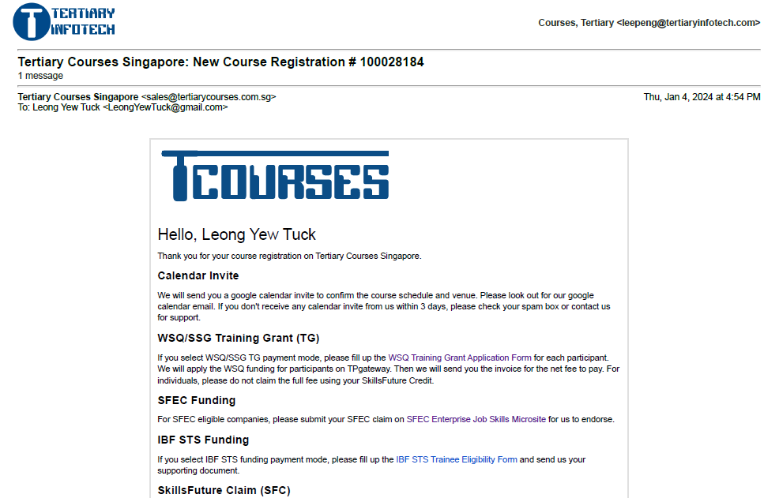
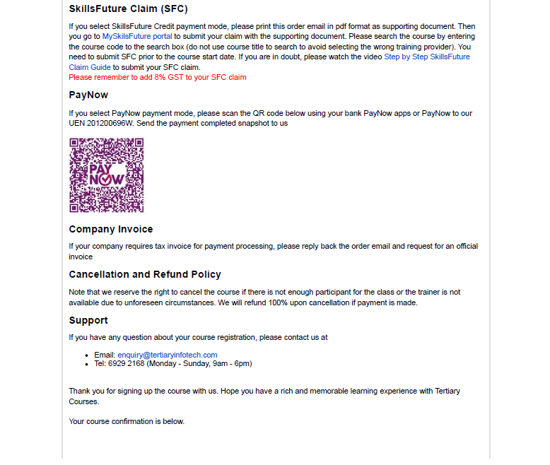



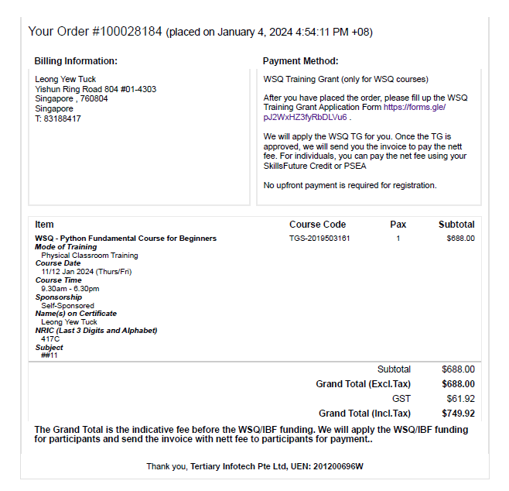
info@chariot-learning.com
67850776


Annex A.2 - Notification / Booking of Trainers and Assessors Email

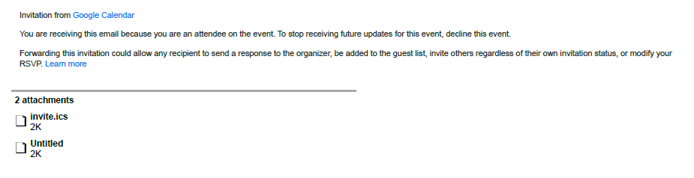
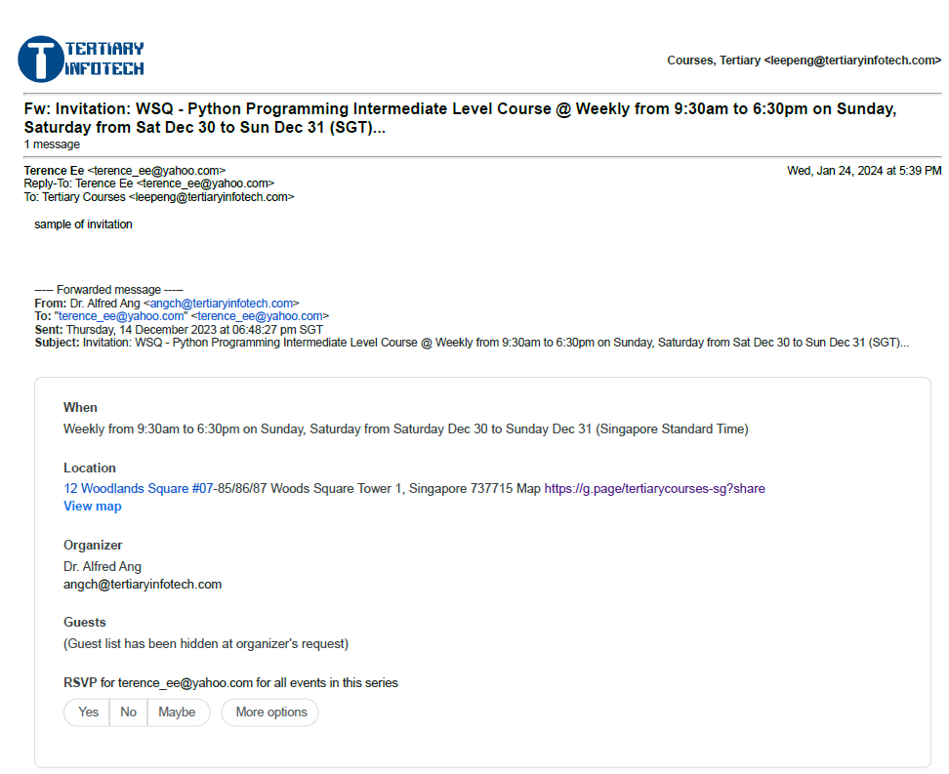

Annex A.3 – Confirmation / Reminder Email

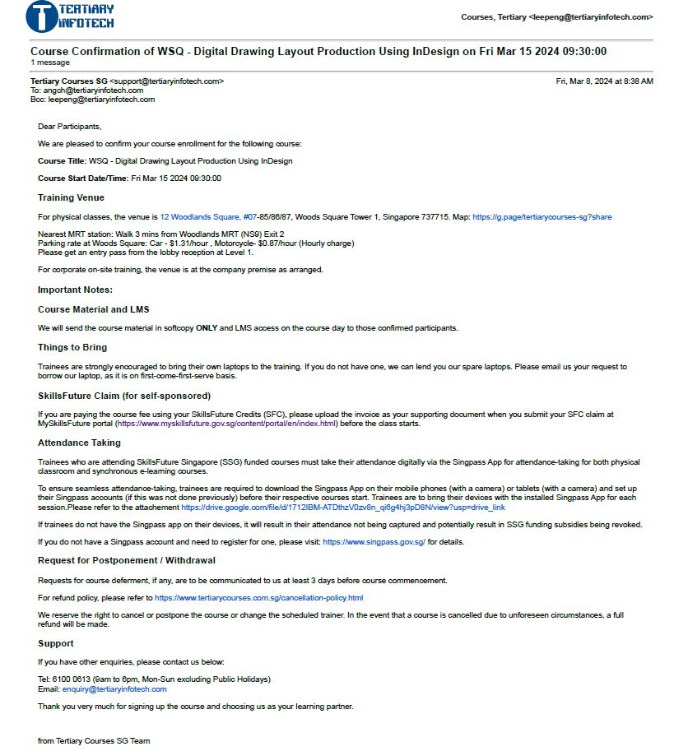

Annex A.4 - Final Reminder Email
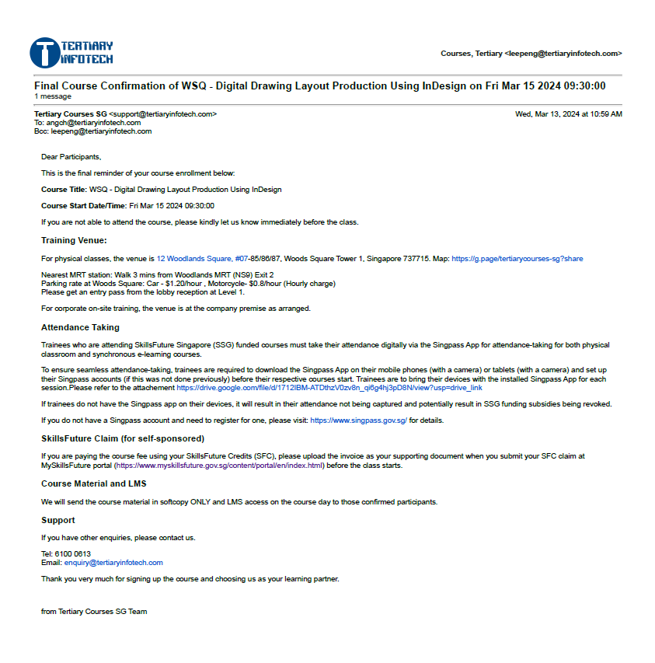

Annex A.5 - Email for Course Materials
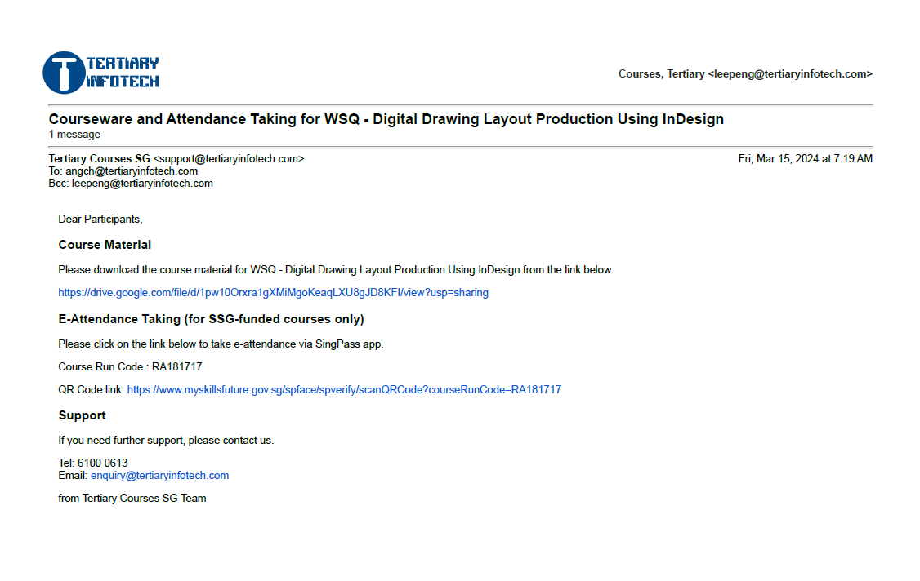

Annex A.6 - Email for Grant Application Reminder and Invoice
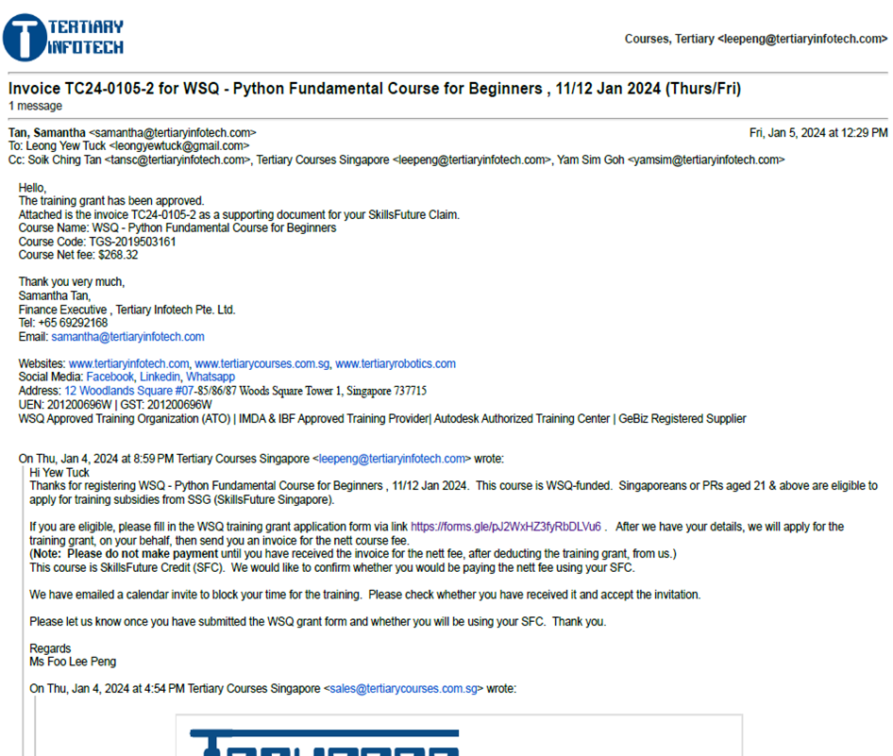

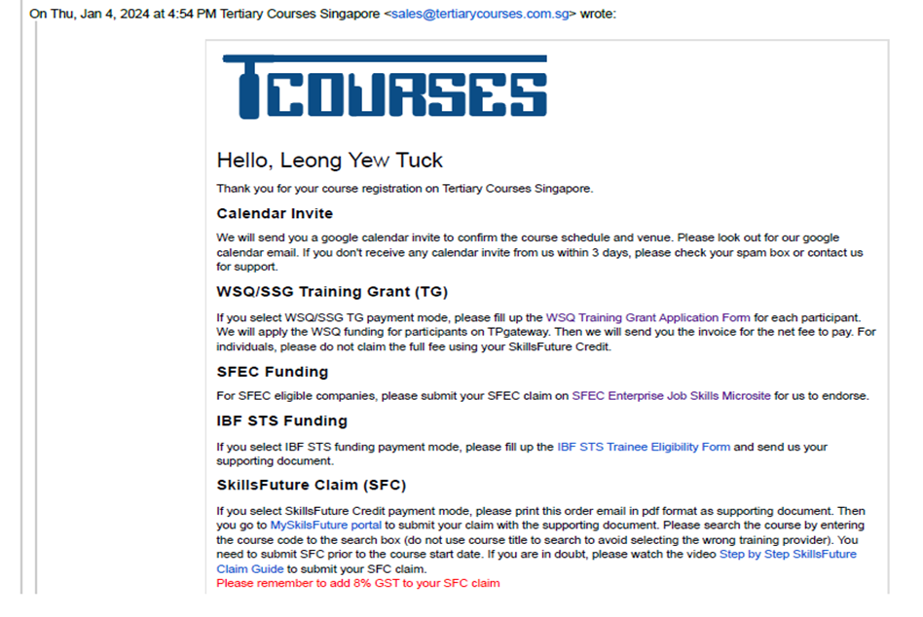
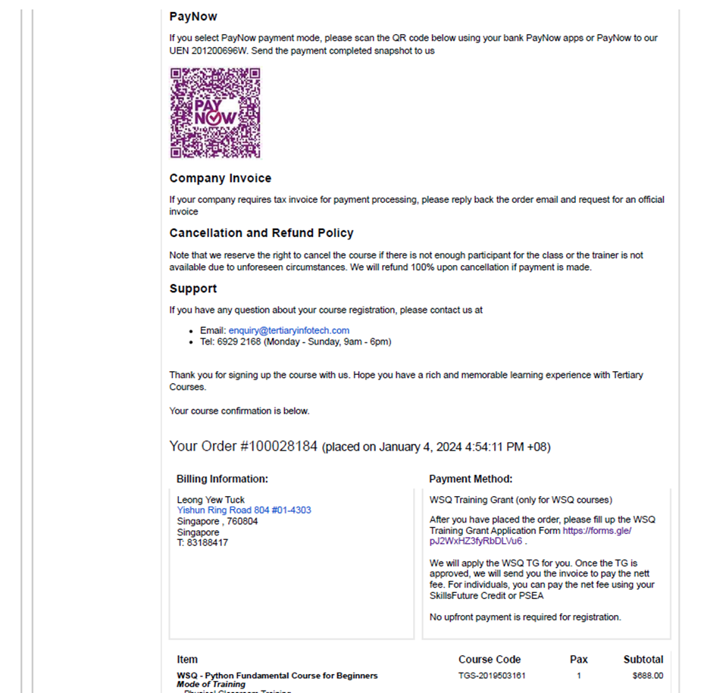
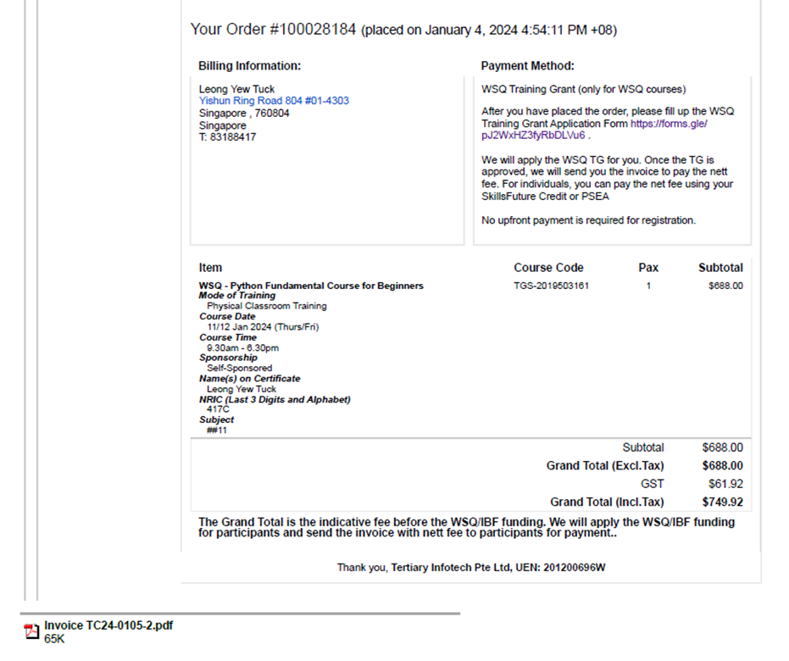

Annex A.7 - Sample Invoice – Individual-sponsored, Payment by SFC

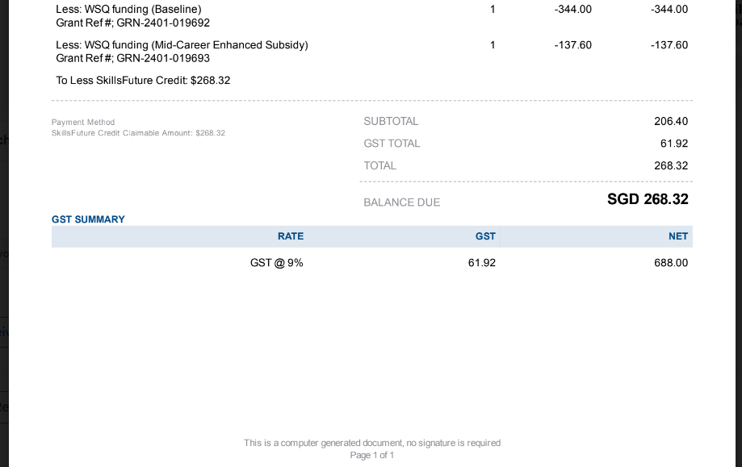
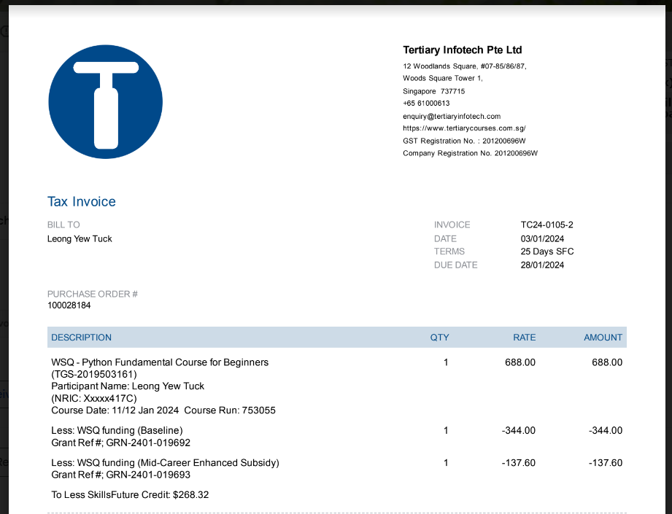

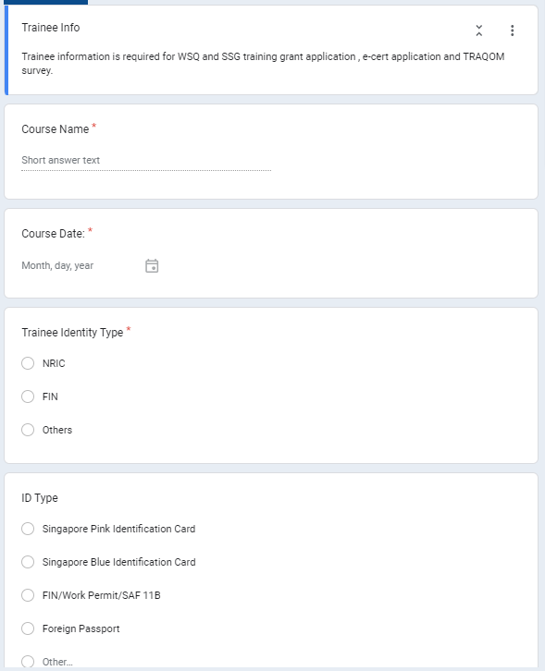
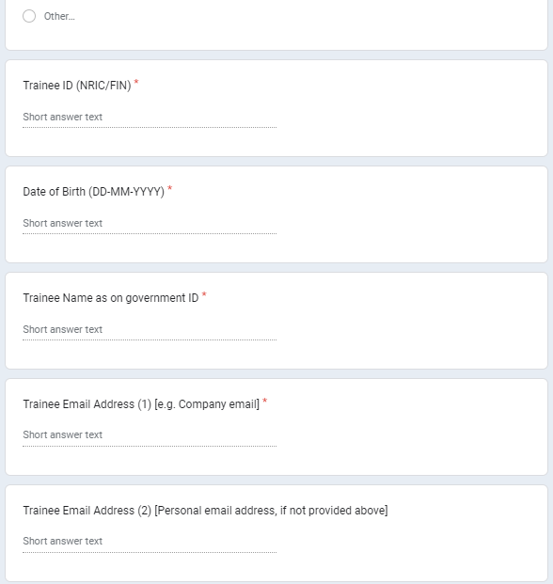
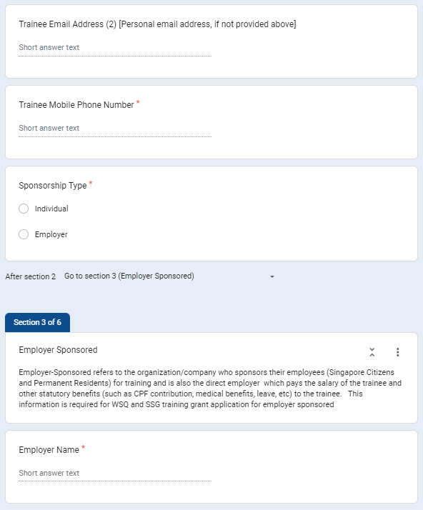
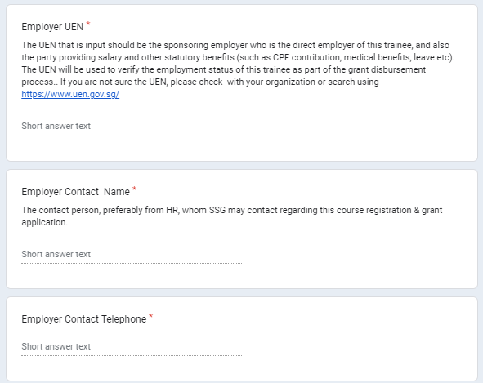
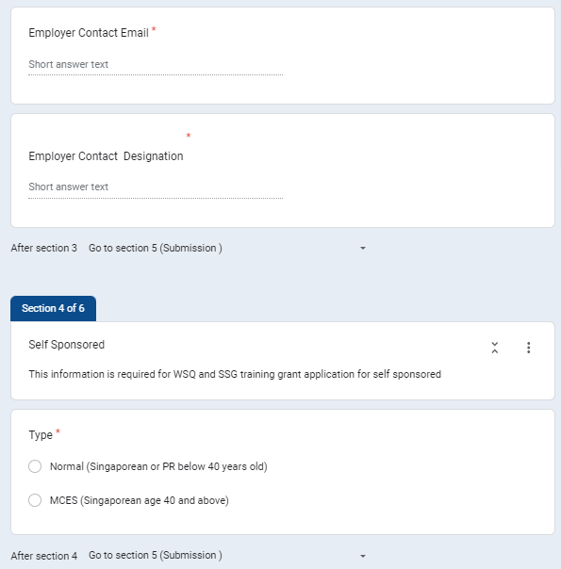

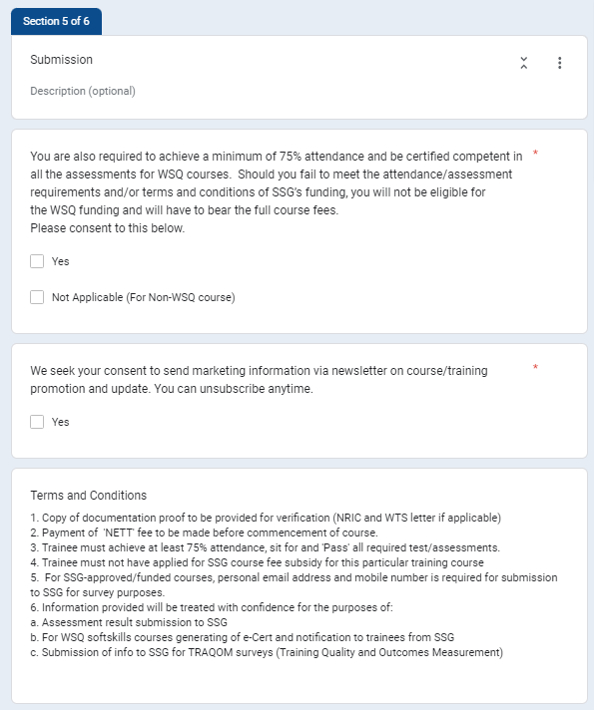
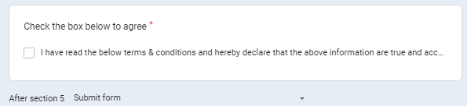

Annex A.8 - SSG Training Grant Application Form

Annex A.9 - Post-Course Email

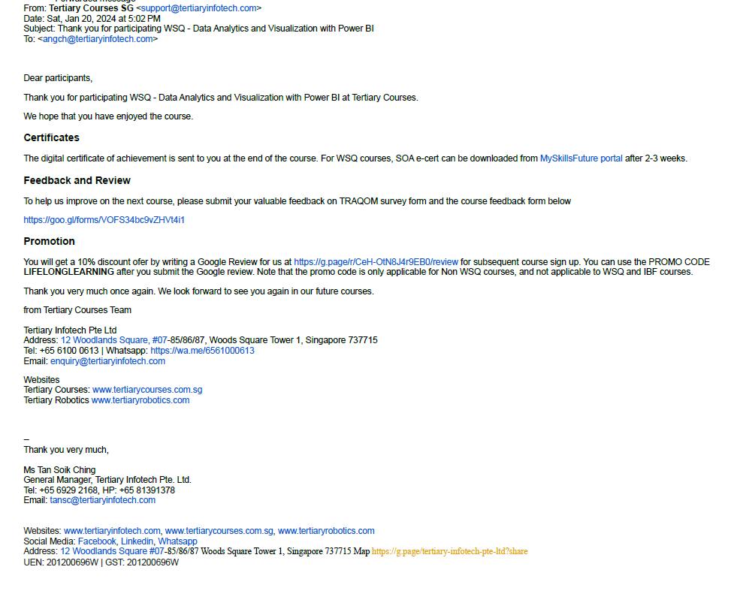

Annex A.10 - Attendance Sheet Template


Course: |  |  | Time:
Date:

 |  |  |  |  | Signature
S/No | Full Name (as per NRIC) | NRIC (Last 4 characters) | Company | Invoice # | AM | PM | Assessment
1
2
3
4
5
 |  |  | Total Participants Count:

Company Name: |  |  | Trainer Name:
Company Stamp: |  |  | Trainer Signature:
Name/Signature:
Designation:

Annex A.11 - Refund Process
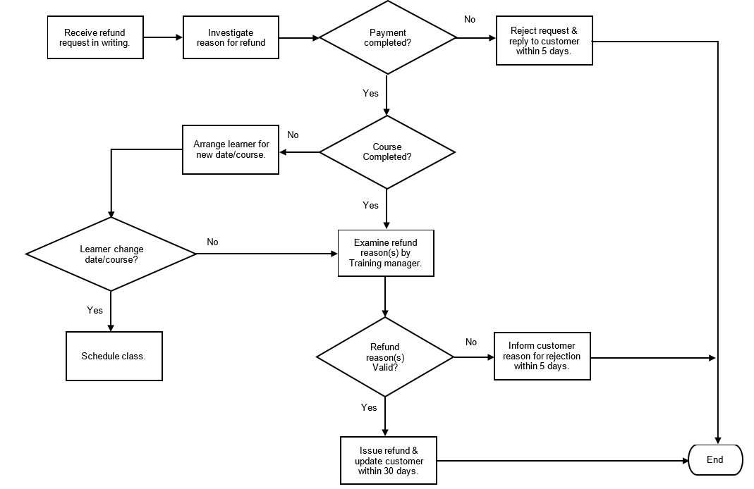

Annex A.12 - SSG Funding Eligibility Check Process
Enroll training grant via TPG.
Employer-sponsored?
Yes
Request submit SSG grant application form## with learner’s & employer’s info.
Request for supporting doc to show learner is direct employee.
Learner Singaporean/PR?
Yes
No
No
Cat C funding
Cat B or Cat C funding?
Cat B funding
Self or Employer-sponsored?
Self-sponsored
Request submit SSG grant application form## with learner’s info.
Learner# Singaporean/PR?
Yes
# Only Singaporean & PR learners aged 21 & above are eligible for SSG funding.

## Learner & sponsoring employer declared they will pay for full course fee if they do not meet the requirements of SSG fundings.

Receive course registration order.
SSG-funded course?
No
Yes
End
No
Employer-sponsored
End

Annex A.13 - Review of Assessment Appeal Case Form

Course Name:
Date of Appeal:
- Assessor’s Feedback
Assessor Name: |  | Date of FA:
Has the Assessor informed the Candidate of the appeal process? |  |  | Yes / No
Reason(s) for NYC:
- Candidate’s Feedback
Candidate Name: |  |  |  |  |  |  |  | NRIC:
Reason(s) for Dissatisfaction: (May tick more than one)
Assessor |  |  |  | Assessment Result
Assessment Process |  |  |  | Others:
Provide more details of the above:

- Final Decision
Overall Comments:

Resolution Outcome: Tick the appropriate box
No change to “Not Yet Competent” outcome.
- Candidate is required to sign on the Assessment Record Forms
Recommendation for candidate to go through a re-assessment.
- The next FA date:
Appeal Panel 1 Name: |  |  |  |  | Date:
Appeal Panel 1 Signature:
Appeal Panel 2 Name: |  |  |  |  | Date:
Appeal Panel 2 Signature:

Annex A.14 - Assessment Appeal Procedure

The procedure used for dealing with appeals is as follow:

1.All written documentation relating to an appeal shall be filed in the Appeal File.

2.The Candidate has the right to appeal for review of the assessment decision made by the Assessor. When feedback is given to the Candidates regarding the assessment, the Assessor must ask the Candidate if he / she is agreeable with the outcome.

3.If both the Candidates and the Assessor are agreeable with the outcome, both parties must sign the Assessment Summary Record. If the Candidate is not agreeable with the outcome, the Candidate should not sign the Assessment Summary Record.

4.If the Candidate intends to appeal the decision, he / she should discuss the matter with the Assessor. If he / she is unsatisfied with the decision, the Candidate must notify the Assessor of his / her intention to appeal.

5.The Assessor must notify the Training Manager about the Candidate’s intention to lodge an appeal.

6.The Candidate must lodge the appeal in written form providing reasons for the appeal within 1 week of the date of assessment.

7.The Training Manager must collect information from both the Candidate and the Assessor, using the Review of Assessment Appeal Case Form.

8.The Appeal Panel is responsible for reviewing and giving a decision on appeals against a “Not Yet Competent” (“NYC”) award.

9. The panel consists of the following:
a. Director
b. Training Manager
c. Finance / Grant Manager

10.The appeal outcome will be announced within 14 working days.

11.The Training Manager will (consider all documentation provided):
a. Request further information where necessary.
b. Prepare formal advice to the candidate; and
c. File a copy of the formal advice in the Appeal File and forward a copy to the candidate.

12.The outcome as set down by the Appeal Panel is to be abided to by all parties.

Annex A.15 - SSG Marketing Guidelines Checklist

Marketing Type: Please select the appropriate type
Website/ Brochure / Newsletter / Email / Social Media / Others (please specify):

S/No | SSG Marketing Guideline Question | Yes/No
1 | Any logo belonging to SSG (SkillsFuture Singapore) or SkillsFuture logo ?  Example of logo:  
2 | Any “SkillsFuture Approved” term used?  (Note: “SFC-eligible” may be used.)
3 | For non-SSG funded courses:
 | a) Any mention/display of ‘funded’ or with word(s) of similar import or effect?
 | b) Any mention/display of ‘accredited’ or with word(s) of similar import or effect?
4 | The following details are printed/displayed?
 | Our ACRA-registered name: Chariot Learning and Consultancy LLP.
 | ii. Our UEN number / ACRA registration number: T17LL1342K
 | iii. the Registered Course title or Listed Course title as approved by SSG
 | iv. the Registered Course duration or Listed Course duration as approved by SSG
v. the full course fees, as well as (where applicable) the nett course fees payable after
taking into account subsidies (this shall not be construed to include SkillsFuture Credit)
available from SSG
vi. (where applicable) the period during which the relevant subsidies (this shall not be
construed to include SkillsFuture Credit) from SSG are expected to be available
 | vii. Mode of training e.g. classroom, e-learning, etc
6 | SSG approved course(s) are active and course name(s) are aligned with SSG ?  Please indicate total number of SSG approved course(s) checked:
7 | Is this from a 3rd party marketing? If yes, please provide the following
 | a) Company name of 3rd party marketing:
 | b) Name of OIC:
 | c) Email address & mobile of OIC:
8 | Any wording that convey any impression to the public that SkillsFuture Credits may be used only for our company or course(s)?
9 | Any wording that list SSG approved course(s) as “free”, “paid by the government”, “paid by SSG” or using words or phrases with similar import or effect?
10 | Unless permitted by SSG in writing (such permission to be given or withheld at SSG’s sole and absolute discretion), for SSG approved courses is there any mentioning of:
 | a) provide any referral awards / rewards;
 | b) conduct any lucky draws;
 | c) provide gifts or vouchers; or
 | d) use similar means to incentivise or persuade the public to sign up for SSG approved course(s).
11 | Unless permitted in writing by SSG, any SSG approved courses is there any mentioning of incentives provided by SSG (such as cash awards under the SkillsFuture Qualification Award scheme) ?
12 | Any request for the following from prospective trainee or registered trainee
 | i. Trainee SingPass login password
 | ii. Trainee user ID
13 | For SSG approved courses, any wording that state completion of any Registered Course or Listed Course does not require the passing of any assessment or examination (even if this is true)?
14 | For SSG approved courses, any printing / mentioning of Training Quality and Outcomes Measurement (TRAQOM) survey– related information to mislead any person so as to encourage registration / enrolment for your Registered Courses or Listed Courses?
15 | Any publication of testimonials/feedback from trainee? If yes, all the following information provided?
 | a) Name of trainee:
 | b) Date of testimonial/feedback:
 | c) Source of feedback:
 | d) Email address of trainee:
 | e) Mobile number of trainee:
 | f) Is the trainee related to Chariot Learning and Consultancy LLP. ?
 | g) Is the trainee related to any employee of Chariot Learning and Consultancy LLP. ?
Note: We are required to provide to SSG, within fourteen (14) calendar days from SSG’s request , the contact details of the Trainee / Applicant who provided the testimonial to enable SSG to contact him / her to verify the authenticity of the testimonial or ask questions concerning the testimonial.
16 | Any superlatives or exaggerated claims in your Advertisements, e.g. “Guaranteed success in life” and “most demanded course in Singapore”, which may be construed as false and/or misleading?
17 | Any mentioning / representation that we can secure any employment opportunities for Trainees / Applicants?
18 | Any misleading or false information?
Note: Within fourteen (14) calendar days of SSG’s request, you shall provide to SSG such information as it (SSG) may specify concerning any Advertisement. This may include, without limitation, information substantiating the truth of any content in any Advertisement.

Name of Checker:
Signature & date:

Annex B.1 - Associate Trainer Application Form
Associate Trainer Application From
(*) Denotes a compulsory field.
Your application is subject to the agreement of the terms and conditions governing personal data protection, which can be accessed via Chariot Personal Data Protection Policy.
(Yes/No)*
- Personal Particulars
Salutation*:
Full Name*:
Last Name*:
Full Name*:
NRIC Number* (last 4 characters only):
Designation:
Email*:
Alternate Email*:
Mobile Number*:
Office Tel Number:
Office Address Line 1*:
Office Address Line 2*:
Postal Code*:
Country based in:
Nationalities*:

Do you have regional training experience? *
 | Asia |  | Europe |  | United States |  | None

Do you have other regional training experiences? *
Creativity & Innovation
 | Agile Thinking |  | Design Thinking |  | Innovation & Creativity |  | Project Management/Scrum
 | Systems Thinking

Digital
 | AI/Machine Learning |  | Business Analytics |  | Cloud/Cyber |  | Digital Tools
 | Internet of Behaviour

Leadership & Management
 | Entrepreneurship |  | Leadership |  | Management |  | Organisational Learning
 | Systems Leadership

People Skills
 | Communication |  | Customer Orientation |  | Emotional & Social Intelligence |  | Mental Wellness
 | Mindfulness & Resilience |  | Self-Management |  | Transdisciplinary Thinking

Sustainability
 | Leadership & Governance |  | Planet |  | Sustainability

Target Audience*
 | Level 1 – Administrative & Support |  | Level 2 – Supervisors, Executives & Emerging Managers
 | Level 3 – New Managers (3 years or less) |  | Level 4- Managers (4 – 7 years)
 | Level 5 – Senior Managers & Directors (Above 7 years) |  | Level 6 – C-Suitr

Industries that you have worked in*
 | Aviation & Transportation |  | Banking & Finance |  | Education |  | Government
 | Hospitality & Pharmaceutical |  | Infocomm & Communication |  | Logistics |  | Manufacturing
 | Marine & Offshore |  | Real Estate |  | Social Service |  | Others, please specify

Industries that you have trained for*
 | Aviation & Transportation |  | Banking & Finance |  | Education |  | Government
 | Hospitality & Pharmaceutical |  | Infocomm & Communication |  | Logistics |  | Manufacturing
 | Marine & Offshore |  | Real Estate |  | Social Service |  | Others, please specify

Years of Experience in Facilitation*
Years of Experience in Curriculum
Development*
Expected fee per day (public run)*
Expected fee per day (in-house)*
Language that you are able to train in

 | English |  | Chinese |  | Malay |  | Other, please specify:

Highest Academic Qualification*
ACTA/ACLP certified? *
DACE/DDDLP certified? *

Attachments to email:
Photo
CV/bio data
Highest academic certificate
ACTA/ACLP certificate (if applicable)
DACE/DDDLP certificate (if applicable)
Other industry certificate (if applicable)

Company’s details (if applicable)
Company Name*
Company Registration Number *
Address of Company*
Full Name of the authorised
Signatory for and on behalf of
Company

Annex B.2 - Interview / Selection Evaluation Form for Trainer / Assessor - For training and assessment function

Recruitment Criteria | Sources of Evidence | Mode of Assessment | Assessment Criteria | Interviewer’s Remarks
At least a Workplace Literacy (WPL) skills at the proficiency level equivalent to level 5 or Diploma or equivalent AND | - Formal qualification(s) attained | - Interview  - Portfolio Submission | - Able to show evidence of highest educational qualification
A WSQ Advanced Certificate in Learning and Performance (ACLP) or equivalent AND | - SOAs attained | - Interview  - Portfolio Submission | - Able to show evidence of qualification
Preferably 3 years of working experience in relevant industry OR | - CV with details of relevant work history  - Testimonials | - Interview  - Reference Check | - Able to justify relevance and value- add from previous employment that will contribute to the effectiveness of this position
 |  |  | - Able to show positive testimonials that are relevant to this position
Preferably 2 years of experience in adult training and education | - CV with details of relevant work history  - Testimonials from previous learners | - Interview  - Reference Check | - Able to demonstrate training and assessment competencies  - Able to show positive testimonials from previous learners

Annex B.3 - Interview / Selection Evaluation Form for Course / Curriculum Developer - For Design and Delivery of Training Programmes

Recruitment Criteria | Sources of Evidence | Mode of Assessment | Assessment Criteria | Interviewer’s Remarks
A WSQ Diploma in Adult and Continuing Education (DACE) AND | - SOAs attained | - Interview  - Portfolio Submission | - Able to show evidence of qualification.
At least 5 years of working experience in the relevant industry OR | - CV with details of relevant work history  - Testimonials | - Interview  - Reference Check | - Able to justify relevance and value- add from previous employment that will contribute to the effectiveness of this position.
 |  |  | - Able to show positive testimonials that are relevant to this position.
At least 5 years of experience in adult training and education | - CV with details of relevant work history  - Testimonials from employers/learners | - Interview  - Demonstration  - Portfolio Submission | - Able to show positive testimonials that are relevant to this position.
 |  |  | - Able to show positive testimonials that are relevant to this position.

Annex B.4 - Trainer Competencies Checklist

Details About the Training Observed
Name of Trainer: | Name of Observer:
Training Venue: | Date of Observation:
Course Observed:
A. Section I
For each statement below, please tick the response that best represents your opinion on how well the trainer has performed.

The rating scale is as follows:
5 – To a Very Large Extent 4 – To a Large Extent 3 – To Some Extent
2 – To a Small Extent 1 – Not at all
Preparation — the trainer: | 5 | 4 | 3 | 2 | 1
1. Ensured training resources, facilities and environment were sufficient and in working order.
2. Ensured seating arrangement was suitable for learners’ needs and nature of course.
3. Was punctual.
Delivery — the trainer: | 5 | 4 | 3 | 2 | 1
4. Spoke loudly and clearly.

5. Maintained good eye contact.
6. Described the learning outcomes clearly.
7. Summarized the main points before ending the
course.
8. Managed time effectively.
Preparation — the trainer: | 5 | 4 | 3 | 2 | 1
9. Involved the learners by using open ended questioning techniques.
10.Provided clear instructions for all activities.
11.Clarified or rephrased questions from learners when needed.
12.Circulated among groups and checked on progress during learning activities and provided guidance when needed.
13.Provided opportunities for learners to contribute their own learning and understanding.
Visual Aids — the trainer: | 5 | 4 | 3 | 2 | 1
14. Used visual aids effectively.
15. Made sure materials could be read easily from the back of the room.
16. Did not block the screen or flipchart.
17. Used key words rather than sentences.
18. Wrote legibly.
Technical Competency — the trainer: | 5 | 4 | 3 | 2 | 1
19. Taught the technical content accurately.
20. Used effective examples and illustrations.
21. Defined unfamiliar technical terms.
22. Provided good answers to technical questions from the learners.
23. Provided examples on how the content can be contextualized to their work environment
Closure — the trainer: | 5 | 4 | 3 | 2 | 1
24. Briefed learners on the purpose of the post-course evaluation and reassured them of confidentiality of their feedback.
B. Section II
Please use the space below to specify.
25. Specific topics where the trainer lacks technical knowledge/expertise.
26. Ways the trainer might connect better with and engage the learners; be more inclusive:
27.Ideas where the trainer might use materials/resources more effectively:
28. Suggestions where the trainer might use a clearer and more organized approach:
Other comments / feedback:
C. Overall Rating – the trainer: | 5 | 4 | 3 | 2 | 1
30. is well prepared for the training.
31. has delivered the training well.
32. is responsiveness to the learners.
33. has good knowledge of subject matter.
D. Training & Development Plan & Review
E. Observer has shared the above findings with the trainer:
Observer Signature & Date: | Trainer Signature & Date

Annex B.5 - Assessor Competencies Checklist

Details About the Assessor Observed
Name of Assessor: |  |  | Name of Observer:
Training Venue: |  |  | Date of Observation:
Course Observed:
A. Section I
For each statement below, please tick the response that best represents your opinion on how well the trainer has performed.

The rating scale is as follows:
5 – To a Very Large Extent 4 – To a Large Extent 3 – To Some Extent
2 – To a Small Extent 1 – Not at all
Preparation — the assessor: |  | 5 |  | 4 | 3 | 2 | 1
1. Ensured assessment facilities and environment were
properly setup and in working order.
2. Ensured the props needed for the assessment were
ready.
3. Was punctual.
Briefing — the trainer: |  | 5 |  | 4 | 3 | 2 | 1
4. Put candidate at ease e.g. offered a greeting.
5. Checked and verified candidate’s identity.
6. Explained purpose and area of assessment.
7. Informed candidate of the duration of assessment.
8. Informed candidate of the confidentiality of assessment.
9. Explained the possible outcomes of assessment clearly.
10. Explained the appeal process if the outcome was ‘NYC’.
11. Checked that candidate has fully understood all aspects of assessment
12. Checked if candidate had any special needs.
Conduct of Assessment — the assessor: |  | 5 |  | 4 | 3 | 2 | 1
13. Conducted assessment according to the assessment
plan systematically.
14. Ensured the safety of candidate was not compromised
during the execution of assessment
15. Used open ended questions to probe for understanding
or allowed candidate to clarify.
16. Recorded outcomes promptly and accurately during the
assessment.
17. Paraphrased to confirm understanding of candidate's
response.
18. Used modulated tone of voice to reassure candidate.
19. Provided sufficient time for candidate to response
Evidence of Performance — the assessor: |  | 5 |  | 4 | 3 | 2 | 1
20. Verified the evidence collected was valid (matched assessment criteria).
21. Verified the evidence collected was current (completed
recently).
22. Verified the evidence collected was sufficient (based on
more than one task and not a chance occurrence).
23. Verified the evidence collected was authentic (candidate’s own work).
Feedback — the assessor: |  | 5 |  | 4 | 3 | 2 | 1
24. Asked candidate for his/her own performance assessment such as what he/she has done well, what he/she thinks were areas to improve, and what he/she acknowledged were issues (note: these should not be seen as examples of incompetence).
25. Provided affirmation when candidate performed to expectation.
26. Provided clear and constructive feedback when candidate did not perform to expectation.
Closure — the assessor: |  | 5 |  | 4 | 3 | 2 | 1
27. Checked all documents were completed and signed off by both candidate and assessor.
B. Section II
Please use the space below to specify.
28. Strategies used in assessing evidence of performance:

29. Comparable evidence gathered:
30. Reasonable adjustment made:
31. Other comments / feedback:
C. Overall Rating – the assessor: |  | 5 |  | 4 | 3 | 2 | 1
32. is well prepared for the assessment.
31. is fairness and objective.
32. is responsiveness to candidates.
33. has good knowledge of subject matter.
D. Training & Development Plan & Review
E. Observer has shared the above findings with the assessor:
Observer Signature & Date: | Trainer Signature & Date

Annex B.6 - Course Survey Sample

Performance Gaps and Training Needs for
<Course Tittle>

We are applying for WSQ funding support for this new course <Course Tittle> according to <Technical Skills and Competency (TSC), TSC code > under <category> Skills Framework.

Please help to feedback on the training needs and performance gaps for this course.

- What are the performance gaps in the industry (1-2 paragraphs are sufficed)

- Why you think this WSQ course will address the training needs for the industry (1-2 paragraphs are sufficed)

B. Please fill up your details and sign here to validate this course

Name : Company :
Date : Designation :
Email : Tel :

__________________________________
Your Signature

Annex B.7 - Course Proposal Template


COURSE PROPOSAL (CP) Form
Instructions to Applicants
You may submit your application for 1 of the following 2 types of courses by filling up the relevant segments in the Course Proposal Form (CP). Each course application is to be accompanied by 1 CP Form.
(A) WSQ Singular Course
(B) WSQ Integrated Course*

 | Contents are FULLY mapped to Skills Framework (SFw) |  | Contents are PARTIALLY mapped to SFw due to transition arrangement or review of SFw
Segments to be completed | (A) WSQ Singular Course | (B) WSQ  Integrated Course | (A) WSQ  Singular Course | (B) WSQ  Integrated Course | (C) CCS courses  [Singular /  Integrated] by CFP –  appointed TPs
1 | ✔ | ✔ | ✔ | ✔ | ✔
2 | ✔ | ✔
3 | ✔ | ✔ | ✔  (Sections C, D, E only) | ✔  (Sections C, D, E only) | ✔
4 | ✔ | ✔ |  |  | ✔
5 | ✔ | ✔ |  |  | ✔  (Declaration)
Incomplete submission of information in CP Form will lead to delay in the processing of your course application
Important Note for Compliance
We (TP) shall take note of the following:
- TP shall market the course adhering to Marketing Guidelines (Annex A) to SSG Terms for We and only upon approval of your course application
- TP must develop the courseware in accordance with the course proposal upon accreditation. The following changes made to an accredited course proposal will warrant a NEW submission of course application for re-accreditation:
  - Changes in delivery mode (i.e., classroom, e-learning and workplace learning), or
  - Changes in assessment methods, or
  - Reduction or increase in course duration by more than 50% of the approved duration.

- As part of the continuous effort by SSG to help TP improve the robustness and quality of their courses, post-approval quality checks will be conducted on a regular basis.

*WSQ Integrated course refers to a course application with more than 1 Technical Skills and Competencies
(TSC) but not leading to a full qualification.

For application of WSQ Full Qualification, please click here:
https://www.tpgateway.gov.sg/plan-courses/course-accreditation select “What do I need for the application?
s/no b.”

Part 1: Particulars of Course
Application Reference Number as generated in TPGateway | [Please insert the number (E.g.: TPG-2022xxxxx) here during CP clarification.]
Type of Course Application you are applying | ☐ (A) WSQ Singular Course  ☐(B) WSQ Integrated Course  [Please select 1 option only]
Name of your Organisation
(As with the Accounting and Corporate Regulatory Authority [ACRA])
Course Title
Technical Skills and Competency (TSC)/Critical Core Skill Title(s) (CCS) that your Course is being mapped to (As per title in the TSC / CCS Document) |  | TSC/CCS code

Breakdown of Course Components (in hours¹)
Classroom facilitation
Workplace learning: On-the-Job (OJT)²
Practicum³
Practical⁴
E-learning | Synchronous
 | Asynchronous
Assessment
(Note: We are to ensure there are at least 2 modes of assessment for each course application).
Some of the examples include:
- Work-related Projects/Assignments/Presentation
- Written Assessment
- Oral Questioning
- Simulation(e.g. Role Play etc)

Total Duration (in hours¹)
Note:
- Hours indicated must align with Section 3E and Training Partners Gateway application form. Blended learning is the use of an appropriate mix of classroom learning, e-learning (e.g., Learning Management System or technology-enabled learning e.g., virtual reality) and workplace learning (e.g. OJT or practicum) to improve learning efficacy and accessibility.
- We are only required to submit the OJT Task Analysis form which is downloadable from https://www.tpgateway.gov.sg/plan-courses/course-accreditation and select “What do I need for the application?” s/no d to complete the Form.
- Practicum training refers to structured supervised training carried out in a controlled environment outside the workplace that allows learners to have supervised practical application of the training.
- Practical work is defined as learning through hands-on activities within an environment designed to mirror real work applications with the intent to improve specific skills. Examples include chefs practising their culinary skills in a kitchen within the training institution; nursing professionals learning to handle medical equipment within a simulated healthcare setting; and aircraft engineers learning how to solder.
Part 2: Background

To provide an overview of the research that was conducted to determine the need for the course. This section must cover:
- Targeted sector(s) background and needs for the training.

- Performance gaps that the course will address. Please elaborate how the performance gaps were identified (e.g., market research, focus group discussions, surveys etc) and how the attributes gained post training would benefit learners.

Part 3: Curriculum Design
- Course Learning Outcome
Outline what the learner will achieve from the completion of this course. These outcomes are a general description of his/her newly acquired level of skills, Knowledge (K) and Abilities (A) (i.e. What can he/she do? What does he/she know?).
(Please ensure these outcomes address the Performance gaps as indicated in Part 2ii.)

- Sequencing of Learning Units / Modules
Provide rationale to explain how and why the learning units (LUs)/learning outcomes (LOs) are being sequenced in a particular manner to achieve the course objectives.
(Please ensure that the LUs and LOs stated here aligns with Part 3C.)

Please explain the rationale for sequencing.

Learning Units (LUs) | TPs to indicate topics covered under each LU and state Learning Outcomes (LOs)  [Against each LO, please indicate the topics and list down the numbering and description for the “K” and “A” Statements in the TSC/CCS document]
e.g., LU1: Marketing Strategy | e.g.,Topics:  Topic 1: Marketing Strategy (A1,K1)  LO1 - Develop and establish XiaoHongShu social media marketing plans and objectives  K1: Key elements of an organisational social media plan  A1: Develop plans for social marketing campaign
*add/delete table rows as necessary

C. Curriculum Key Features
This table outlines the important features of the curriculum design that underpin the course. It articulates the coherence between the instructional methods, assessment methods and intended learning outcomes, based on Bigg’s Model of Constructive Alignment.
S/N | LUs | LOs* | Assessment Methods* | Assessment  Duration  (minutes/hours) | Instructional Methods | Duration for Instructional Method¹  (minutes/hours)
 |  |  |  |  |  | CR | Sync  e-learning | Async  e-learning | PP | OJT
Total Delivery Hours
* To list down the Knowledge & Abilities numbering only (e.g., K1, K2, A1, A2). It is not required to state the full description of the Knowledge and Ability statements
here.

CR – Classroom learning | Sync e-learning – Synchronous e-learning | Async e-learning – Asynchronous e-learning | PP – Practical / Practicum | OJT – On-the-job Training

Instructional Methods | Trainer-to-learner ratio  (Indicate min and max ratio) | Elaborate on appropriateness of instructional methods
D. Details of Instructional Methods Proposed

E. Details of Assessment Methods Proposed
Assessment Methods  (e.g., open/closed book assessment, summative/continuous assessment) | Assessor-to-candidate ratio  (Indicate min and max ratio) | Elaborate on appropriateness of assessment methods

This additional section is to be completed only by We appointed under the Critical Core Skills Call-for-Proposal:
1. Please indicate the *thematic focus area(s) to which this course is aligned.

2. Please provide details of the experiential learning (including actual practice and immersion for soft skills acquisition) incorporated within your course design.

*This refers to the 3 pre-defined themes for CCS courses stipulated under the CFP requirements: (A) CCS for Career-Learning-Planning; (B) CCS to Support Change Management at the Workplace; and (C) CCS for Business Resilience. The thematic focus areas have been introduced to guide TPs in developing CCS modules for more effective outcomes, while adopting more innovative curriculum and instructional design. Each course should typically be aligned to one thematic focus area.
Part 4: Facilities and Resources
- Classroom Facilitation/Assessment
Provide images and the details of the facility and equipment supporting the delivery and assessment specific for the applied course.
- Workplace Learning/Assessment
Provide images and the details of the facility and equipment supporting the delivery/assessment.
- Synchronous and Asynchronous E-Learning/E-Assessment
- Provide details on the system capability to authenticate learners’ identities.
- Provide details on the system capability to validate attendance records & track learners’ progress.
Note: Administrator rights to Learning Management System (LMS) to be granted to SSG, if applicable.
- Provide details of how the trainer/instructor support is available for learners who need further clarification or assistance.
- Provide details of how the technical helpdesk support is available.
- Provide details of the authentication process to verify learner’s identity, enable the conduct of e-assessments and ensure accuracy and authenticity of the assessment results.
Note: The 2 criteria listed below are applicable only for Asynchronous E-Learning application for evaluation on Absentee Payroll (AP) funding eligibility. We are required to provide the following information: The information provided is applicable to all subsequent course runs.
- State Asynchronous E-Learning duration; and
- Indicate if Asynchronous E-Learning duration is part of the training duration.
- Provide details on the course commencement date, course end date and the estimated number of learning hours expected to complete the course.
- Provide details on the instructor facilitation (conducted online without the need for such facilitation to be real-time or face-to-face).

Part 5: Monitoring and Evaluation
Tracking of Outcomes
Indicate how the learning outcomes will be measured and tracked using Kirkpatrick’s four levels of evaluation model.
TP to provide details on 4 levels of Kirkpatrick’s evaluation model where applicable:
Tracking Methods | Targets | Explain steps to be taken if target is not met
Level 1
Level 2
Level 3
Note: Applicable for TPs delivering full qualifications
Level 4
Note: It is recommended that, as a form of good practice, TPs to continue to track the L4 outcomes with an interest to know
the impact of training to business.

For We appointed under the Critical Core Skills Call-for-Proposal, please put a tick (✔) in the box below:
☐ We hereby commit to adhering to the outcomes stipulated under the deliverables for the CCS CFP.

Part 6: Audit Outcome of SSG’s Evaluation
Overall Assessment
Status of Accreditation
Pass Audit ☐ Fail Audit ☐
 | Name of Officer | Designation | Division | Date
Audited by:
Recommended by:
Approved by:

Annex B.8 - Training Profiling Form

Name of Person (filling-up this form): |  | Date of Profiling:
Designation of Person (filling-up this form): |  | Class Size (in pax):
Course Title:
Demographics | Please indicate the range and percentage below:
Age (in years) | Range between to years old
 | Below 25 years old |  | %
 | 25 to 34 years old |  | %
 | 35 to 44 years old |  | %
 | Above 45 years old |  | %
Relevant Experience  (in years) | Range between to years
 | Less than 1 year |  | %
 | 1 to 3 years |  | %
 | 3 to 5 years |  | %
 | More than 5 years |  | %
Qualification | Range between to
 | GCE ‘N’, ‘O’ Levels |  | %
 | National ITE Certificate (Nitec) |  | %
 | Diploma / Advanced Diploma |  | %
 | Bachelor Degree and above |  | %
Race | Chinese |  | %
 | Malay |  | %
 | Indian |  | %
 | Others (please specify) |  | %
Special Needs:
Other Comments:

Annex B.9 - Pre-Delivery Course Materials Evaluation Checklist
Purpose: This checklist is used to guide the evaluation of the course materials before delivery.
Use this checklist to review and refine the pre-delivery course materials.
Date of Evaluation:
Qualification: | Statement of Attainment (SOA)
Skill Category:
Course Title:
Materials for Evaluation: | Trainer Guide-Lesson Plan, Learner Guide, PowerPoint Slides
Participants in the Evaluation  Exercise | Training Manager, Course / Curriculum Developer and Master  Trainer
Evaluation Approach:
Date of Evaluation:
Criteria |  | Yes/No | Comments
1. The course materials displayed the title of the course and
course code.
2. The course materials listed the competency element(s) being
covered.
3. The content in the course materials was aligned with the Ks
and As in each TSC.
4. The course materials were appropriate for the learners profile.
5. The course materials had appropriate interactive Learning
Activities (LA).
6. The course materials contained contextualised examples.
7. The instructions to trainers and learners were clear and concise.
8. The course materials followed a consistent presentation style.
9. The course materials had version control and change history.
10. The course materials were aligned to WSQ standards.
11. The course materials were clearly worded.
12. The course materials were easy to navigate.

Evaluation Outcome
Were the course materials ready for use? YES / NO
If NO, state what action is recommended:

Action (If any) | By Whom | By When

Annex B.10 - Post-Delivery Course Materials Evaluation Checklist

Purpose: This checklist is used to guide the evaluation of the course materials after delivery. Use this checklist to review and refine the post-delivery course materials.

Date of Evaluation:
Qualification: | Statement of Attainment (SOA)
Skill Category:
Course Title:
Materials for Evaluation: | Trainer Guide-Lesson Plan, Learner Guide, PowerPoint Slides
Participants in the Evaluation Exercise | Training Manager, Course / Curriculum Developer,  Master Trainer and Trainers
Evaluation Approach:
Criteria |  | Yes/No | Comments
1. The course materials were aligned to WSQ standards.
2. The course materials were appropriate for the learners
profile.
3. The course materials had appropriate Interactive
Learning Activities (LA).
4. The examples were up-to-date and relevant with current
practice.
5. The instructions to trainers and learners were clear and
concise.

Evaluation Outcome
Were the course materials ready for use? YES / NO
If NO, state what action is recommended:

Action (If any) | By Whom | By When

Annex B.11 - Assessment Process Validation Checklist
Purpose: This checklist is used to guide the evaluation of the assessment process for
the course conducted. Use this checklist to review and refine the assessment
process.
Da Date of Validation:
Qualification: | Statement of Attainment (SOA)
Skill Category:
Course Title:
Materials for Validation: | Assessment Plan, Instructions to Assessors, Instructions to  Candidates, Checklist for Assessor
Participants in the Validation  Exercise: | Training Manager, Course / Curriculum Developer, Master  Trainer and Assessors
Validation Approach:
Criteria |  | Yes/No | Comments
1. The assessment plan displayed the title of the course
and course code.
2. The assessment plan was clearly worded.
3. The assessment plan identified the skill(s) being
assessed.
4. The assessment plan detailed the type of assessment
tools to be used.
5. The assessment plan identified the evidence to be
gathered.
6. The assessment plan provided the criterion for the
assessment decision.
7. The assessment plan had version control and changed
history.
8. The pre-assessment checklist for assessors was
comprehensive and clear.
9. The instructions to the assessor and candidate were
clear and concise.
10. The assessment schedule provided information on the
candidate, venue and date/time of assessment.
11. The assessment schedule and venue were
made known to the assessors and candidates.
12. The assessment schedule was fair,
unbiased and could be reasonably adjusted.

Validation Outcome
Was the assessment plan ready for use by assessors? YES / NO
If NO, state what action is recommended:

Action (If any) | By Whom | By When

Annex B.12 - Assessment Methods and Tools Validation Checklist
Purpose: This checklist is used to guide the evaluation of the assessment method and tools used to assess competencies of candidates. Use this checklist to review and refine the assessment methods and tools

Date of Validation:
Qualification: |  | Statement of Attainment (SOA)
Skill Category:
Course Title:
Materials for Validation: |  | Oral Questions and Suggested Answers, Role Play Script and  Observation Checklists, Practical Performance Checklist
Participants in the Validation  Exercise: |  | Training Manager, Course / Curriculum Developer, Master  Trainer and Assessors
Validation Approach:
Criteria Based on Principles of  Assessment | Yes/No |  |  | Comments
Validity
1. The method and tools were appropriate
for the candidate profile.
2. The method and tools were appropriate
for the skills being assessed.
3. The assessment tasks had been designed to allow holistic and integrated assessment of knowledge, skills and attitudes.
4. The tools provided adequate opportunity for the candidate to demonstrate the underlying dimensions of competency.
5. Different sources of evidence of knowledge and skills that underpin the skill unit had been considered in the assessment.
6. The purpose, scope and limitations of
the evidence had been clearly identified.
Reliability
7. Consistent instructions to candidates and procedures for undertaking assessment were available to all assessors.
8. Assessment model answers and
checklist have been prepared for
use by assessors.
9. Clear guidelines for observing and recording evidence were available to assessors to ensure they made consistent decisions over
time and with different candidates.
Flexibility
10.The assessment approach could be
adapted to meet the needs of all
candidates.
11.The assessment strategy
adequately covered both the on and
off-the-job components of the
training.
Fairness
12.Information on assessment methods,
duration, procedures, criteria used in
assessment and feedback were
available to all candidates.
13.The assessment approach catered for the language, literacy, and/or numeracy needs of all candidates.
14.Reasonable adjustment could be made to the assessment strategy to ensure fairness for all candidates, while maintaining the integrity of the assessment outcomes.
15.The assessment provides opportunity  to allow candidates to appeal the  assessment outcomes and provision  for re-assessment. | .
Validation Outcome
Were the assessment methods and tools ready for use in their current form? YES / NO
If NO, state what action is recommended:

Action (If any) | By Whom | By When

Annex B.13 - Assessment Evidence Validation Checklist

Purpose: This checklist is used to guide the evaluation of the evidence collected from candidates. Use this checklist to review the validity of the evidence collected

Date of Validation:
Qualification: | Statement of Attainment (SOA)
Skill Category:
Course Title:
Materials for Validation: | Assessment Plan, Evidence Plan, Assessment Record Forms,  Performance Criteria
Participants in the Validation  Exercise: | Training Manager, Course / Curriculum Developer,  Master Trainer and Assessors
Validation Approach:
Criteria Based on Rules of Evidence: |  | Yes/No | Comments
Valid
1. The evidence was relevant to the
performance being assessed.
2. The evidence collected was based on a
correct interpretation of the skill unit being assessed.
3. The evidence collected was consistent
across all the assessors.
Sufficient
4. The evidence collected was sufficient to
determine a candidate’s competency.
Authentic
5. The evidence collected was verified as the
candidate’s own piece of work.
Current
6. The evidence collected was up-to-date
with current practice.

Validation Outcome
Did the evidence collected by assessors satisfy the rules of evidence? YES / NO
If NO, state what action is recommended:

Action (If any) | By Whom | By When

Annex C.1 - SSG Course Evaluation Form
For each statement below, please tick the response

The rating scale is as follows:
5 – To a Very Large Extent 4 – To a Large Extent 3 – To Some Extent
2 – To a Small Extent 1 – Not at all

 | 5 | 4 | 3 | 2 | 1
1. I will recommend others to attend [Course name.]

For learners who choose a rating of 4/5. That’s great! What was the main reason you feel this way?

For learners who choose a rating of 2/3. What was the main reason you feel this way?

For learners who choose rating 1. We’re sorry to hear that. What was the main reason you feel this way?

2. I am satisfied with the support services provided by We] (e.g. efficiency in handling
registration matters, responsiveness in addressing learner’s queries.)

For learners who choose a rating of 4/5. That’s great! What was the main reason you feel this way?

For learners who choose a rating of 2/3. What was the main reason you feel this way?

For learners who choose a rating of 1. We’re sorry to hear that. What was the main reason you feel this way?

3. The course content covered the knowledge/skills as outlined in the course
synopsis.

For learners who choose a rating 4/5. That’s great! What was the main reason you feel this way?

For learners who choose a rating of 2/3. What was the main reason you feel this way?

For learners who choose a rating of 1. We’re sorry to hear that. What was the main reason you feel this way?

4. The course content is relevant for application in my work.

For learners who choose a rating of 4/5. That’s great! What was the main reason you feel this way?

For learners who choose a rating of 2/3. What was the main reason you feel this way?

For learners who choose a rating of 1. We’re sorry to hear that. What was the main reason you feel this way?

5. The course materials supported my learning (e.g., notes, references, presentation
slides, etc.).

For learners who choose a rating of 4/5. That’s great! What was the main reason you feel this way?

For learners who choose a rating of 2/3. What was the main reason you feel this way?

For learners who choose a rating of 1. We’re sorry to hear that. What was the main reason you feel this way?

6. The teaching methods used were innovative (e.g., teaching strategies and
activities, technological tools, etc.).

For learners who choose a rating of 4/5. That’s great! What was the main reason you feel this way?

For learners who choose a rating of 2/3. What was the main reason you feel this way?

For learners who choose a rating of 1. We’re sorry to hear that. What was the main reason you feel this way?

7. The teaching methods used were effective in helping me learn and acquire skills.

For learners who choose a rating of 4/5. That’s great! What was the main reason you feel this way?

For learners who choose a rating of 2/3. What was the main reason you feel this way?

For learners who choose a rating of 1. We’re sorry to hear that. What was the main reason you feel this way?

8. The instructor(s) demonstrated subject matter expertise.

For learners who choose a rating of 4/5. That’s great! What was the main reason you feel this way?

For learners who choose a rating of 2/3. What was the main reason you feel this way?

For learners who choose a rating of 1. We’re sorry to hear that. What was the main reason you feel this way?

9. The instructor(s) was engaging in the delivery of the course.

For learners who choose a rating of 4/5. That’s great! What was the main reason you feel this way?

For learners who choose a rating of 2/3. What was the main reason you feel this way?

For learners who choose a rating of 1. We’re sorry to hear that. What was the main reason you feel this way?

10. The course duration was just right.
a. Not at all
b. I found the course ________________( Too Long / Too Short)

11. The course met my learning needs.

For learners who choose a rating of 4/5. That’s great! What was the main reason you feel this way?

For learners who choose a rating of 2/3. What was the main reason you feel this way?

For learners who choose a rating of 1. We’re sorry to hear that. What was the main reason you feel this way?

12. The course provided good value-for-money.
Except learners who answered, “Not at all” and “NA, the course was sponsored by my employers”:
Are the following statements true to you (select all that apply)?
a. This course is value for money only because it is subsidised by SkillsFuture Singapore.
b. If this course was not subsidised, I am still willing to attend and pay the full course fee.

Q13 – 14: For SkillsFuture Career Transition / Work Study Programme

If SkillsFuture Career Transition Programme | If Work Study Programme
13. The we was helpful when I needed career advice or help relating to employment facilitation. | 13. There was a good balance on the time spent in the workplace and classroom-based training.
14. The we provided useful resources to aid me in my job search. | 14. The workplace on-the-job training experience complemented the concepts learnt during the classroom-based training.
 | 15. I was sufficiently engaged by tasks and projects during my on-the-job training.

16. What is one thing we can do to improve future classes?

17. Would you like to be contacted by the We about your feedback?
a. Yes, my email address is:
b. Yes, my contact number is:
c. No, thanks

Annex C.2 - Course Evaluation Form
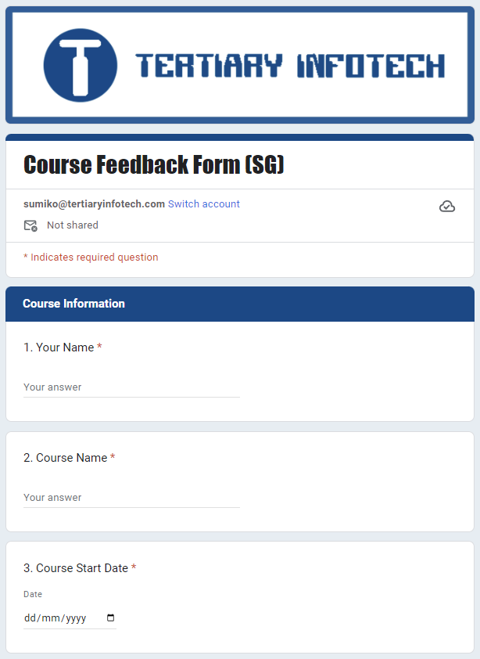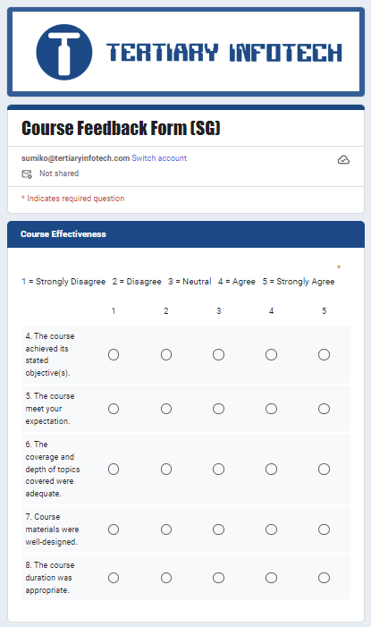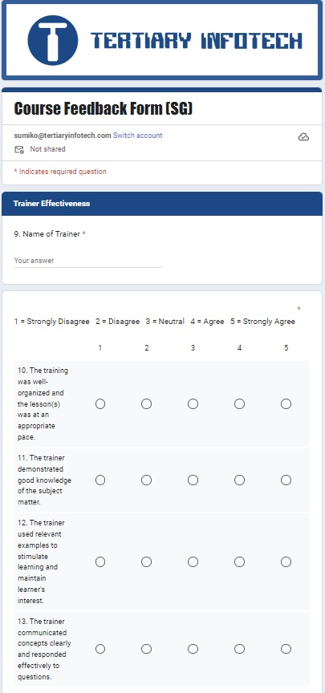
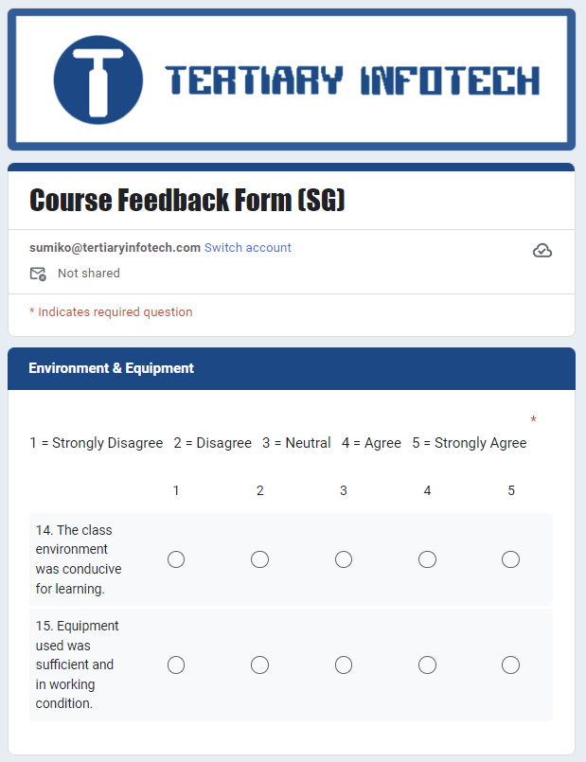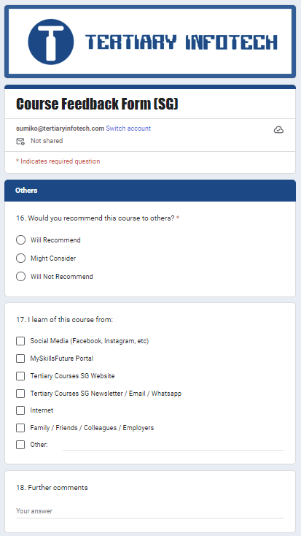

Annex C.3 - L1 Consolidated Course Evaluation
Course Title:
Period of Review:
Name of Trainer:
Performance Criteria | Average Score
No. of Responses
Trainer & Course Content
Learning
Customer Service
- Overall Satisfaction
Consolidated Overall Rating
Evaluation / Comments

Collated by: |  | Date:
Review by: |  | Date:

Annex C.4 - L2 Consolidated Passing Rate Report & Attrition Rate Report

Course Title:
Period of Review:
Passing Rate Report
Formula:
$$Consolidated Passing Rate = \frac{No. of Certified Competent}{No. of Assessments Conducted}×100\%$$

Consolidated Passing Rate | Assessor 1 | Assessor 2 | Assessor 3
No. of Assessments Conducted
No. Certified Competent
No. Certified Not Yet Competent
% Consolidated Passing Rate
Evaluation / Comments
Attrition Rate Report
Consolidated Response | No. of Learner
Condition 1:
No. of learners at the start of training
Condition 2:
No. of learners at the end of training
Attrition Rate:

$$\frac{Condition 1-Condition 2}{Condition 1}×100\%$$

Evaluation / Comments

Collated by: |  | Date:
Review by: |  | Date:

Annex C.5 - SSG Outcome Survey Form

For each statement below, please tick the response

The rating scale is as follows:
5 – To a Very Large Extent 4 – To a Large Extent 3 – To Some Extent
2 – To a Small Extent 1 – Not at all

 | 5 | 4 | 3 | 2 | 1
1. The course has helped me progress in my work / career.

For learners who choose a rating of 4/5. That’s great! What was the main reason you feel this way?
For learners who choose a rating of 2/3. What was the main reason you feel this way?

For learners who choose a rating of 1. We’re sorry to hear that. What was the main reason you feel this way?

2. What was your main intention for attending this course?
2a. Same job role
i Improve work performance for my current job role.
ii Prepare myself for a same job role in a different company / sector
2b. Change job role
i Prepare myself for a different job role in a same company / sector
ii Prepare myself for a same job role in a different company / sector
2c. Personal Interest

 | 5 | 4 | 3 | 2 | 1
3. The course helped me to develop my skills and knowledge
4. I have applied what was taught during the course in my work.
5. The skills and knowledge acquired in the course led to improvements in my performance at work.
6. The training/qualification I received, contributed to an increase/change in my job responsibilities
7. The training/qualification I received, contributed to improvement in my rewards (e.g. salary increase, promotion).

1. I am now more confident to (select all that apply):
a. Transit into the workforce
b. Keep upskilling and/or reskilling
c. Adapt to workplace changes
d. Support my organisation’s transformation
e. Others:

2. I am now more aware to (select all that apply):
a. Key industry trends
b. Skills needed to support organizational transformation
c. Skills needed to support organizational resilience
d. Support my organisation’s transformation
e. Others:

8. What is one thing we can do to improve the impact of future classes on learner’s work and career?

9. Would you like to be contacted by the We about Your Feedback above?
a. Yes, my email address:
b. Yes, my contact number is:
c. No, thanks

Annex C.6 - Post Training Follow-Up Form
Course Title
Period of Review
Name of Staff
Company

The purpose of this exercise is to solicit your comments as a supervisor of the staff on the effectiveness of the courses in enabling the staff to apply his/her learnt knowledge and skills back to his/her existing job responsibilities.

Thank you for your time. Your feedback is important to us and will help us improve our training programmes.

Rating Scale:
5 – To a Very Large Extent (Demonstrates this ability at all times)
4 – To a Large Extent (Demonstrates this ability from time to time)
3 – To Some Extent
2 – To a Small Extent (Seldom demonstrates this ability)
1 – Not at all (Never demonstrates this ability)
0 – Did not make use of this feature

Ref. | Evaluation Criteria | Rating Scale | Comments
1 | The staff is able to:  <To indicate TSC 1> | Circle your option  5 4 3 2 1 0
2 | <To indicate TSC 2> | 5 4 3 2 1 0
3 | <To indicate TSC 3> | 5 4 3 2 1 0
Overall, what do you think of the staff performance? |  | 5 – Excellent  4 – Good  3 – Average  2 – Poor  1 – Extremely Poor
Other Comments:

General Information

Name of Supervisor: | Designation of Supervisor:
Date of Interview: | Name of Interviewer:

Annex C.7 - L3 Consolidated Post Training Report
Course Title:
Period of Review:
Sample Size / Interview Method: | No. of Completed Survey Forms:
Consolidated Response | Average Total Score
% of Supervisor agree that the learners have applied all their learnt knowledge and skills back to their existing job responsibilities
% of Supervisor satisfy with the overall performance of learners
% of Learner agree that they have applied all their learnt knowledge and skills back to their existing job responsibilities
% of Learner satisfy with their overall performance
Evaluation / Comments

Collated by: |  | Date:
Review by: |  | Date:

Annex C.8 - Performance Indicators Checklist

Course Title
Period of Review
Name of Staff
Company

The purpose of this exercise is to solicit your comments as a supervisor of the staff on the effectiveness of the courses impacting your company business because of the programme.

Thank you for your time. Your feedback is important to us and will help us improve our training programmes.

Performance Indicators | Before Training | 6 – 12 Months After  Training
Sales revenue in a year
Number of return clients in a year
Is the staff currently still with the company | 1. Yes 2. No, pls specify date left:
Overall, what do you think of the company's business performance as a result of the programme? | 5 – Excellent  4 – Good  3 – Average  2 – Poor  1 – Extremely Poor
Other Comments:

General Information

Name of Supervisor: | Designation of Supervisor:
Date of Interview: | Name of Interviewer:

Annex C.9 - Minutes of Meeting Template

Minutes of Meeting

Attendance: |  | Date & Time of Meeting:
Absent with Apologies: |  | Venue of Meeting:
S/N | Agenda / Key Points of Discussion |  | Action / Follow-Up By

Recorded by: |  | Date:
Reviewed by: |  | Date:

Annex D.1 - Administrative Support and Processes
Process |  | Responsible By /Resource(s) | Process
1 | Confirm training schedule | Training Manager | Every quarter
2 | Create course run via API | Training Executive | Within 14 working days after confirmation of the training schedule.
3 | Start course registration ¹ | Training Executive | Once training schedule published on website
4 | Send course registration acknowledgement notification ² | Training Executive | Within 1 working day from date of course registration
5 | Send notification / booking of trainers and assessors | Training Executive | Once there is sign-up
6 | Update learner registration details in database | Training Executive | Within 3 working days from date of course registration
7 | For WSQ-funded course: Send email request for learner’s / sponsoring employer’s information & supporting document for grant application³ | Training Grant Executive | Within 3 working days from date of course registration
8 | Close registration | Training Executive | 1 working day before commencement of course
9 | Create course run / sessions in TPG via API | Training Executive | At least 5 working days before commencement of course
10 | Enrol learner in TPG | Training Grant Executive | At least 5 working days before commencement of course
11 | Send confirmation/reminder emails to trainers & assessors and learners | Training Executive | Confirmation email: 7 days before commencement of course  Reminder email: 2 days before commencement of course
12 | Email course materials and attendance sheet (for synchronous & external training) to Trainers and Assessors. Update trainers/assessors’ attendance URL link⁴ | Training Executive | Course Materials: At least 7 days prior to start of training and assessment
13 | Send courseware to Learners | Training Executive | First day of course
14 | For Synchronous class:  Send zoom details to learners | Trainer Coordinator | 2 working days before commencement of course
15 | Send Invoice to Learners⁵ | Finance Team | At least 5 working days before commencement of course
16 | Prepare Learner Guides and Assessment Records (e.g. send for printing / setup shared folder with Learners) | Training Executive | 2 working days before commencement of course
17 | Take e-attendance via SingPass for each session using TPG dynamic QR code. Ensure all learners' attendance are taken and their name & last 4 characters displayed in e-attendance summary page. | Training Executive | Start of each session
 | Submit Attendance Sheets to Training Executive, if applicable |  | First day of training (for confirmation of attendance); and  Last day of training (attendance sheets of all training days); and  Last day of assessment period
18 | Inform Training Co- Ordinator of Absentee/Learner who unable to take e-attendance via SingPass | Trainers and Assessors | Same day of absence/e-attendance cannot be taken
 | For Learners unable to take e-attendance:  - Take pictures of Learner’s mobile phone error messages and mobile phone operating system version and  - Log case for appeal for manual attendance via the Service Portal | Training Executive | Same day of absence/e-attendance cannot be taken
19 | For Absentee case: Follow-up with email/phone call on rescheduling. | Trainer Coordinator | Same day of absence/e-attendance cannot be taken
20 | Display static QR code for learners to submit TRAQOM Quality Survey. | Trainers and assessors | Last day of course, before class dismissal.
21 | Send Post-Course Email⁶ | Trainer Coordinator | Last day of course
22 | Complete assessment Records | Assessors | Same day of assessment
23 | Submit & Upload Assessment records to Training Executive for Checking & Verification | Assessors | Within 5 working days from date of assessment
24 | Upload assessment results to TPG via API &  Record assessment number & upload date into database | Training Executive | Within 7 working days from date of assessment
25 | For Absentee case which has SSG funding:  - Cancel or defer training grant via TPG.  - Delete or revised invoice | Finance/Grant Executive | Within 3 working days from confirmation of revised date / cancellation
26 | For Absentee case using SFC:  Delete SFC claim via TPG | Finance/Grant Executive | Within 3 working days from confirmation of revised date / cancellation
27 | Check Training Grant:  Update payment status in TPG via API and check assessment date (for WSQ courses). | Training Grant Manager | Within 14 days upon course completion
28 | Issue Statement of Attainments (SOAs) to successful candidates upon request4 | Training Executive | Upon request
29 | Check learner’s SFC claim submission is approved | Finance Team | Within 5 days before course start
30 | Check for ‘Ready for Payout’ SFC via TPG | Finance Team | Weekly
31 | Submit ‘Ready for Payout’ SFC via TPG | Finance Team | Weekly
32 | Check for SFC Payout Request Disbursement via TPG notification | Finance Team | Weekly
33 | Reconcile SFC Payout / SSG TG Disbursement with bank statement and receive payment | Finance Team | Within 2 days
34 | Update TPG to ensure profile data is up-to-date⁷ | Training Manager | Within 7 days from date of change

¹For courses with prerequisite skills and knowledge, Training Executive will email to confirm learners possess the required prerequisite skills and knowledge. Should the learners do not possess the required skills and knowledge, the Training Executive will suggest suitable courses to attain the required prerequisite skills and knowledge first before registering for the intended course.

²Training co-order will email registration order to learner, once registration has been submitted successfully, to acknowledge registration order has been received. A google invite will be emailed to learners to block their time for the training.

³For courses with SSG funding, the training grant executive will check whether the learner has filled in the WSQ training grant form. If there is no submission of a grant form, the training grant executive will email to learners to inform them of the SSG funding and its eligibility criteria and remind them to fill in and submit the grant application if they are eligible and want to tap on the funding. By submitting the grant form, learner/representative of sponsoring employers declare they will pay the full course fee, without WSQ funding, if SSG revokes the training grant due to inaccurate information/criteria not met.

⁴During physical classroom courses: Trainers will project the dynamic SingPass QR Code for learners to take their e-attendance, by scanning the SingPass QR code via their SingPass App.

⁵For courses that are eligible for SkillsFuture Credit (SFC), the training grant executive will email the learner to confirm whether the learner will pay nett fee using SFC. Invoice will indicate payment by SFC and SFC claim amount.

⁶Upon training completion learners will receive a post-course email regarding their certificate, feedback (if any) and post-course support. For learners who passed the WSQ assessment, they will be informed that they can download the e-certificate from MySkillsFuture Portal. Should the earner be unable to download the e-certificate, he/she can approach the Training Executive for a copy.
Upon receiving the request from the learner, the Training Executive will verify the learner’s profile (i.e. name, NRIC, course attended and assessment result). Once the learner’s profile has been verified, the Training Executive will login to TPG to download a copy of the e-certificate.
If the learner has requested a soft copy – email the e-cert (pdf) to the learner.
If the learner has requested a hard copy – print the e-cert and hand it to the learner over the counter or mail to his/her mailing address.

⁷Any changes to the profile data such as organisation information (e.g. address, telephone, email, officers); course information (e.g. course title, course fee, course duration); and adult educator information (e.g. new hire, resigned) shall be updated promptly.

Annex D.2 - Learning Management / Learner Support System

Course Schedule
Courses are offered, 1-2 classes per month. Each class is limited to 20 learners.

Registration for Course
Step 1: Visit the website at https://chariotconsultancy.com to view course dates and details.
Step 2: Submit the online registration form for the desired class.
Step 3: A course confirmation email will be sent to learners at least 5 working days before the course starts.

For SSG funded courses, learner(s)/sponsoring employer(s) will be informed of SSG funding and its criteria. Followed by confirmation of eligibility and declaration that they will pay the full course fee, without WSQ funding, if SSG revokes the training grant due to inaccurate information/criteria not met.

See Annex A.12 for SSG Funding Eligibility Check Process.

For further queries, learners can contact the training centre via:
- Website: https://chariotconsultancy.com
- Email: info@chariot-learning.com
- Phone Call: 67850776
- Walk-in: 10 Jalan Besar #15-05 Sim Lim Tower, Singapore 208787 (By appointment only)

This page is intentionally left blank

